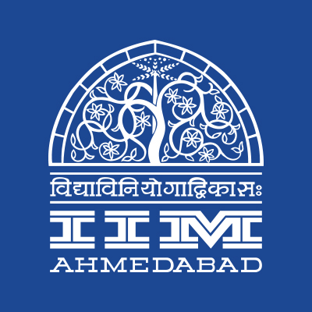

**PRESS RELEASE**

**IIMA to host Annual Inter IIT-IIM Quizzing Event - Nihilanth**

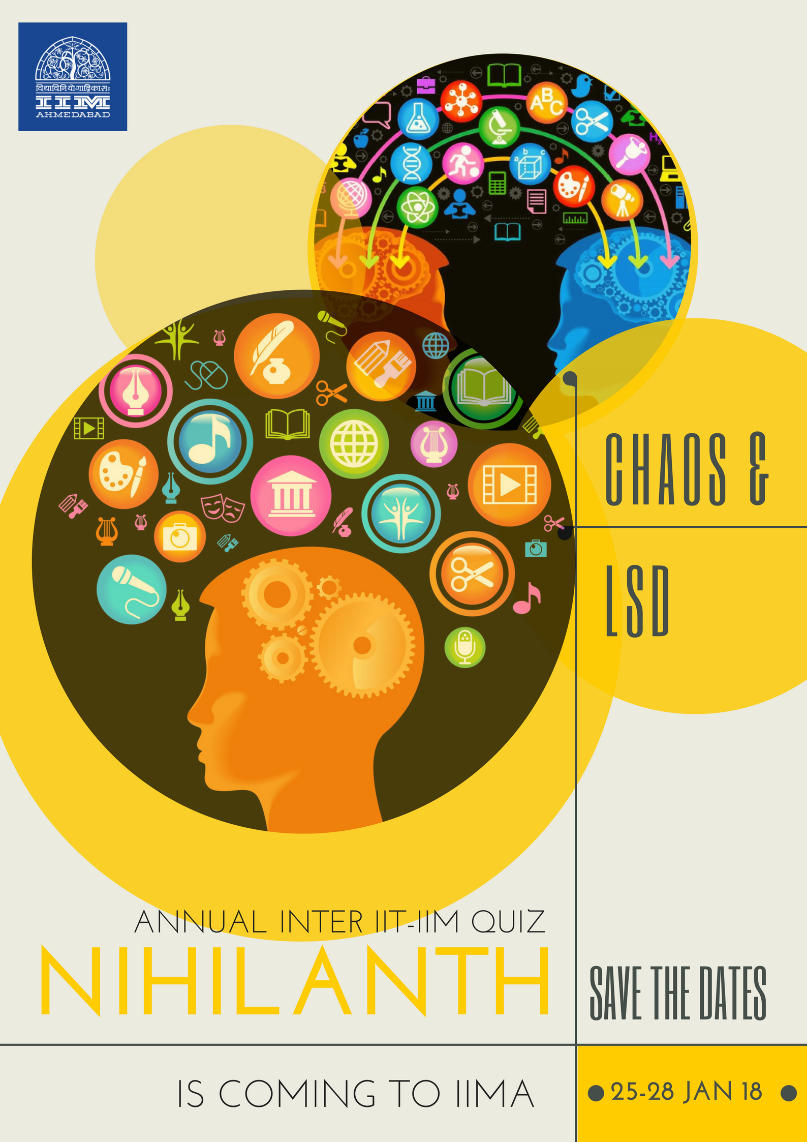

**October 24, 2017 | Ahmedabad**

Indian Institute of Management Ahmedabad is set to host the 3-day quiz extravaganza - *Nihilanth,* the Annual Inter IIT-IIM Quiz championship. The hosts for the 15th edition of *Nihilanth* have been decided by competitive bidding among 3 contenders including IIM Calcutta, IIT Roorkee, and IIM Ahmedabad. IIMA has received the baton to host from IIM Lucknow who have hosted the 14th edition of Nihilanth from 13-15 Jan’2017. Started in 2003, *Nihilanth* provides a platform to students of IITs and IIMs to compete for supremacy over nerdiness.

Nihilanth 2018 would be held as part of Chaos, the Annual Cultural Event of IIMA scheduled from January 25-28, 2018. The event would feature over seven quizzes for the institutes to slug it out for the coveted championship. Expected participation of 450+ students from over 39 contingents (19 IITs, 20 IIMs) in this edition of the event is sure to pique interest levels among all quizzing enthusiasts across India.

The competitive bid for hosting the event was coordinated by LSD (Literary Symposium Desk) of IIM Ahmedabad, an umbrella student body for all literary events on campus. LSD also plays a regular host for Ahmedabad Quiz Club’s Quiz sessions. *Commenting about the successful bid, Shobhit Shubhankar, Alumni & External Affairs Secretary of IIMA & an avid quizzer, said “It is wonderful to have Nihilanth at IIMA. We bid for hosting Nihilanth 2017 too where we lost by a narrow margin to IIM Lucknow. The event would go a long way in cementing the quizzing culture on campus and act as a booster shot for LSD’s quizzing activities.”*

*Ankush Pumba, Chaos Secretary, quoted “The Chaos committee is determined for making the Annual Cultural Event bigger and better than last year. We want Chaos to be an all-encompassing cultural event, and the combination of Chaos & Nihilanth undoubtedly will make IIMA an irresistible place to spend the first long weekend of 2018.”*

-End of Text-

|  |
| --- |
| **News in Brief**  Indian Institute of Management Ahmedabad will host the 15th edition of Annual Inter IIT-IIM Quiz championship, *Nihilanth 2018*. Started in 2003, IIM Indore hosted the first ever *Nihilanth*. IIMA receives the baton of playing the host from IIM Lucknow which hosted Nihilanth 2017. To be spread over three days, 450+ quizzers from over 39 contingents (19 IITs, 20 IIMs) are expected to attend the event to be held as part of Chaos, Annual Cultural event of IIMA from January 25-28, 2018. |

**About Indian Institute of Management Ahmedabad (IIMA)**

Established in 1961, the Indian Institute of Management, Ahmedabad (IIMA) is recognized globally for excellence in management education. One of the top management schools in the world, IIMA educates leaders of the enterprises.

The Institute’s strategic priorities include: strengthening connection with its various constituencies, including academics, practitioners, alumni, and the community; nurturing a high performance work environment of stretch, autonomy, and teamwork; and strategic growth while maintaining emphasis on quality.

As per the latest ranking by *The Economist*, IIMA is No. 1 School in the world on the parameter of opening up new career opportunities for students. The flagship Post Graduate Programme (PGP) is ranked 16th in the *Financial Times* Masters in Management Ranking 2016. As per the *Financial Times’* Global MBA Ranking 2016, IIMA’s Post Graduate Programme for Executives (PGPX) is ranked 24th in the World. IIMA has been ranked as #1 Management institute as per the National Institutional Ranking Framework (NIRF) rankings of Ministry of Human Resource Development, Government of India.

For media queries, please contact:

|  |  |
| --- | --- |
| Nikhil Nayak  Coordinator, Literary Symposium Desk (PGP-2)  Indian Institute of Management Ahmedabad  Ph: (Cell) +91-9920348270  Email: p16nikhiln@iima.ac.in | Balaji Uppala  Media Secretary (PGP-2)  Indian Institute of Management Ahmedabad  Ph: (Cell) +91-7042705642  Email: p16srimukhab@iima.ac.in |