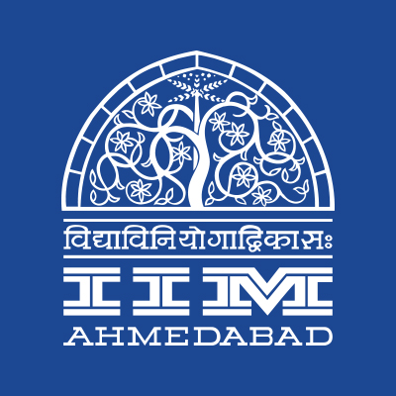

**PRESS RELEASE**

**IIMA emerges as Nihilanth 2018 Winners**

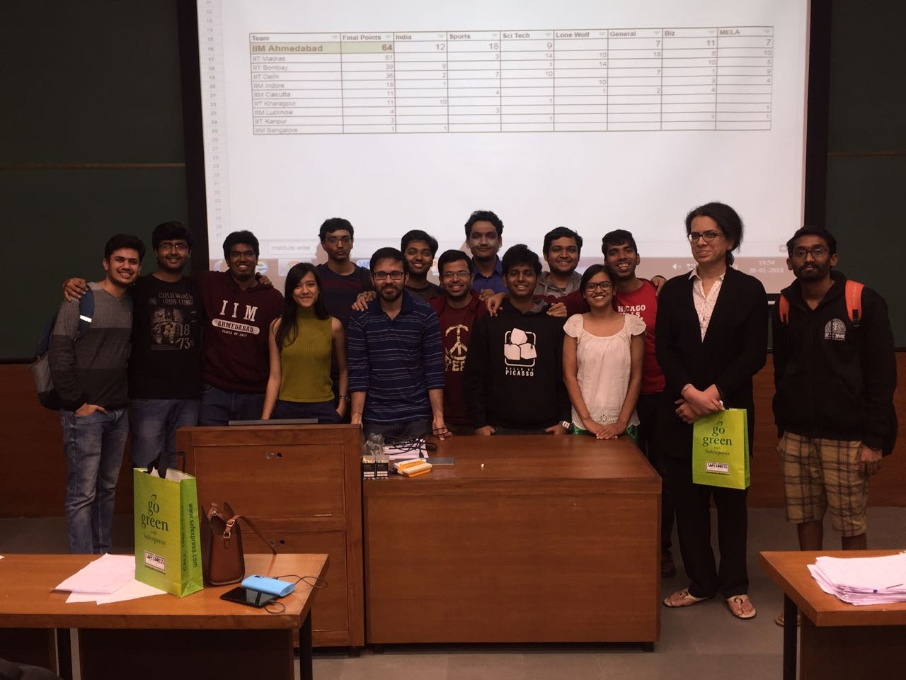

*-IIMA Contingent after Nihilanth 2018*

**February 2, 2018 | Ahmedabad**

Nihilanth 2018, the 15th edition of the prestigious quizzing tournament, was hosted by IIM Ahmedabad during its cultural festival Chaos. With IITs and IIMs from all over the country contending for the glorious trophy, Nihilanth is fiercely competitive and tests the mettle of experienced quizzers every year. This year, the tournament witnessed a plethora of nail biting moments across the three days with seven intense quizzes on themes such as India, Sports, Business, Sci-Tech and Music, Arts and Literature. It was especially significant that IIM Ahmedabad finally came through as the winners of such this illustrious tournament in their own home ground.

The tournament saw a staggering participation of 370 students from more than 20 IITs and IIMs. With esteemed quizmasters such as Suraj Menon, Vikram Joshi, Sachin Ravi, Thejaswi Udupa, Major Chandrakant Nair and Sreshth Shah, the quality of the questions across themes and topics was highly appreciated by every contingent. IIM Ahmedabad established its dominance in the tournament through their presence in the finals of six of the quizzes. Veteran institutes with a legacy in Nihilanth such as IIT Madras, IIT Bombay, IIT Delhi and IIM Indore ensured the quality of the competition. The final tally of scores is as follows:

|  |  |
| --- | --- |
| **Team** | **Final Points** |
| IIM Ahmedabad | 64 |
| IIT Madras | 61 |
| IIT Bombay | 39 |
| IIT Delhi | 36 |
| IIM Indore | 18 |
| IIM Calcutta | 11 |
| IIT Kharagpur | 11 |
| IIM Lucknow | 4 |
| IIT Kanpur | 4 |
| IIM Bangalore | 1 |

*Shayari Devbarman, organizing member of Nihilanth 2018, was quoted as describing the event as, “A great learning experience for all the participants. The passion, the energy & the enthusiasm across the 3 days was simply amazing with some quizzes stretching till 3am.”*

**-End of Text-**

|  |
| --- |
| **News in Brief**  Indian Institute of Management Ahmedabad won the 15th edition of Inter IIM - IIT quiz championship, Nihilanth 2018. IIM A claimed its victory at their home turf. The tournament was spread over 3 days with 7 quizzes on themes such as India, Sports, Business, Sci-Tech and Music, Arts and Literature. Nihilanth 2018 saw a staggering participation of 370 students in more than 100 teams from around 20 IIMs and IITs. |

**About Indian Institute of Management Ahmedabad (IIMA)**

Established in 1961, the Indian Institute of Management, Ahmedabad (IIMA) is recognized globally for excellence in management education. One of the top management schools in the world, IIMA educates leaders of the enterprises.The Institute’s strategic priorities include: strengthening connection with its various constituencies, including academics, practitioners, alumni, and the community; nurturing a high performance work environment of stretch, autonomy, and teamwork; and strategic growth while maintaining emphasis on quality.

As per the latest ranking by The Economist, IIMA is No. 1 School in the world on the parameter of opening up new career opportunities for students. The flagship Post Graduate Programme (PGP) is ranked 16th in the Financial Times Masters in Management Ranking 2016. As per the Financial Times’ Global MBA Ranking 2016, IIMA’s Post Graduate Programme for Executives (PGPX) is ranked 24th in the World. IIMA has been ranked as #1 Management institute as per the National Institutional Ranking Framework (NIRF) rankings of Ministry of Human Resource Development, Government of India.

Nihilanth 2018 was coordinated by Literary Symposium Desk (LSD), an umbrella student body for quizzing, debating and creative writing. The tournament was organized during Chaos 2018 – the annual cultural festival of IIM Ahmedabad.

For media queries, please contact:

|  |  |
| --- | --- |
| Raghuram Valluri  Member, Media Cell  Indian Institute of Management Ahmedabad  Ph: (Cell) +91-9800172995  Email: [p17vraghuram@iima.ac.in](mailto:p17vraghuram@iima.ac.in) | Shayari Devbarman  Member, Literary Symposium Desk  Indian Institute of Management Ahmedabad  Ph: (Cell) +91-9871185811  Email: p17shayarid@iima.ac.in |