

**PRESS RELEASE**

**Community Service in Response to Covid-19 by IIMA**

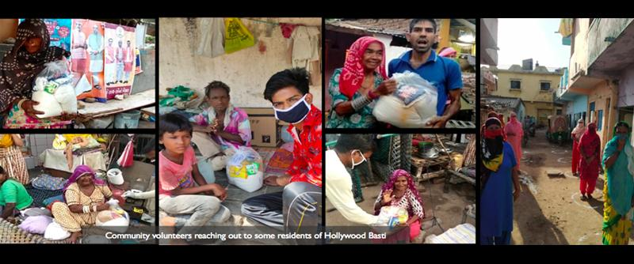

*Few of the many times when the needs of the families were fulfilled by IIMA amidst this crisis*

**July 1, 2020 | Ahmedabad**

On the announcement of the nationwide lockdown by the Government of India, a group of Faculty, Students, Researchers and Staff at IIM Ahmedabad formed a team of over 80 volunteers to help the low-income families and migrant workers who were much adversely affected by the lockdown. Till date, the team has aided more than **2300 families** and more than **800 migrant workers** by providing *ration kits, financial aids, supporting community kitchens and helping migrants reach their hometown*.

Due to the lockdown, many poor households, mostly those dependent on daily wages, were out of income and rations. While a section of society rested safely within the comfort of their houses, a large number of people struggled to survive amidst the crisis. IIMA has always been active in giving back to society and this time was no exception. Realizing the need of the hour, the team worked with dedication to helping the community. The goal of this relief work was to reach out to those falling through the cracks of government and other civil societies’ efforts.

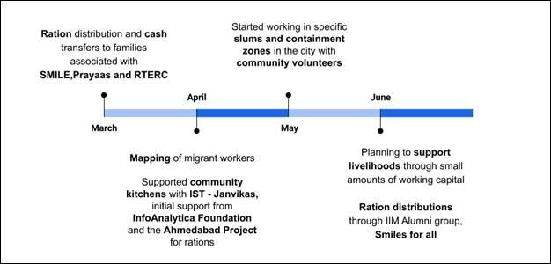

*A brief depiction of the timeline and relief work carried out by IIM A*

*"Targeting is costly. You try to target, you miss the right people often because they are the poorest of the poor"*, said Nobel laureate Abhijit Banerjee. Keeping this in mind, the team carried out the relief work in a systematic approach in order to provide help to those who need it the most. The team surveyed the poor households which they have worked with previously via IIMA student societies – Prayaas, Student-Mediated Initiative for Learning to Excel (SMILE) and Right to Education Resource Centre (RTERC), which work for the education of underprivileged children and upliftment of underprivileged communities. Based on these surveys, households were divided into four categories based on the urgency of need: Red, Orange, Yellow and Green. The survey also indicated that about 85% of the households were not earning a regular income, about 54% households had reduced the number of meals consumed per day and many had difficulties in procurement of Ration via PDS. The data collected from the survey helped identify the specific problems faced by the households and the number and location of households which needed help the most and this was used for planning the relief work.

More than 550 Ration kits were distributed to different households over a period of 2 months. The reach was in several slums in Hollywood basti – Gulbai Tekra, Bombay Hotel – Bapunagar, Danilimda, Wadaj, Vatva, Juhapura, Gota and Behrampura areas of Ahmedabad. These distributions were made with the help of security guards of IIMA living near these areas, 30+ motivated individual volunteers including Hozefa Ujjaini, Shailesh Shah and many more from the community as well as several civil societies such as Aasman Foundation, The Robin Hood Army and more. The volunteers ensured safety by using masks, gloves, sanitizers and maintained social distancing. At the places where direct ration kits couldn’t be supplied, money was either transferred directly to the accounts of the families or it was given to the nearby Ration shop from which families could then obtain ration free of cost. About Rs. 2.3 Lakhs were sent directly to households to aid them, in this manner.

The team was also swift in assisting the migrant workers. Within two days of the lockdown, volunteers supported a community worker Ajaz Sheikh, to help map out clusters of worksites where migrant workers were stranded without any food or income and raising funds to help support families. Over 252 families were identified in the eastern part of the city (Gomtipur, Rakhial, Bapunagar, Saraspur, Amraiwadi, Behrampura, Vatva) and funds were raised to support them with the help of local police. These efforts led to the creation of community kitchens used by around 4000 workers and supported by Janvikas, InfoAnalytica Foundation and the Ahmedabad Project. The IIM team helped do the back-end work of geo-tagging the places, as the volunteers reported on WhatsApp, making it easier to deliver cooked food every day for 45 days. The team also helped in setting up a community kitchen in Narol, for 90 labourers from Jharkhand for a month.

The team carried out 2 more surveys in between in order to understand the developments in the situation of the households and modify the strategies to adapt to the changes. The team has also been involved in - helping migrants getting lockdown exempt passes made, registration, digitizing data and coordinating with the governments of Gujarat and Jharkhand for easy passage of migrants. The team has so far assisted around 800 people in getting train tickets, funds for bus tickets and arranging private transport. The team raised around Rs. 5 Lakhs for travel of 112 migrant workers (from Bihar and Jharkhand).

A total of about Rs. 14 Lakhs was raised for the entire work through different channels. The major contributions were by the IIMA staff and IIMA community. A fundraising campaign was also launched on crowdfunding platform Ketto.org and about Rs. 3 Lakhs were raised from the same. An online workshop conducted by an IIMA Alumnus also raised about Rs. 1.2 Lakh, with another one, conducted by the PGP students raising over Rs. 20 thousand.

Through these months, the team has learnt and evolved ways in which they reached out to the affected residents of the city. Through this work, the team also mobilized and strengthened new community actors, those that are not involved with existing NGOs in order to pave the way for better community mobilization in the future.

As the Unlock takes place, the need for relief amidst this crisis is still overwhelming as it would take time for the world to return to a ‘New Normal’. The team would continue to provide help along with many institutions to the families which still require assistance due to lost employment. As communities try to get back on their feet, the team is also planning to attempt creative ways to support the families and build livelihoods.

For more info, please visit our webpage: <https://covid19.iima.ac.in/index.php>

-End of Text-

**About Indian Institute of Management Ahmedabad (IIMA)**

Established in 1961, the Indian Institute of Management, Ahmedabad (IIMA) is recognized globally for excellence in management education. One of the top management schools in the world, IIMA educates leaders of the enterprises.

The Institute’s strategic priorities include: strengthening connection with its various constituencies, including academics, practitioners, alumni, and the community; nurturing a high performance work environment of stretch, autonomy, and teamwork; and strategic growth while maintaining emphasis on quality.

IIMA has been ranked as #1 Management institute as per the National Institutional Ranking Framework (NIRF) 2020 rankings of Ministry of Human Resource Development, Government of India. The flagship Post Graduate Programme (PGP) is ranked 21st in the *Financial Times* Masters in Management Ranking 2019. As per the *Financial Times’* Global MBA Ranking 2020, IIMA’s Post Graduate Programme for Executives (PGPX) is ranked 61st in the World.

For media queries, please contact:

|  |  |
| --- | --- |
| Ganesh V  Coordinator, RTERC (PGP-2)  Indian Institute of Management, Ahmedabad  Ph: (Cell) +91-830979610  Email: p19ganeshv@iima.ac.in | Goldy Admane  Media Secretary (PGP-2)  Indian Institute of Management, Ahmedabad  Ph: (Cell) +91-7758962987  Email: p19goldy@iima.ac.in |