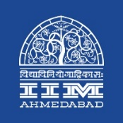

**PRESS RELEASE**

**Krishi Manthan, 2019-20 was held at IIMA**

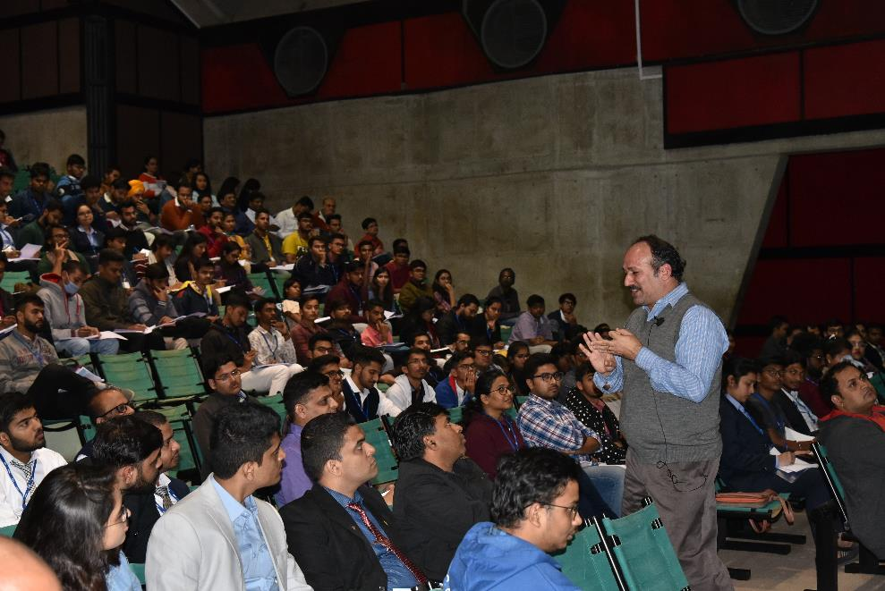

*Prof. Chetan Soman of IIMA teaching the participants of Krishi Manthan 2019-20*

**January 16, 2020 | Ahmedabad**

The 1st Edition of *“Krishi Manthan”*, the largest Food, Agribusiness and Rural Development Summit of Asia, was organised by the Food and Agribusiness Committee at Indian Institute of Management Ahmedabad.

The summit saw 1500+ attendees, ranging right from students from various sections of the academic diaspora to the current and future leaders of the agribusiness field. The students from 50+ colleges in Food, Agriculture and allied sector benefited from the workshops, apart from that working professionals from 30+ agribusiness companies like Amnex, Wipro, Grow Indigo, Arya Logistics, etc. Other students from different Agribusiness management colleges and IIMs came in huge numbers. It held up to its promise of being a platform for everyone to share ideas, knowledge and expertise to create innovative entrepreneurial solutions.

Eminent speakers like Padma Shri Prof. Anil Gupta (founder of Honey Bee Network, SRISTI, NIF, GIAN), Prof. Chetan Soman (Professor, Production and Quantitative Methods, IIM A), Rajashekhar Reddy Seelam (Founder, 24Mantra Organic), Vikram Puri (ex-EVP of Mahindra Agri Solutions, ex-CEO of Mahindra Shubhlabh Services Ltd.) and Kunal Prasad (co-founder and COO of CropIn) interacted with the audience and gathered numerous creative ideas to solve current agricultural as well as industry problems. Workshops on Social Entrepreneurship, Sustainable Growth Opportunities, Data Analytics and Supply Chain Management integrated into the field of agribusiness, provided useful insights to the leaders of the future, opening newer opportunities for them to discover and act upon. Audience participation in the workshops just went to prove everyone’s commitment to making the event a huge success.

The event also saw enthusiastic participation in business competitions which tested 1200+ participants for their mettle. True to its IIMA image, case studies on the burning issues of Organic Foods and Cooperative & Sustainable Management of FPOs saw students and entrepreneurs from all over the country face off over the span of two days. The competitions also acted as a platform for the competitors to interact with each other and share their thoughts. Experienced judges from diverse fields of industries gave their insights to all the participants and further acknowledged the success of the competitions.

In its first edition, Krishi Manthan also organised a round table discussion on “Catalysing Private Partnerships in Strengthening Producer Companies” in association with the National Association for Farmer Producer Organisations (NAFPO). The discussions were spearheaded by prominent leaders like Nilanjan Dey (Senior Manager, FWWB), Yogesh Diwedi (CEO, Madhya Pradesh consortium of FPOs), Kuldeep Solanki (CEO, GUJPRO) and many other delegates representing organisations like FICCI, PwC, Techno Serve, UNDP, NEML and Origins amongst others. The panel discussion was made open for participants and everyone of IIMA diaspora, which saw exchange of many innovative ideas. IIM Ahmedabad also hosted Social entrepreneur associated with these organisations who are trying to create paradigm shift in Indian grassroots innovations.

IIM Ahmedabad is proudly serving and continue to serve the Food, Agri and Rural sector in the country and the world. The managers which it produces under PGP-FABM (Post Graduate Programme in Food and Agribusiness Management) programme (which is rated world’s no. 1 programme in Food and Agribusiness Management by a France based institution named Ed Universal) are dedicated to this sector and are achieving milestones in the industry.

**Participant’s message**

*“It was a rigorous thought building session of 4 workshops in Two days. I would like to thank the organizers for giving us opportunity.” -* ***Meghana Bhardwaj, R&D Assistant Manager, IRM Enterprises Pvt Ltd.***

*“It was a really great experience at IIMA, attending all the workshops from immensely experienced spokespersons. Being a student food science and technology, it is great to know about the opportunities, and skills needed towards setting up and growing a business.” -* ***Harit Garg MSc food science and technology, Choudhary devi lal University, Sirsa.***

*“It was a great experience; the workshops were very informative and insightful. I trust it will be helpful to us.” -* ***Shivangi Bharatbhai Patel, College of Fisheries Science, Navsari Agricultural University.***

*“Krishi Manthan at IIMA was the best way to end 2019. It augmented our knowledge and gave us informative, innovative ideas to look and work forward in Agriculture and Agribusiness sector.” -* ***Sakar Joharapurkar, B. Sc. Agriculture, S. S. S. M. C. A. Pimpalkhuta***

**About IIMA:**

The Indian Institute of Management Ahmedabad (IIMA) was set up as an autonomous institution in 1961 by the Government of India in collaboration with the Government of Gujarat and the Indian industry. IIMA is the first management school in India to receive international accreditation for five years. It was the first business school in India to receive EQUIS (European Quality Improvement System) accreditation, by the European Foundation for Management Development (EFMD) in June 2008 and has maintained EQUIS accreditation since then.

In 2018, IIMA made it to the number 4 position in the Financial Times (FT) Asia Pacific Top 25 Business School Rank, ahead of all Indian B-School. FT conducted the ranking after considering the quality and breath of all the B-schools programmes. In addition, it has been ranked 19th in the Financial Times (FT) Masters in Management Rankings 2018 and 31st in the FT (Financial Times) Global MBA Ranking 2018. Over the years, the Post Graduate Programme in Food and Agri-business Management (PGP-FABM) of IIMA has been ranked number one globally in its category in the Eduniversal Best Masters’ Ranking in Agribusiness/Food Industry Management.

IIMA features at the top position in the India Ranking 2018 (National Institutional Ranking Framework) released by the Ministry of Human Resource Development (MHRD), Government of India.

For any clarifications please contact:

**Mr. Deepak Bhatt**

Manager, Communication, IIMA

Ph: (Cell) +91-9426229429, (O) +91-79-71524683

Email: [mngr-comm@iima.ac.in](mailto:mngr-comm@iima.ac.in)

**Ms. Mitaaly Naidu**

Executive, Public Relations, IIMA

Ph: (Cell) +91-7069074816, (O) +91-79-71524684

Email: [pr@iima.ac.in](mailto:pr@iima.ac.in)