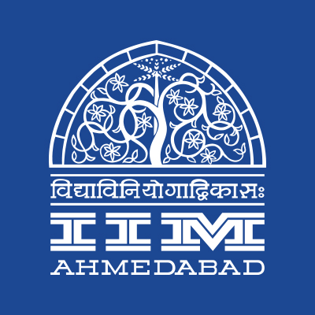 

**PRESS RELEASE**

**An evening of Raag Desh**

**July 18, 2017 ∣ Ahmedabad**

On July 17, Ravi J. Matthai Auditorium of IIM Ahmedabad became the platform for IIMACTS - IIM Ahmedabad Cultural and Theatrical Society, by hosting a panel discussion on **‘Cinematic Representation of the Independence Struggle: INA Red Fort Trials’.** The event saw imminent personalities: Tigmanshu Dhulia, Director/Screenwriter/Actor and Actors Kunal Kapoor and Mohit Marwah. The panel attended the discussion as a part of the promotion of the film releasing soon, ‘Raag Desh’ which showcases the famous INA Red Fort trials in the pre-independence era.

National Award-winning director, Tigmanshu Dhulia (of Pan Singh Tomar fame), started the discussion by explaining how the depiction of freedom struggle has seldom been authentic in the past. He commented that the depictions that one sees today either end up being too dramatic with song and dance sequences or end up as documentaries, which are factually correct but do not give viewing pleasure. He stressed on the fact that he wants to see movies like the Pearl Harbour in India, which achieve the right balance between facts and entertainment.

Mohit Marwah, while commenting about some of the must-watch war films of all time mentioned the names of Hacksaw Ridge, Apocalypse Now and Saving Private Ryan. When asked about the research journey for *Raag Desh*, Tigmanshu Dhulia said that the research itself took close to a year while the script took almost 6 months. During this research journey, Tigmanshu Dhulia himself had a newfound respect for the Azad Hind Fauj (Indian National Army – INA) when he read about their battle in Kohima where they lost more than 25 thousand of their men and yet fought valiantly in harsh environmental conditions like slush, rain and maggots.

***Mr. Dhulia concluded the discussion by saying, “Film-making is an art of the highest form but it is commerce at the same time. And that the best idea cannot work without leadership and a great team.”***

Saumya Shrirup, Head of the IIMA Cultural and Theatrical Society, mentioned in hindsight the importance of cinematic medium in shaping the collective consciousness of the community. Referencing movies like The Ghazi attack, Parmanu, Indu Sarkar, Bhaag Milkha Bhaag, she commented on how there is a surge of new-cinema culture with an influx of stories with contemporary realism.

A photograph from the event are attached with the mail. The following are the details of the guests who graced the event.

* **Tigmanshu Dhulia (Director/ Screenwriter/Actor)**

*Has directed various films like Pan Singh Tomar, Sahib Biwi aur Gangster; Famous as Ramadhir Singh in Gangs of Wasseypur*

* **Kunal Kapoor (Actor)**

*Known for his roles in Rang De Basanti, Don 2, Dear Zindagi et al*

* **Mohit Marwah (Actor)**

*Best known for his role in Fugly; Acted in various short films*

End of Text --

**About IIMACTS:** IIMACTS - IIM Ahmedabad Cultural and Theatrical Society is the in-house dramatics society for IIMA. As the Dramatics Club of IIM Ahmedabad, IIMACTS gives the IIMA community a chance to act, direct and produce stage and street dramas in Hindi and English.

**About Indian Institute of Management Ahmedabad (IIMA)**

Established in 1961, the Indian Institute of Management, Ahmedabad (IIMA) is recognized globally for excellence in management education. One of the top management schools in the world, IIMA educates leaders of the enterprises.

The Institute’s strategic priorities include: strengthening connection with its various constituencies, including academics, practitioners, alumni, and the community; nurturing a high performance work environment of stretch, autonomy, and teamwork; and strategic growth while maintaining emphasis on quality.

As per the latest ranking by The Economist, IIMA is No. 1 School in the world on the parameter of opening up new career opportunities for students. The flagship Post Graduate Programme (PGP) is ranked 16th in the Financial Times Masters in Management Ranking 2016. As per the Financial Times’ Global MBA Ranking 2016, IIMA’s Post Graduate Programme for Executives (PGPX) is ranked 24th in the World. IIMA has been ranked as #1 Management institute as per the National Institutional Ranking Framework (NIRF) rankings of Ministry of Human Resource Development, Government of India.

**For media queries, please contact:**

|  |  |
| --- | --- |
| **Saumya Shrirup**  IIMACTS Coordinator  Indian Institute of Management Ahmedabad  Ph: (Cell) +91-8107518128  Email: [a16saumya@iima.ac.in](mailto:a16saumya@iima.ac.in) | **Arpit Jain**  External Media Relations  Indian Institute of Management Ahmedabad  Ph: (Cell) +91-9916288168  Email: [p16arpitj@iima.ac.in](mailto:p16arpitj@iima.ac.in) |