

Press Release

IIMA steps towards green energy with Solar Power Plant

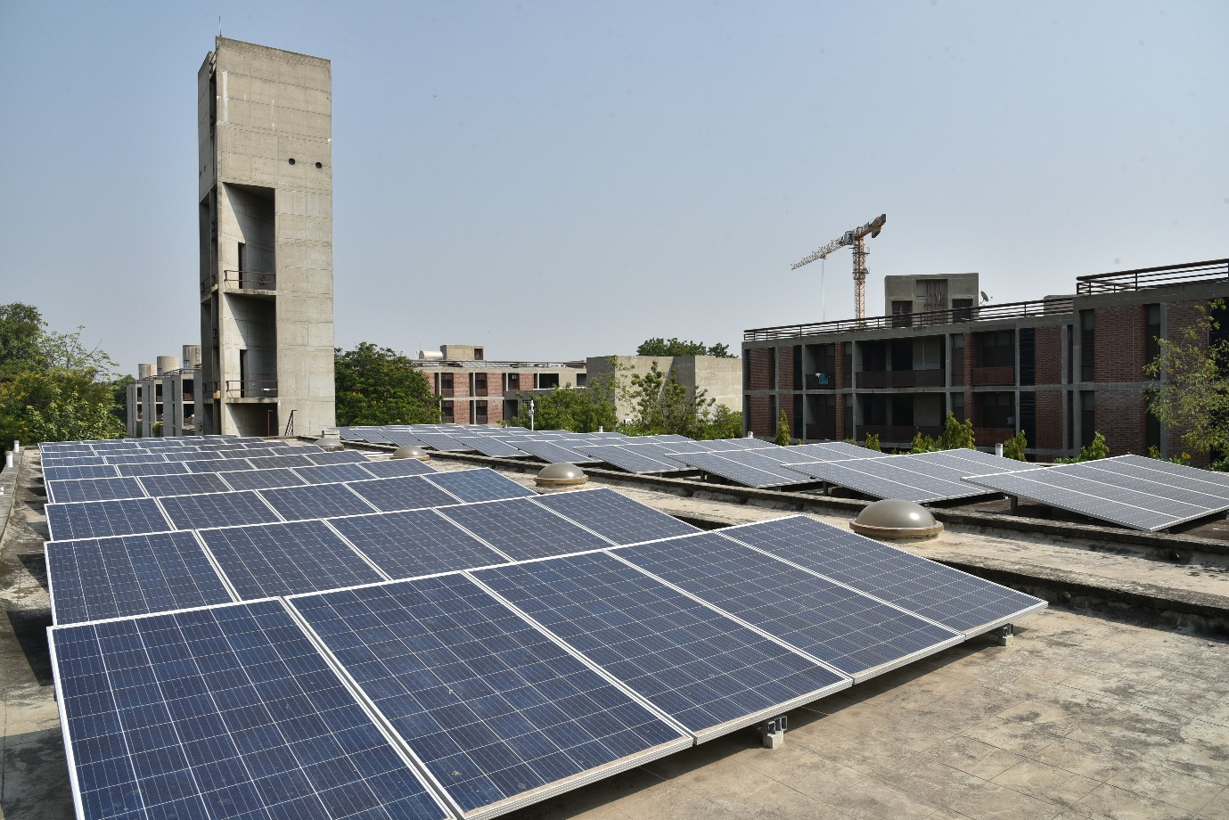

Solar panels on one of the rooftops

**October 29, 2020 | Ahmedabad**

The key to a sustainable future lies in green energy and alternative energy sources, and Indian Institute of Management Ahmedabad has joined the initiative by successfully commissioning its first Roof Top Solar Power Plant.

The first phase was completed in New campus on top of five set of buildings (Dorms, MSH, IMDC Wings, Academic Blocks and Substation) with the total installed capacity of 365 kWp.

The trial run commenced on July 14, 2020, and the plant is now fully operational. The plant has generated about 80000 units of electricity till end September 2020 and thereby saved approximately 70 tonnes of CO2 emission.

On a regular academic day, we are likely to save up to 15% from conventional consumption of New Campus with this first phase.

IIMA is committed to increasing use of renewable energy, and the implementation of this project is being carried out in phases.On completion of phase one with 365 kWp capacity, we are likely to add around 50 kWp in phase two over the next few months. In subsequent phases we intend ramping up electricity generation from Rooftop Solar to 50 % of our requirement.

Through this initiative, the aim is to enrich the on-campus experience for community members and visitors through the application of sustainable technology to improve lifestyle and reduce carbon footprint.

-

**About IIMA:**

Indian Institute of Management Ahmedabad (IIMA) is a premier B-school in the Asia Pacific region. Globally, the Institute's programmes have earned high reputation and acclaim, becoming the first Indian institution to receive international accreditation EQUIS. Founded in 1961 as a unique public-private partnership for development through the application of knowledge, today it has overseas presence in Dubai and associates with over 80 foreign B-schools to offer academically superior, market-driven and socially impactful programmes, research and consultancy services. In 2018, IIMA made it to the number four position in the Financial Times (FT) Asia Pacific Top 25 Business School Rank, ahead of all Indian B-Schools. FT conducted the ranking after considering the quality and breath of all the B-schools programmes. Over the last several years, IIMA is the only Indian B-school to feature in the reputed Economist ranking and emerged at number one position in India Ranking 2020 NIRF (National Institutional Ranking Framework), released by the Ministry of Human Resource Development, Government of India.

Over the years, IIMA has benefited more than 38,000 alumni who graduated from its various programmes. Currently, besides its renowned flagship Two-year Master in Business Administration (MBA), earlier known as Post Graduate Programme in Management (PGP); the Institute continues to draw top-quality students to its PhD Programme in Management, MBA in Food and Agri-Business Management (FABM), MBA-PGPX (One-Year Full-Time Post Graduate Programme in Management for Executives), Faculty Development Programme (FDP), Armed Forces Programme (AFP), e-Post Graduate Programme (ePGP), e-Post Graduate Diploma in Advanced Business Analytics (ePGD-ABA), and benefits industry professionals through its short duration Executive Education Programmes.

*For media queries, please contact:* **Mitaaly Naidu  
Executive, Public Relations**Ph: (Cell) +91-7069074816, (O) +91-79-7152 4684, Email: [pr@iima.ac.in](mailto:pr@iima.ac.in)