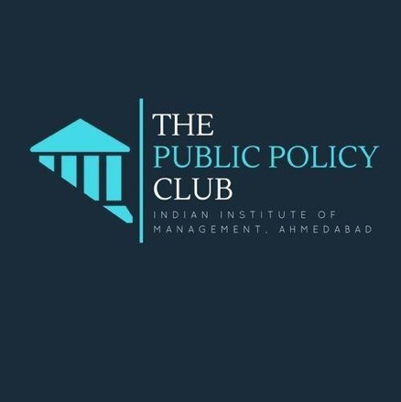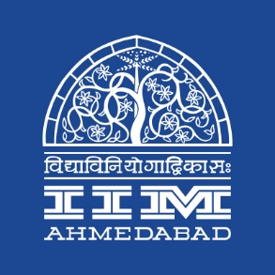

**PRESS RELEASE**

**IIMA hosts Shri Feroze Varun Gandhi**

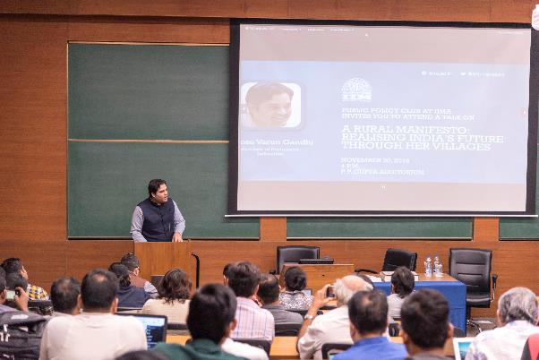

**Caption:** Shri Feroze Varun Gandhi addresses the crowd

**November 30, 2018 | Ahmedabad**

On Friday, November 30, 2018, Shri Feroze Varun Gandhi delivered a lecture at IIM Ahmedabad, at an event organised by the Public Policy Students Club of the Institute. The lecture was attended by around 100 people including students from the PGPM, Food and Agribusiness Management (FABM) and Armed Forces Programmes besides staff and some faculty members.

Mr. Gandhi is a Member of Parliament and has been lecturing at leading universities and policy thinktanks and civil society organizations across India for a while now. At the session in IIMA, he also released his new book 'A Rural Manifesto: Realising India’s Future Through her Villages'. The talk was an interesting peek into Mr. Gandhi’s 2.5 years of research that goes behind the book, fondly referred to as ‘the unreadably dense volume’ by the author. He gave succinct examples from his experiences, both urban and rural, to highlight the inequalities prevalent in the Indian society currently. He discussed how ‘privilege perpetuates privilege’ and how technology has the potential to act as an equaliser, if used well. He spoke in detail about possible political reforms that would help strengthen India’s democratic governance, such as parliamentary addressal of public petitions, need for addressing electoral corruption and strengthening the parliamentary discussion process on passing laws. Among other things, he also talked about grassroot innovations in the rural economy.

Referring to the talk, second year PGP student and coordinator of the Public Policy Club, Mr. Aditya Govil said, “*The talk was highly insightful and displayed various facets of the problem in the agriculture sector in India. Encompassing a mix of academic as well as practical knowledge, Mr. Gandhi focused on the growing inequality in the country leading to an increase in inequity in the society as well. The premises that a change in the country’s systems and institutions is related to the way politics is run in this country was well brought out through a series of examples in modern day India. Mr. Gandhi stressed upon the fact that the future of the country is in the hands of young, bright minds and narrated incidents from all across India that suggested this.”.*

-End of Text-

**About Indian Institute of Management Ahmedabad (IIMA)**

*Established in 1961, the Indian Institute of Management, Ahmedabad (IIMA) is recognized globally for excellence in management education. One of the top management schools in the world, IIMA educates leaders of the enterprises. The Institute’s strategic priorities include: strengthening connection with its various constituencies, including academics, practitioners, alumni, and the community; nurturing a high-performance work environment of stretch, autonomy, and teamwork; and strategic growth while maintaining emphasis on quality.*

*The flagship Post Graduate Programme (PGP) is ranked 21st in the Financial Times Masters in Management Ranking 2017. As per the Financial Times’ Global MBA Ranking 2017, IIMA’s Post Graduate Programme for Executives (PGPX) is ranked 29th in the World. The postgraduate program in food and Agri Business (PGP-FABM) is ranked 1st in the Eduniversal Masters Ranking 2018. IIMA has been ranked as #1 Management institute as per the National Institutional*

*Ranking Framework (NIRF) rankings of Ministry of Human Resource Development, Government of India.*

**For media queries, please contact:**

|  |  |
| --- | --- |
| Raghuram V  Media Secretary  Indian Institute of Management Ahmedabad  Ph: (Cell) +91- 9800172995  Email: p17vraghuram@iima.ac.in | Mithila Hegde  External Media Liaison (Student)  Indian Institute of Management  Ahmedabad  Ph: (Cell) +91- 9740499011  Email: p17mithilah@iima.ac.in |