**IIMA Welcomes the 58th class of PGP and 22nd Class of PGP-FABM**

*~ 432 outstanding students from across the country join the two programmes*

*~ Women students increase in both programmes*

**July 01, 2021| Ahmedabad:** The Indian Institute of Management Ahmedabad (IIMA), a premiere global management Institute, today announced the commencement of the 58th class of the two-year Post Graduate Programme in Management (PGP) and 22nd class of the Post Graduate Programme in Food and Agribusiness Management (PGP-FABM), virtually.

The inauguration and orientation programme was held in the Ravi J Matthai auditorium of the Institute in the presence of the Director, Dean (Programmes), Dean (Faculty), Dean (A & ER) and other senior faculty members.

Delivering the inaugural address to the incoming classes, **Professor Errol D’ Souza, Director, IIMA** said, ***“****You are about to embark on one of the most important and vibrant phases in your life. The two years at IIMA will present you with unlimited opportunities to acquire knowledge and skills, explore your interests, and most important of all, build a network of friends and mentors who will supp ort you in the future.*

*As a premier global management Institute, it will be our endeavour to give you world class education and groom you to move into a career of your choice”.*

Welcoming the new batches, **Professor Pradyumana Khokle, Dean (Programmes), IIMA** said*, “Welcome to IIMA’s Two Year Post Graduate Programmes. IIMA’s post graduate programmes are a transformative journey that requires setting high standards and working in ways that may be different and better from the way you have worked earlier. As you navigate through this journey, you will encounter some great things, some thunderstorms, some things familiar and some unfamiliar waters. I hope you will enjoy navigating through all of them.”*

This year, the Institute has registered a total intake of 432 students of which 385 students have joined in the PGP programme and 47 students joined the PGP-FABM programme. The PGP class comprises 72 per cent men and 28 per cent women. The average age of the PGP class is around 23 years and 67 per cent of the total students have been professionals with prior work experience.

In the current PGP-FABM batch, about 57 per cent are men and 43 per cent are women. About 96 per cent of the class comprises students in the age group of 21 to 25 years. Of the 47 students, as many as 14 come with prior work experience.

**Diversity as Usual**

IIMA has been a consistent advocate of diversity in its batches and follows an admissions policy that looks at diversity across education, profession, gender, socioeconomics, work experience and culture. Peer learning is an integral part of the learning experience at IIMA and this diversity enriches the learning experience of the students within and beyond the classroom. The present classes comprise students from arts, science, commerce, engineering, agriculture, and allied sciences, among others.

**Increase in the Number of Women Students**

It is interesting to note that there has been an increase in the number of women joining in both the PGP and PGP-FABM programmes. Women comprise 28 per cent of the total class size in the new PGP batch and 43 per cent of the total number of students in the new PGP-FABM batch – the numbers being 6 per cent higher than 22 per cent registered in the PGP class in 2020 and 9 per cent higher than the 34 per cent registered in the PGP-FABM programme in 2020, respectively.

**Increase in Students from Agriculture and allied backgrounds**

This year, the PGP-FABM programme has witnessed an increase in the number of students from agriculture and allied backgrounds as compared to the previous two years. PGP-FABM is a niche programme offering from the IIMA. It was launched as a Special Programme in Agriculture (SPA) in 1974.

Sharing his views on the process of student intake, **Prof MP Ram Mohan, Chairperson – Admissions, IIMA, said**, “This year the complete admissions process was conducted successfully online in a fair and transparent manner. This helped us onboard a meritorious class of students drawn from across the country. *We are happy to welcome the new batch of young, bright and deserving candidates to our PGP and PGP-FABM programmes.*”

Due to the prevailing situation, the Institute has taken the decision to start Term-I courses in online mode. It is likely to make further changes in the teaching mode based on the situation and Government guidelines announced from time to time.

**FACT SHEET**

**Two Year Post Graduate Programme in Management**

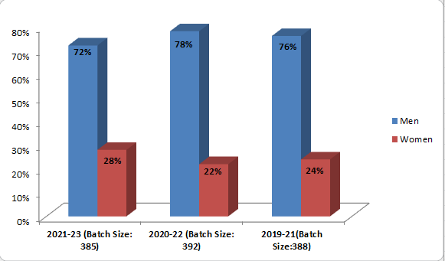

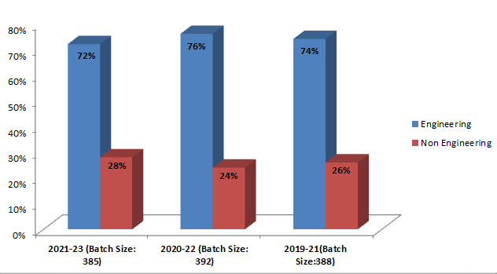

|  |  |  |  |  |  |  |
| --- | --- | --- | --- | --- | --- | --- |
| **Batch** | **Educational Background** | **%age** | **Educ**  **ational Background** | **%age** | **Educational Background** | **%age** |
| 2021-23 | **Arts** | **5%** | Commerce | 21% | Science | 2% |
| 2020-22 | **Arts** | **5%** | Commerce | 18% | Science | 1% |
| 2019-21 | **Arts** | **3%** | Commerce | 21% | Science | 2% |

**Post Graduate Programme in Food and Agribusiness Management (PGP-FABM)**

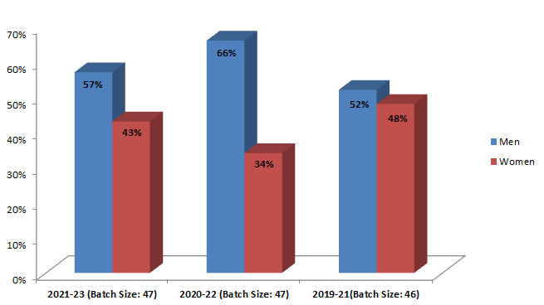

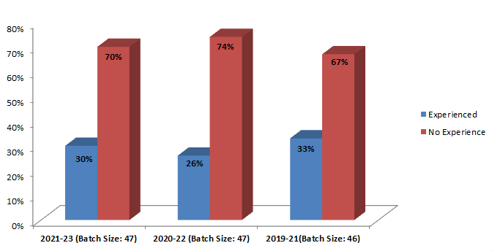

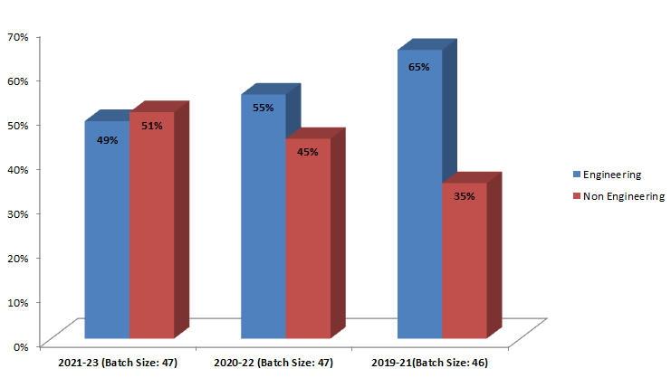

**About IIM Ahmedabad:**

The Indian Institute of Management Ahmedabad (IIMA) is a premier, global management Institute that is at the forefront of promoting excellence in the field of management education. Over the 60 years of its existence, it has been acknowledged for its exemplary contributions to scholarship, practice and policy through its distinctive teaching, high-quality research, nurturing future leaders, supporting industry, government, social enterprise and creating a progressive impact on society.

IIMA was founded as an innovative initiative by the Government, industry and international academia in 1961. Since then it has been consolidating its global footprint and today it has a network with over 80 top international institutions and a presence in Dubai. Its eminent faculty members and close to 40,000 alumni, who are at the helm of influential positions in all walks of life also contribute to its global recognition.

Over the years, IIMA’s academically superior, market-driven, and socially impactful programmes, have earned high reputation and acclaim globally. It became the first Indian institution to receive international accreditation from EQUIS. The renowned flagship two-year Post Graduate Programme in Management (PGP) is ranked 20th in the FT Master in Management Ranking 2020 and the one-year Post Graduate Programme in Management for Executives (PGPX) has been ranked 48th in the FT Global MBA rankings 2021. The institute also is placed first in the Government of India’s National Institutional Ranking Framework (NIRF), India Rankings 2020. IIMA offers consultancy services and more than 200 curated executive education programmes in customized, blended, and open enrolment formats for a diverse audience comprising of business leaders, policymakers, industry professionals, academicians, government officials, armed forces personnel, agri-business and other niche sector specialists and entrepreneurs. To know more about IIMA, please visit: **https://www.iima.ac.in/**

**For any media related queries, feel free to reach out to:**

**Ms Ishita Solanki |** IIMA **|** Email: [pr@iima.ac.in](mailto:pr@iima.ac.in)

**Ms Sunitha Aravind|** IIMA **|** **|** Email: [pr@iima.ac.in](mailto:pr@iima.ac.in) | +91-7069074816