

**PRESS RELEASE**

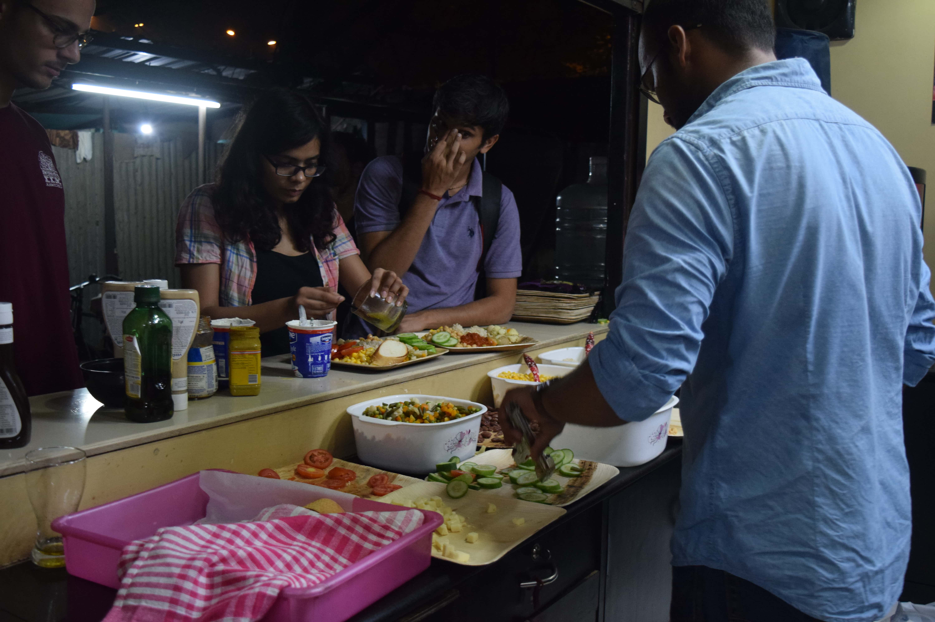**Fostering Entrepreneurship at IIMA**

*Members of SaladBar[1] serving their customers*

**January 27, 2018 | Ahmedabad**

From September to November, a group of students from Indian Institute of Management, Ahmedabad (IIMA) would regularly visit the Jamalpur vegetable mandi early morning 4 a.m. almost daily. In another corner of the campus, another group would start collaborating with Rambhai (the famous chai-wallah outside IIMA) for the day’s breakfast delivery. Every evening, a small group would don aprons and begin serving salads after classes *(Their picture is captured above)*. Another team would start their work after 10 p.m. serving desserts for the entire campus. In case it was not evident, all these students of Post Graduate Program in Management at IIMA were running their own businesses while attending classes concurrently.

Over 40 people from the second year of the flagship program of IIMA signed up for a course, Experiencing Live Action of Business (E-LAB) in their penultimate term at IIMA. The course, intended to simulate an authentic simulation of the business life cycle to the students. Being offered for the first time at IIMA, this experimental course was coordinated by Prof. Amit Karna, Prof. Mukhesh Sud, and Prof. Neharika Vohra with the support of IIMA’s own startup incubator, Center for Innovation, Incubation, and Entrepreneurship (CIIE).

As part of the course, every group of 4 to 5 students were provided a maximum seed fund of INR 25,000 to start a small venture and grow it over a period of 3 months. Guidance and mentorship were provided by the faculty and CIIE. The course aimed to function as a catalyst for kindling entrepreneurial motivations of participants. As the vision was expansive and encompasses beyond the walls of IIMA, the course was thrown open to participants from other participating institutes from A-League. Students from NIFT, NID, IIT-GN, etc. enthusiastically participated in the course and collaborated with students of IIMA.

***Talking about the conception of the course, Prof. Neharika Vohra said, “the course came about from our desire to create a real laboratory for learning various concepts about starting and running a business. Learning we believe is enhanced by the simultaneous opportunity to do, observe, reflect, and conceptualize. We had some funding available from CIIE and access to A-league students to be able to create the right infrastructure and diversity in the student group for the course. In the faculty team, also we chose to create a team with diverse backgrounds for us to be able to contribute to student learning.”***

*Tapish Bhatt, Vice President at CIIE, said “The course provides a model for similar institutes to work towards creating a culture of entrepreneurship in their respective ecosystems. The ventures, though small, provided students with a complete overview of how businesses function and how any venture has to go through a cycle of iterations before they reach an optimum product/ scale.” Sumit Singare, one of the participants in the course, said, “Gone are the days when people talked about capitalism without cause and described the youth as rebels without reason. All the initiatives of E-LAB had a social impact quotient pre-embedded in them at their conception stage itself. Many more institutes should setup sandboxes like E-LAB to encourage students to realize a Start-Up India and an entrepreneurial India.”*

In the section below, we give brief information about some of the ventures undertaken by participants of E-LAB course during the 3-month period.

**Nashta – Breakfast at your doorstep**

*Says Harshwardhan, one of the people behind Nashta, “We felt there was a need for quality and healthy breakfast option which takes into account the busy life of an IIMA student and hence zeroed in on the healthy breakfast delivery option.”* The team partnered with Rambhai, the well-known tea stall owner, working with him on a profit-sharing model to minimize the downside risks and keep their fixed costs under control. After conducting detailed market research and trials among their target audience, they decided to offer a variety of breakfast options including poha, sandwiches, a mixed fruit plate, sprouts, milk and juice to people on IIMA campus. The emphasis was on keeping the products simple and providing something which could be eaten cold. Initially taking orders through a Google form, the team soon graduated to a fully functional website to streamline their operations. From a fixed menu, the group slowly advanced to multiple menu options, customizable options and a choice of delivery timings.

**Dho Daala – A best-of-the-class washing service from local dhobis**

Conceptualized by 4 students, Dho Daala aimed to improvise the laundry service on IIMA campus. They worked with 5 dhobis on campus who served 3 student dormitories each which were strictly allocated within themselves. Dho Daala members created a website to record orders from students and streamline payment. They provided all the necessary equipment such as steam irons, pilling machines, fabric softeners and trained dhobis for various value-added services. Their efforts have enhanced incomes of the dhobis who continue to provide value-added services incorporated by Dho Daala. Speaking about the novelty of their venture, Sumit who belonged to Dho Daala group, says, ‘we not only wanted to help students get better laundry services, but also sought to improve the livelihoods of the Dhobis who faced intense competition from services outside the campus.’

**Cook up (Cooking simplified) – Ready-to-cook food**

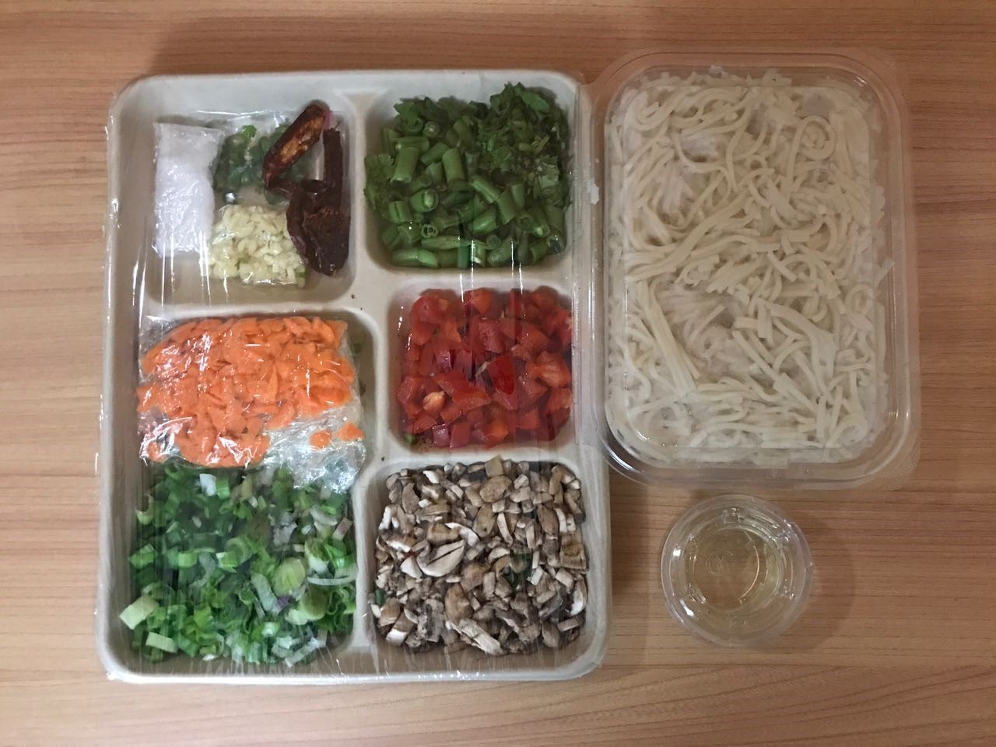Cook up was started by 4 students of IIM Ahmedabad with an aim to provide other students the opportunity to enjoy self-cooked healthy cuisines. *Udit Ahuja, a member of the team who conceptualized this idea, says “The customer gets to cook a fun, healthy and tasty meal in less than 45 minutes and earn bragging rights for cooking something extraordinary from scratch”.* All ingredients – spices, oil, and vegetables along with the recipe cards arrive pre-portioned in a packaged box to minimize food waste and prep time. Also, there is no need to have the required apparatus as they will provide it to the customers on rent. They wanted to give people the ultimate culinary experience and also the satisfaction of having cooked something themselves. They operated on weekends with 2 recipe offerings of main course and a few snacks as side offerings.

**Onion Knights – Last-mile delivery for vegetable vendors**

With uber-isation of nearly everything in daily life, the Onion Knights team saw the potential to make profits by reducing the number of steps in the vegetable supply chain. The business initially started with the team procuring vegetables from wholesale sellers and distributing them to vegetable vendors. A typical day for the team starts at 4 am when they go to the wholesale market to buy vegetables. From 5-7 am, the vegetables are sorted at the small warehouse that the team had rented. By 8 am, the vegetables are distributed to the vendors, kick-starting their day. The idea germinated when the team realized that vegetable vendors buy not from the wholesale market but from retailer’s right outside the wholesale market. The explanation for this is that vegetable vendors prefer to buy in small quantities to prevent wastage, but the wholesalers sell in bulk. This introduces a set of crafty middlemen into the system who buy from the wholesale market, barely move a few yards and sell to the vegetable vendors at a premium. The Onion Knights team has been selected for prestigious Louis Kahn prototyping grant by CIIE for incubation and scale-up.

**-End of Text-**

|  |
| --- |
| **News in Brief**  Over 40 people from the second year of the flagship program of Indian Institute of Management, Ahmedabad signed up for a course, Experiencing Live Action of Business (E-LAB) in their penultimate term from September to November 2017. The course intended to simulate an authentic simulation of business life cycle to the students. Being offered for the first time at IIMA, this experimental course was coordinated by Prof. Amit Karna, Prof. Mukhesh Sud and Prof. Neharika Vohra with support of IIMA’s own startup incubator, Center for Innovation, Incubation and Entrepreneurship (CIIE). As part of the course, every group of 4 to 5 students were provided a maximum seed fund of INR 25,000 to start a small venture and grow it over a period of 3 months. Guidance and mentorship was provided by the faculty and CIIE. The course aimed to function as a catalyst for kindling entrepreneurial motivations of participants |

**About Indian Institute of Management Ahmedabad (IIMA)**

Established in 1961, the Indian Institute of Management, Ahmedabad (IIMA) is recognized globally for excellence in management education. One of the top management schools in the world, IIMA educates leaders of the enterprises.The Institute’s strategic priorities include: strengthening connection with its various constituencies, including academics, practitioners, alumni, and the community; nurturing a high performance work environment of stretch, autonomy, and teamwork; and strategic growth while maintaining emphasis on quality.

As per the latest ranking by *The Economist*, IIMA is No. 1 School in the world on the parameter of opening up new career opportunities for students. The flagship Post Graduate Programme (PGP) is ranked 16th in the *Financial Times* Masters in Management Ranking 2016. As per the *Financial Times’* Global MBA Ranking 2016, IIMA’s Post Graduate Programme for Executives (PGPX) is ranked 24th in the World. IIMA has been ranked as #1 Management institute as per the National Institutional Ranking Framework (NIRF) rankings of Ministry of Human Resource Development, Government of India.

For media queries, please contact:

|  |
| --- |
| Balaji Uppala  Media Secretary (PGP-2)  Indian Institute of Management Ahmedabad  Ph: (Cell) +91-7042705642  Email: p16srimukhab@iima.ac.in |

1. SaladBar was also one of the student initiatives undertaken as part of E-LAB course which served healthy dinner options (Salads) to people on campus.