

PRESS RELEASE

IIM Ahmedabad adds GRE as one more criteria for admission into ePGP* Programme other than CAT & GMAT

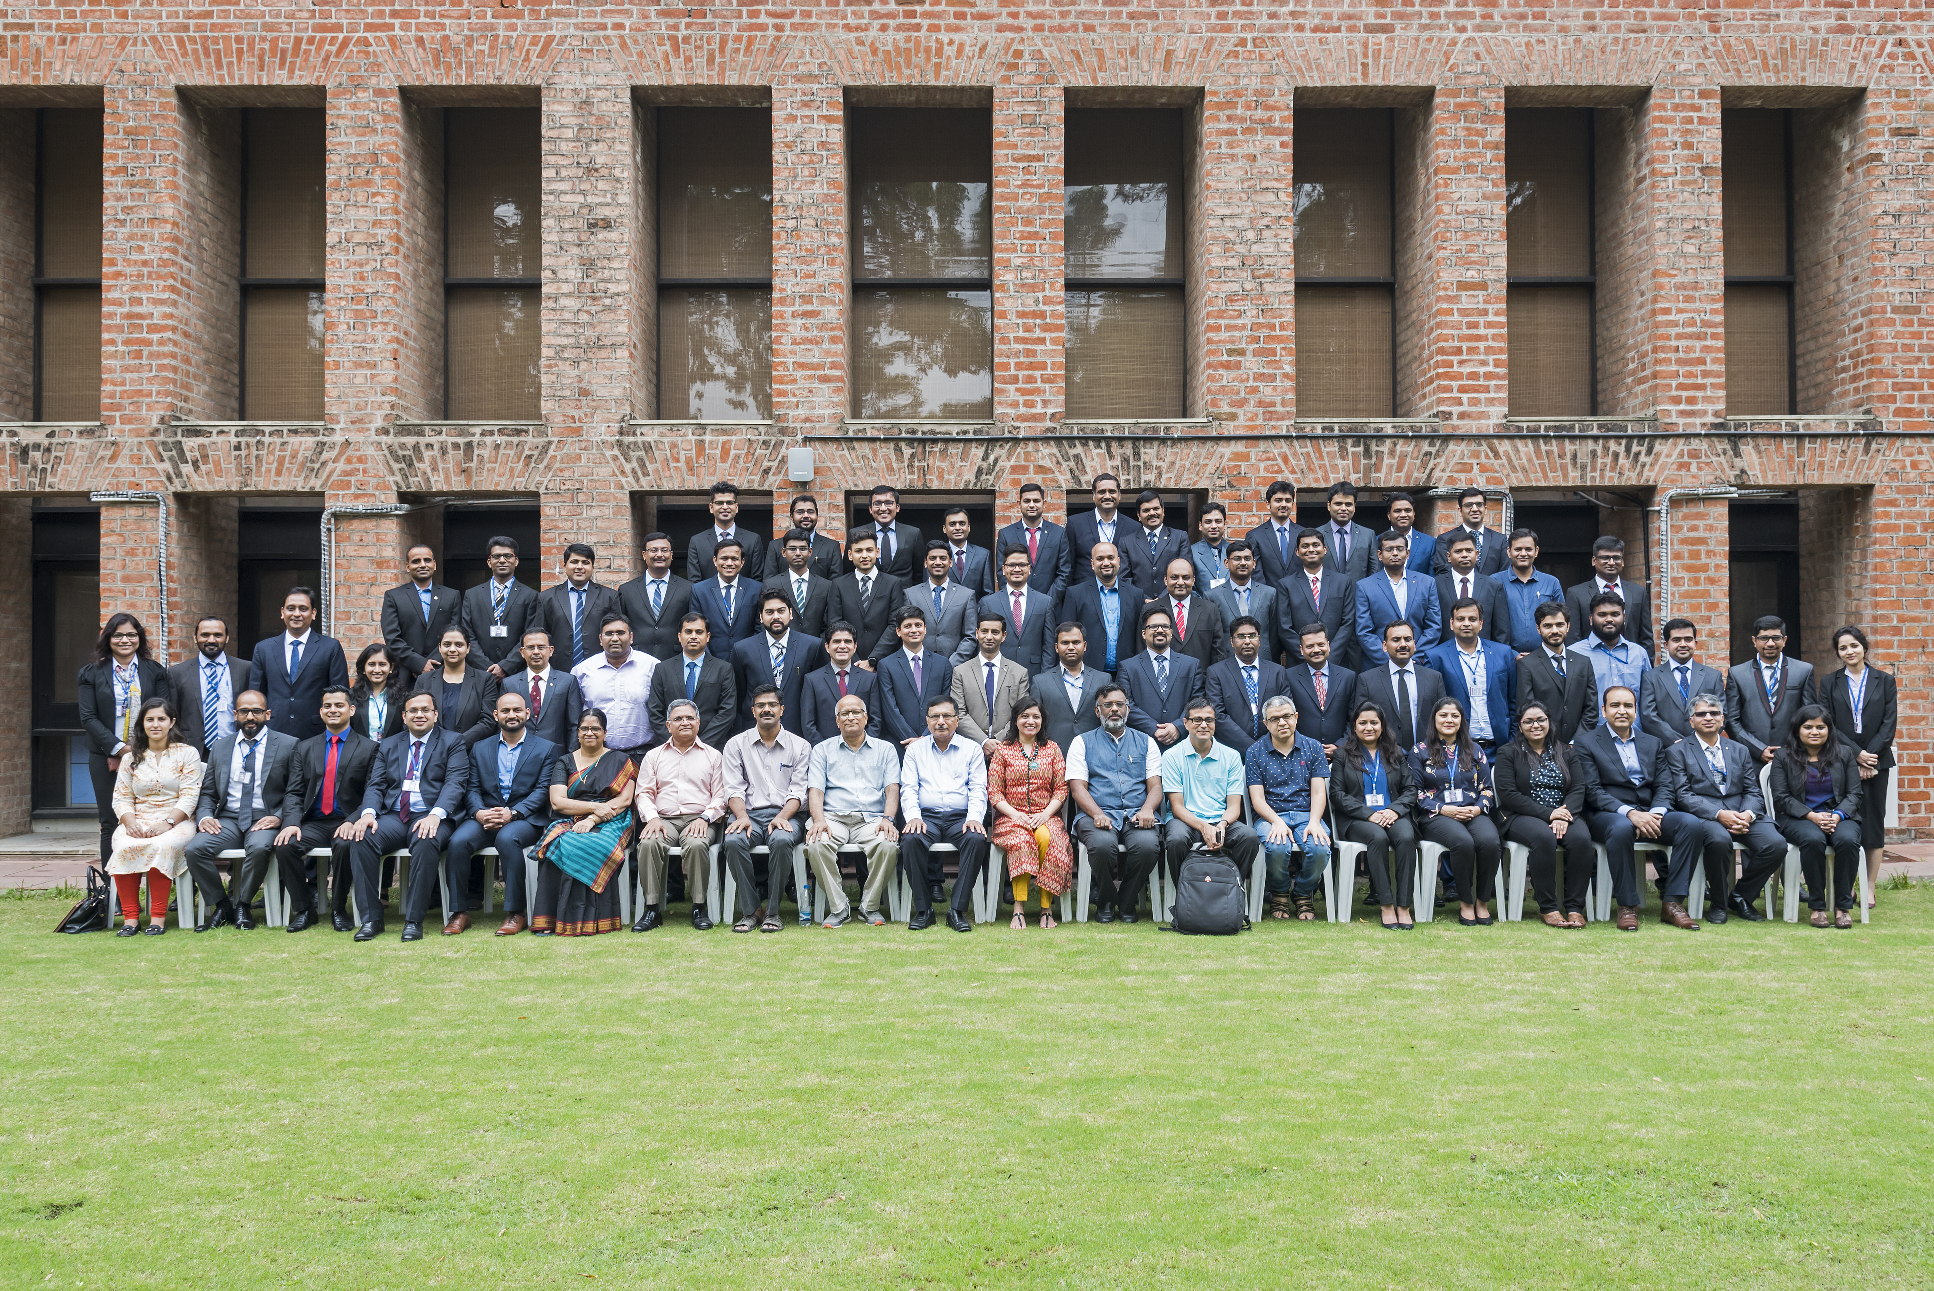

Dean(s), Chairperson ePGP, Faculty IIMA, and office staff with ePGP 2018-20 Students.

February 15, 2019 | Ahmedabad:

The e-Mode Post Graduate Programme marks IIMA's foray to offering long-term hybrid management education course leading to awarding a PG Diploma. The ePGP is a hybrid learning programme, with online lessons attended through study centers, classroom teaching at IIMA campus at regular intervals and, mentored project work. The two year course is comprehensive and designed for working executives and entrepreneurs. The programme is aimed to enhance strategic thinking and impart the entrepreneurial as well leadership abilities required for taking organizations to the next level, while also advancing individual career aspirations. The innovative curriculum is designed by the faculty members of IIMA, with their diverse experience in research, consulting / advisory, and teaching the regular students and executives in various programmes. The pedagogy is benchmarked with global standards in management education, thus providing participants with knowledge that are vital in today's knowledge economy.

From 2019-21 batch onwards, IIMA will also be accepting valid GRE scores (of last five years) apart from GMAT & CAT. Candidates who have missed the CAT 2018 deadline can also appear in GMAT / GRE until March 31, 2019 in order to be eligible for 2019-21 batch application. Shortlisted candidates applying for 2019-21 batch will be invited for personal interview at IIMA campus or other cities decided by Institute.

The application for admission into ePGP 2019-21 batch has already begun. The last date for the application is May 31, 2019. The first campus module for new batch is slated to start from September 23, 2019.

*'e' stands for Electronic Mode (Interactive Onsite Learning).

About Indian Institute of Management Ahmedabad (IIMA)

Established in 1961, the Indian Institute of Management, Ahmedabad (IIMA) is recognized globally for excellence in management education. One of the top management schools in the world, IIMA educates leaders of the enterprises. The Institute’s strategic priorities include: strengthening connection with its various constituencies, including academics, practitioners, alumni, and the community; nurturing a high-performance work environment of stretch, autonomy, and teamwork; and strategic growth while maintaining emphasis on quality.
The flagship Post Graduate Programme (PGP) is ranked 21st in the Financial Times Masters in Management Ranking 2017. As per the Financial Times’ Global MBA Ranking 2017, IIMA’s Post Graduate Programme for Executives (PGPX) is ranked 29th in the World. The postgraduate program in food and Agri-Business (PGP-FABM) is ranked 1st in the Eduniversal Masters Ranking 2018. IIMA has been ranked as #1 Management institute as per the National Institutional Ranking Framework (NIRF) rankings of Ministry of Human Resource Development, Government of India.

-End of Text -

For media queries, please contact:

Deepak Bhatt, Manager, Communications
Ph: (Cell) +91-9426229429, (O) +91-79-66324683, Email: mngr-comm@iima.ac.in

Mitaaly Naidu, Executive, Public Relations
Ph: (Cell) +91-7069074816, (O) +91-79-66324684, Email: pr@iima.ac.in

