

**PRESS RELEASE**

**Day 2 of The Red Brick Summit at IIM Ahmedabad**

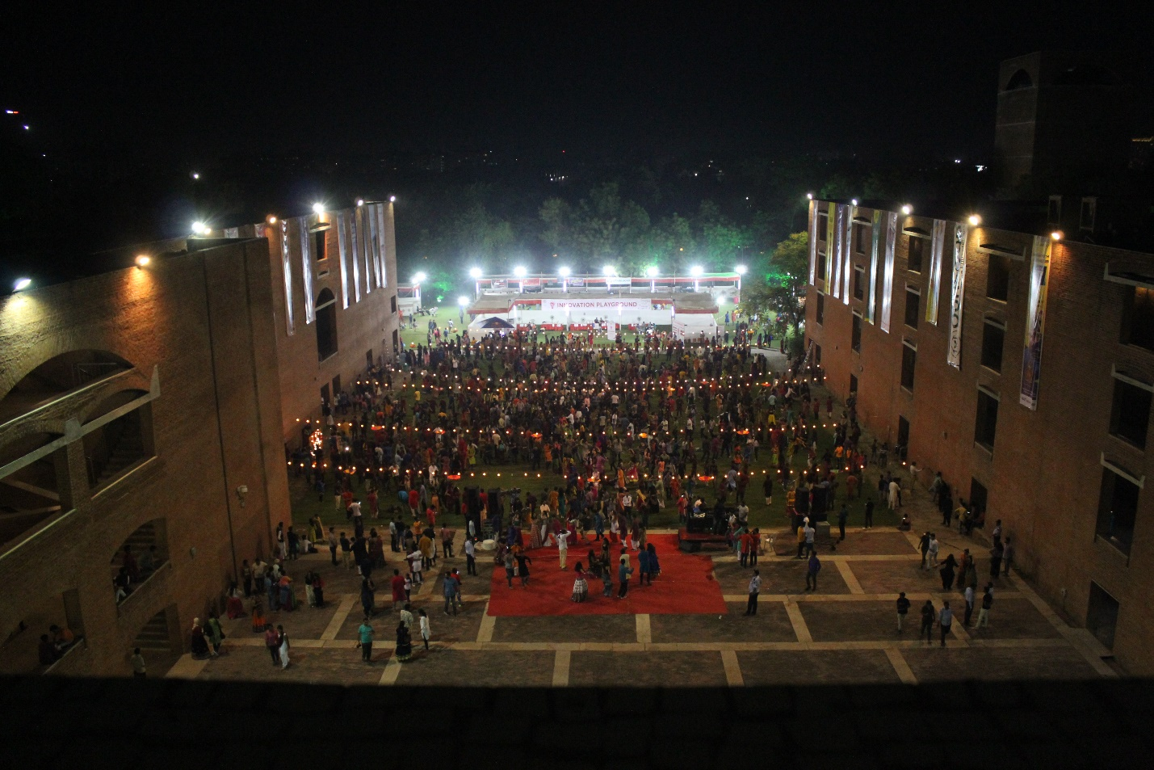

*- Garba at IIM Ahmedabad*

**October 1, 2018 | Ahmedabad**

The Red Brick Summit (TRBS), IIMA’s flagship management symposium, continued into its second day with great enthusiasm on September 30,2018. TRBS is a four-day medley of the erstwhile Big Four of IIMA – Insight, Confluence, Amaethon and ConneXions – aptly echoed its theme “Envision, Endeavour, Experience.” Continuing from Day 1 which saw speaker sessions by Rajdeep Sardesai and Anant Maheshwari, Day-2 of the fest witnessed a plethora of workshops, speaker sessions and impromptu events. A garba night was organised towards the end of the day so that all participants from distant colleges could experience the unique and rustic beauty of garba celebrations in Ahmedabad. The events during the day included an open mic by the music club and dance performances by Footloose, the dance club of IIMA.

**Speaker Sessions:**

Mr. Sanjeev Sanyal, Principal Economic Advisor in the Ministry of Finance, addressed a packed classroom of economics enthusiasts on day 2 of TRBS. Mr. Sanyal began by drawing an interesting parallel between economics and Victorian-era steamships, and gradually moved on to the impact of the recent structural changes in government policy such as the GST and the Insolvency and Bankruptcy code. Throughout the duration of his talk, he used everyday examples to explain his opinions of macroeconomic policy making it an interesting session for both novices as well as the more experienced members of the audience.

Another speaker of the day was, Mrs Falguni Nayar, founder of Nyyka, an online beauty retailer. Mrs Nayar discussed with the audience Nykaa’s journey towards growth and the acceptability it has achieved as a brand. She elaborated upon various innovations Nykaa has incorporated in the business model to address the need gap of the beauty and wellness products. She attributes Nykaa’s success to the focus company has maintained when faced with challenges. Finally, Mrs Nayar encouraged the audience to challenge the norms and believe in the power of the ideas. In her words, ‘A unique idea is not the one everyone likes (in my case it was the investors), if it is a unique idea many won’t like it and that is what makes it unique.’

**Workshops:**

Mr. Saket Govind, manager at Havmor’s ice cream unit spoke about the nuances of developing brands through Havmor's personal story of churning out new varieties of ice-creams every now and then. The speaker talked of a method which he called OLI:- observing, learning and ideating; qualities that are essentials to developing a new brand. The participants were encouraged to think about brand with a perspective outside the textbooks.The importance having a good advertising mix was demonstrated through interesting clips of company’s ad campaigns. The idea is to keep in mind the desires of the customer and develop the product accordingly. Havmor developed a program where top food processing graduates were selected throughout the country and tasked with developing lip-smacking innovative ice-cream flavours. This is how they endeavoured to keep up constant innovation. Participants opined that the workshop was informative, fun and educative.

Nielsen’s market research workshop began with the organizers proudly announcing, “Nobody understands a company better than us.” The host echoed the company’s mission statement, that is, to drive data-based decisions in a connected world and create outcomes for their clients and customers. He went on to explain how the retail measurement services are different for modern trade stores and traditional kirana stores. Contrary to systematic data collection with sampling from the former, about 1200 Nielsen auditors collect retail data (such as price, quantity, etc.) from 9.9 million kirana stores. He went on elaborate on the dimensions for data analysis, the types of facts significant for analyzing and the various estimation methods. He referred to popular brands where Nielsen has contributed in providing significant customer insights, such as Fogg which was branded as “less gas, more spray” with consistent messaging and no selling in Kirana stores. He also explained us about “shopper walk” - how the arrangement of items in a store influence our buying. The workshop turned out to be very interesting and informative and the audience was brimming with queries.

-End of Text-

**About Indian Institute of Management Ahmedabad (IIMA)**

*Established in 1961, the Indian Institute of Management, Ahmedabad (IIMA) is recognized globally for excellence in management education. One of the top management schools in the world, IIMA educates leaders of the enterprises.*

*The Institute’s strategic priorities include: strengthening connection with its various constituencies, including academics, practitioners, alumni, and the community; nurturing a high performance work environment of stretch, autonomy, and teamwork; and strategic growth while maintaining emphasis on quality.*

*The flagship Post Graduate Programme (PGP) is ranked 21st in the Financial Times Masters in Management Ranking 2017. As per the Financial Times’ Global MBA Ranking 2017, IIMA’s Post Graduate Programme for Executives (PGPX) is ranked 29th in the World. IIMA has been ranked as #1 Management institute as per the National Institutional Ranking Framework (NIRF) rankings of Ministry of Human Resource Development, Government of India. The postgraduate program in food and Agri Business (PGP-FABM) is ranked 1st in the Eduniversal Masters Ranking 2018*

For media queries, please contact:

|  |  |
| --- | --- |
| Kashika Lal  PR & Media Relations, TRBS (PGP-2)  Indian Institute of Management Ahmedabad  Ph: (Cell) +91-7838526332  Email: p17kashika@iima.ac.in | Ankita Saha  External Media Relations (PGP-1)  Indian Institute of Management Ahmedabad  Ph: (Cell) +91-9836550393  Email: p18ankita9@iima.ac.in |