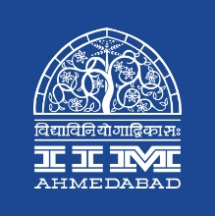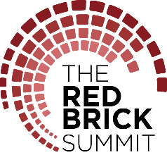

**PRESS RELEASE**

**The Red Brick Summit Kicks off at IIM Ahmedabad**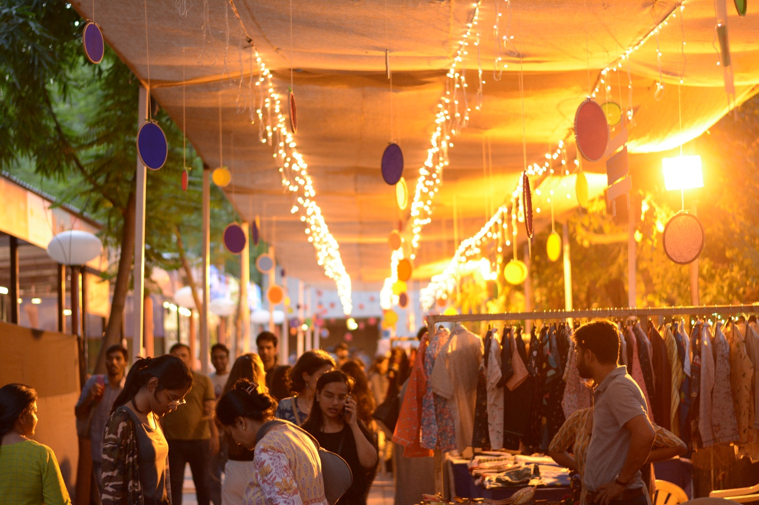

*The flea market ‘Kaleido’ at IIMA*

**September 30, 2018 | Ahmedabad**

Indian Institute of Management Ahmedabad initiated the first day of The Red Brick Summit (TRBS), its flagship management symposium, with a lot of exuberance and dynamism on September 29, 2018. The four-day potpourri of the erstwhile Big Four of IIMA – Insight, Confluence, Amaethon and ConneXions – aptly echoed its theme “Envision, Endeavour, Experience.” The Red Brick Summit, appropriately named after the famous environs that have come to be associated with over 50 years of academic excellence is supported by Tata Trusts and will also be hosting the “Social Impact Award” to felicitate notable social contributions in the Water & Sanitation Sector by the entrepreneurial minds of our country. TRBS features a total of 16 business competitions, 15 workshops, more than a dozen speaker sessions and panel discussions as well as a number of activities, performances, and exhibitions that appeal to all age groups.

The inaugural session of TRBS hosted Mr. Pratap T. P, the co-founder and director, Qwikcilver and Woohoo gift cards and Anant Maheshwari, the President of Microsoft India who is also an alumnus of IIM Ahmedabad. Mr Maheshwari engaged the audience with insights around the on-going digital transformations and it’s the powerful impact on the society. In his words ‘A bit of technology exists in everything we do and anything we do. And in the process, we are constantly generating data’. He discussed the power of this data through examples of usage of data analytics in the field of education, healthcare and agriculture. He then discussed his journey from McKinsey to Microsoft and the ‘corporate athlete’ attitude that has helped him make this possible. As explained by Mr Maheshwari, a corporate athlete draws his inspiration from four forms of energies: - physical energy, emotional energy, intellectual energy & spiritual energy. He inspired the audience to be curious, seek knowledge and question everything using these energies. In the end he urged the audience to step up and do what they love without the fear of failure, it’s the ability to handle failure that makes good leaders.

The second speaker of the day was veteran journalist and Padma Shree awardee Mr. Rajdeep Sardesai. Mr. Sardesai addressed a jam-packed auditorium on the many changes Indian journalism has undergone since he joined the field three decades earlier. He reminisced about the early days of TV journalism and how far it has come today with over 400 news channels. He then discussed at length about the state of the news media today, with TV journalists and politicians alike, vying for prime time and TRPs. Mr. Sardesai urged the audience to wonder if today we have reduced the news to noise and sense to sensationalism, and if there was any credibility to all the chaos. He also spoke at length about the rising intolerance of the society and how we’re increasingly becoming a “hyper-polarized” society. He ended the session by reciting a paraphrased version of Tagore’s famous poem “Where the mind is without fear” from his latest book, “Newsman: Tracking India in the Modi era.”

The first day of the four-day festival saw a slew of incredible workshops like Google’s digital marketing workshop, Zerodha’s Investment Planning workshop and Ujjivan Bank’s Social Entrepreneurship workshop.

The workshop in collaboration with Google on Digital Marketing was conducted by Mr. Sreekant Lanka, Head of Programmatic Account Strategy for India. The workshop covered the need for digital marketing in an increasingly digital world. He further discussed various Google tools like Analytics, Adsense and Adwords and its benefits for a marketer. Attendees were then asked to analyze in groups of 2-3 the digital marketing strategy of a brand of their choice, and a few of them presented their analyses. Mr. Sreekant further discussed the challenges faced by the sector and the growing need of data analytics in the business world.

The talk on Journalism by Tamal Bandyopadhyay began with the man of the hour defining the 3 Cs – key drivers – of the journalism industry: Curiosity, Communication and Common Sense. He pressed upon the need to be ethical in one’s conduct as journalists are seen as the custodians of truth. When asked if business journalism is the ideal career path for millennials he responded by saying that the grind is severe, a lot of travelling is required and not everyone can take the hit. If one is passionate about journalism and enjoys it, then it is the right decision. Also, a bit of psychological knowledge is needed to read between the lines. The journalist needs to perfect the art of persuasion and be an all-rounder, not a specialist in one field.

IDEOS in collaboration with TRBS hosted its Innovation Symposium wherein some of the best innovations in the sphere of social entrepreneurship geared up to display their projects and take them to the next level. On healthcare and social support, some of the key innovations on display were ADLE – an Assistive Device for Life Enhancement for the visually challenged, an affordable Braille Printer and Titli - an activity-based learning kit for creating awareness about menstruation. In the domain of agri-tech and rural development, there was an Automatic Cotton Wick Making Machine, a cotton ball picker, a Jacquard lifting machine, a multi-tree climber and an orchard sprayer for controlled pesticide spray. In Ed-tech and livelihood generation, there was Jungroo Learning - an AI-based chatbot for learning assessment, Krishworks – a tablet-based solution for learning English and a low-cost automation kit for training people on PLC operation.

-End of Text-

**About Indian Institute of Management Ahmedabad (IIMA)**

*Established in 1961, the Indian Institute of Management, Ahmedabad (IIMA) is recognized globally for excellence in management education. One of the top management schools in the world, IIMA educates leaders of the enterprises.*

*The Institute’s strategic priorities include: strengthening connection with its various constituencies, including academics, practitioners, alumni, and the community; nurturing a high performance work environment of stretch, autonomy, and teamwork; and strategic growth while maintaining emphasis on quality.*

*The flagship Post Graduate Programme (PGP) is ranked 21st in the Financial Times Masters in Management Ranking 2017. As per the Financial Times’ Global MBA Ranking 2017, IIMA’s Post Graduate Programme for Executives (PGPX) is ranked 29th in the World. IIMA has been ranked as #1 Management institute as per the National Institutional Ranking Framework (NIRF) rankings of Ministry of Human Resource Development, Government of India. The postgraduate program in food and Agri Business (PGP-FABM) is ranked 1st in the Eduniversal Masters Ranking 2018*

For media queries, please contact:

|  |  |
| --- | --- |
| Kashika Lal  PR & Media Relations, TRBS (PGP-2)  Indian Institute of Management Ahmedabad  Ph: (Cell) +91-7838526332  Email: [p17kashika@iima.ac.in](mailto:p17kashika@iima.ac.in) | Ankita Saha  External Media Relations (PGP-1)  Indian Institute of Management Ahmedabad  Ph: (Cell) +91-9836550393  Email: p18ankita9@iima.ac.in |