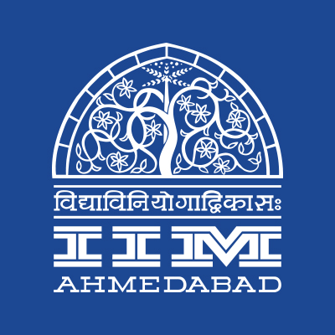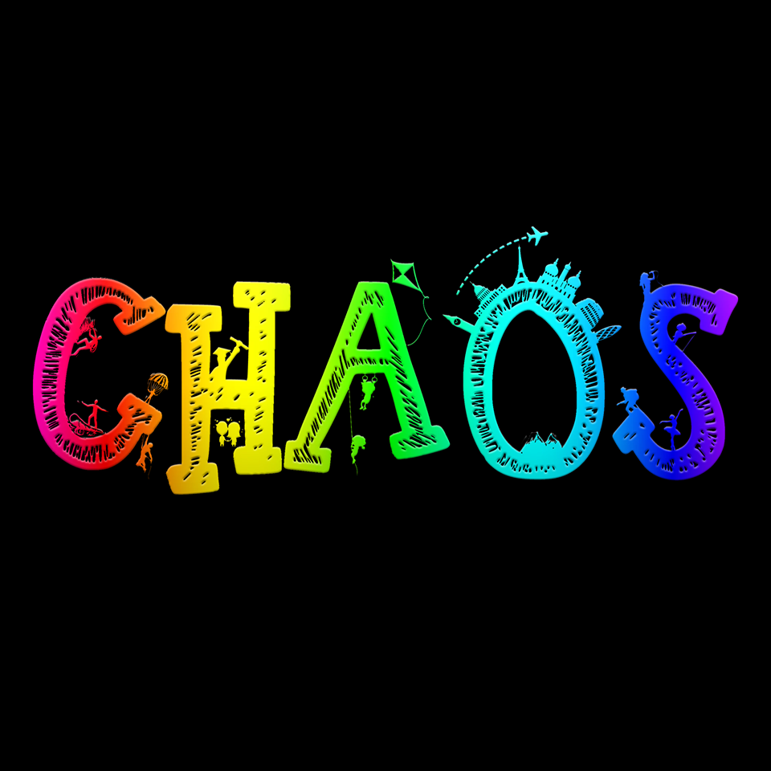

**PRESS RELEASE**

**IIMA to host Chaos 2018 from 25th to 28th Jan**

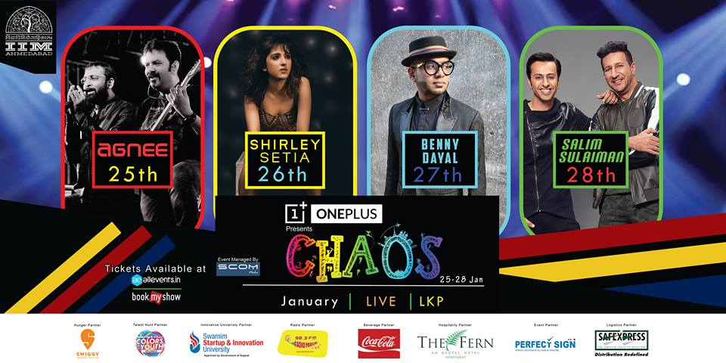

**January 23, 2018 | Ahmedabad**

The Indian Institute of Management Ahmedabad is all set to host Chaos, its cultural festival from January 25-28, 2018. The annual cultural extravaganza is one of the biggest cultural events across management institutes in the country with over 50000 individuals attending the previous editions of the event. The event has also seen the like of stalwarts like Shankar Mahadevan, Sonu Nigam, Sunidhi Chauhan; Amit Trivedi etc. performs at the same.

This year's Chaos is planned on a larger canvass with 50+ events showcasing the best of the breed across music, literature, quizzing, art, dance and drama. The theme of the festival this year is Colors of Life. The star performers of the fest this year are musical duo Salim-Sulaiman. The event will also host a musical performance by Benny Dayal, YouTube sensation Shirley Sethia and rock band Agnee. Besides musical performances, the event will also include competitions in dance, drama and literary arena along with engaging workshops such as Radio Mirchi’s RJ Workshop conducted by popular RJ Dhvanit and RJ Rohan, Certified Marketing & Digital Marketing workshops, Light Graffiti Workshop, Terribly Tiny Tales’ flagship Writing Workshop, The Corporate Simulation Workshop to name a few.

The fest would also comprise of speaker sessions by SS Rajamouli, director of blockbuster Bahubali and Balaji Vishwanathan, CEO of Invento Robotics and India’s most followed celebrity on Q&A website, Quora. The fest is expected to receive over 20,000 registrations and host students from over 500 national institutes over the 4-day period which would include participants for events including Hip-notize, the Western dance competition, Natya Katha, the stage play competition, Crescendo, the Solo Singing Competition and Parliamentary Debate. This year, the fest will also host the much-coveted 3-day quiz extravaganza - Nihilanth, the Annual Inter IIT-IIM Quiz championship. The 15th edition of the quiz will feature over seven quizzes for the institutes, on topics ranging from Sports, Sci-Tech, Business and so on. The quiz alone is expected to see the participation of 450+ students from over 39 contingents of 19 IITs and 20 IIMs. Chaos also includes events for those having an entrepreneurial outlook hosting Swarnim: Entrepreneur of the Year, in association with SSIU, India's first startup and Innovation University, and Abhiyaan, a crowd funding competition.

With its extensive range of events, competitions, speakers, and artists, the fest promises something for everyone! For more information, please visit <https://www.facebook.com/IIMA.Chaos/>.

**Team Chaos speaks:**

*“"Chaos is a manifestation of the celebratory spirit of the IIMA way of life. Chaos, with participation from over 500+ colleges across India tries to simulate the WIMWIan ideals of co-creation through co-existence. It is visualized to be a melting pot for diverse people accommodating distant cultures, lifestyles and preferences. This festival of color, lights, music, dance and culture is the most awaited event in the calendar of Western India.”*

-Ankush Pumba, Secretary, Chaos 2018

*“This year, Chaos seeks to bring together the cultural and business arenas. We have handpicked workshops and events that will appeal to people across diverse interest. In fact, almost 90% of our workshops are already sold out. This is a sure testimony of the success of Chaos 2018.”*

- Aashish Gupta, Marketing & PR Cell, Chaos 2018

**-End of Text-**

|  |
| --- |
| **News in Brief**  Indian Institute of Management Ahmedabad is all set to host Chaos, its cultural festival from 25th January to 28th January, 2018. The annual cultural extravaganza is one of the biggest cultural events across management institutes in the country with over 40000 individuals attending previous editions. The event will host musical performances by musical duo Salim-Sulaiman, Benny Dayal, YouTube sensation Shirley Sethia and rock band Agnee. The event will also include competitions in dance, drama and literary arena along with engaging workshops such as Radio Mirchi’s RJ Workshop, Graffiti Workshop, Terribly Tiny Tales’ flagship Writing Workshop, The Corporate Simulation Workshop to name a few. |

**About Indian Institute of Management Ahmedabad (IIMA)**

Established in 1961, the Indian Institute of Management, Ahmedabad (IIMA) is recognized globally for excellence in management education. One of the top management schools in the world, IIMA educates leaders of the enterprises.The Institute’s strategic priorities include: strengthening connection with its various constituencies, including academics, practitioners, alumni, and the community; nurturing a high performance work environment of stretch, autonomy, and teamwork; and strategic growth while maintaining emphasis on quality.

As per the latest ranking by *The Economist*, IIMA is No. 1 School in the world on the parameter of opening up new career opportunities for students. The flagship Post Graduate Programme (PGP) is ranked 16th in the *Financial Times* Masters in Management Ranking 2016. As per the *Financial Times’* Global MBA Ranking 2016, IIMA’s Post Graduate Programme for Executives (PGPX) is ranked 24th in the World. IIMA has been ranked as #1 Management institute as per the National Institutional Ranking Framework (NIRF) rankings of Ministry of Human Resource Development, Government of India.

For media queries, please contact:

|  |  |
| --- | --- |
| Shubham Varshney  Marketing & PR Cell, Chaos (PGP-2)  Indian Institute of Management Ahmedabad  Ph: (Cell) +91-7503602678  Email: p16shubhamv@iima.ac.in | Aashish Gupta  Marketing & PR Cell, Chaos (PGP-2)  Indian Institute of Management Ahmedabad  Ph: (Cell) +91-8090026763  Email: p16aashishg@iima.ac.in |