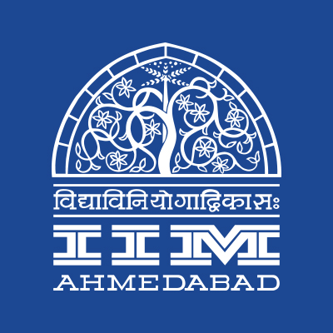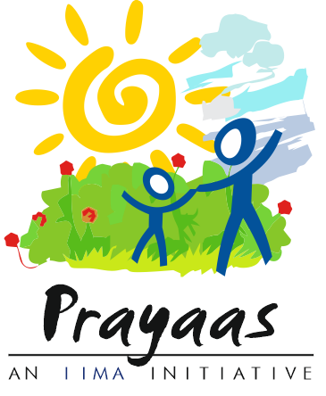

**PRESS RELEASE**

**A DAY AT IIMA**



**September 25, 2018 | Ahmedabad**

Prayaas, the social initiative of Indian Institute of Management Ahmedabad, hosts the 8th iteration of its annual flagship event, **A Day at IIMA** on October 2, 2018. The program aims to make the participants experience the life of a student at IIMA. The proceeds from this event are directed towards the Education of Prayaas kids.

Participants of **A Day at IIMA** will be taken through a day in the life of a first-year student of IIMA’s flagship Post Graduate Programme. The day will constitute of lectures, case discussions and practical exercises from four of IIMA’s esteemed professors to acquaint the participants with the case pedagogy used here; there will be group activities to reflect the dynamics of study group learning and some surprises, along with a tour of the hallowed red brick walls and a special session with 100+ Prayaas kids.

Organized as a part of the ‘Joy of Giving Week,' **A Day at IIMA** is the flagship event of Prayaas. Started in 2011, it saw a footfall of more than 70 participants last year. The entire registration amount collected from the event will be used to fund the education of underprivileged children part of Prayaas. Currently, Prayaas supports ~100 children within the IIMA campus.

*“A Day at IIMA provides a unique opportunity for people to experience the life of an IIMA student. We receive participation not only from young aspirants looking to get into a B-school but also individuals with significant industry experience who once had considered a management degree from IIMs.”*

Ankit Jain (Coordinator, Prayaas)

Prayaas invites all who want to experience a day at IIMA first hand. The members of Prayaas look forward to welcome all the guests and host the event on the 2nd of October. Registrations are open.

**Link**: [www.meraevents.com/event/A-day-at-iima-Year2018](http://www.meraevents.com/event/A-day-at-iima-Year2018)

-End of Text-

**About Indian Institute of Management Ahmedabad (IIMA)**

Established in 1961, the Indian Institute of Management, Ahmedabad (IIMA) is recognized globally for excellence in management education. One of the top management schools in the world, IIMA educates leaders of the enterprises.

The Institute’s strategic priorities include: strengthening connection with its various constituencies, including academics, practitioners, alumni, and the community; nurturing a high-performance work environment of stretch, autonomy, and teamwork; and strategic growth while maintaining emphasis on quality.

The flagship Post Graduate Programme (PGP) is ranked 21st in the Financial Times Masters in Management Ranking 2017. As per the Financial Times’ Global MBA Ranking 2017, IIMA’s Post Graduate Programme for Executives (PGPX) is ranked 29th in the World. IIMA has been ranked as #1 Management institute as per the National Institutional Ranking Framework (NIRF) rankings of Ministry of Human Resource Development, Government of India. The postgraduate program in food and Agri Business (PGP-FABM) is ranked 1st in the Eduniversal Masters Ranking 2018

For media queries, please contact:

|  |  |
| --- | --- |
| Ankit Jain  Coordinator, Prayaas (PGP-2)  Indian Institute of Management Ahmedabad  Ph: (Cell) +91-9989250044  Email: p17ankitjain@iima.ac.in | V Raghuram  Media Secretary (PGP-2)  Indian Institute of Management Ahmedabad  Ph: (Cell) +91-9800172995  Email: p17vraghuram@iima.ac.in |