 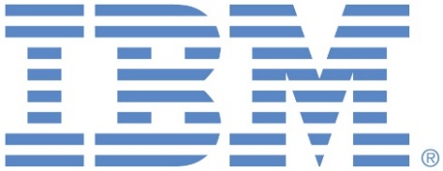

**PRESS RELEASE**

**IIM Ahmedabad announces ICADABAI-2019 conference and D’Avatar Hackathon organized in collaboration with IBM**

**7 February, 2019 | Ahmedabad**: IIM Ahmedabad is organizing its 6th International Conference on Advanced Data Analysis, Business Analytics and Intelligence on April 6-7, 2019. This conference aims to bring together leading academicians, researchers and professionals from around the world to share cutting-edge research experiences, new ideas and applications, debate issues and address latest developments in the field of data analytics and artificial intelligence.

Briefing on the conference, *Prof. Arnab K Laha, Conference Convener, ICADABAI-2019 says, “The aim of the conference is to bring all the major stakeholders in the data analytics and artificial intelligence arena on the same platform to discuss the key issues and challenges with the hope that it would encourage research and innovation that would eventually impact all organizations in a positive way”.* The two-day conference will include workshops, keynote speeches, panel discussions and a hackathon.

The D’Avatar hackathon on “Reincarnation of personal data entities in unstructured data sets” is being held in collaboration with IBM and addresses the very important area of protection of data privacy. This hackathon challenge can be worked on by students, researchers, academicians and professionals interested in the field of data science.

**- The End –**

**About Indian Institute of Management Ahmedabad (IIMA)**

*Established in 1961, the Indian Institute of Management, Ahmedabad (IIMA) is recognized globally for excellence in management education. One of the top management schools in the world, IIMA educates leaders of the enterprises. The Institute’s strategic priorities include: strengthening connection with its various constituencies, including academics, practitioners, alumni, and the community; nurturing a high-performance work environment of stretch, autonomy, and teamwork; and strategic growth while maintaining emphasis on quality.*

*The flagship Post Graduate Programme (PGP) is ranked 21st in the Financial Times Masters in Management Ranking 2017. As per the Financial Times’ Global MBA Ranking 2017, IIMA’s Post Graduate Programme for Executives (PGPX) is ranked 29th in the World. The postgraduate program in food and Agri Business (PGP-FABM) is ranked 1st in the Eduniversal Masters Ranking 2018. IIMA has been ranked as #1 Management institute as per the National Institutional*

*Ranking Framework (NIRF) rankings of Ministry of Human Resource Development, Government of India.*

For media queries, please contact:

**Mr. Deepak Bhatt**

Manager, Communications

Email: mngr-comm@iima.ac.in | Phone: 079-66324683 (O)

Mobile: +91-94262-29429

**Ms. Mitaaly Naidu**

Executive, Public Relations

Email: pr@iima.ac.in | Phone: 079-66324684 (O)

Mobile: +91-7069074816

Website: <www.iima.ac.in>