

**PRESS RELEASE**

**IIM Ahmedabad welcomes Fifteenth Batch of the**

**Armed Forces Program (AFP-19)**

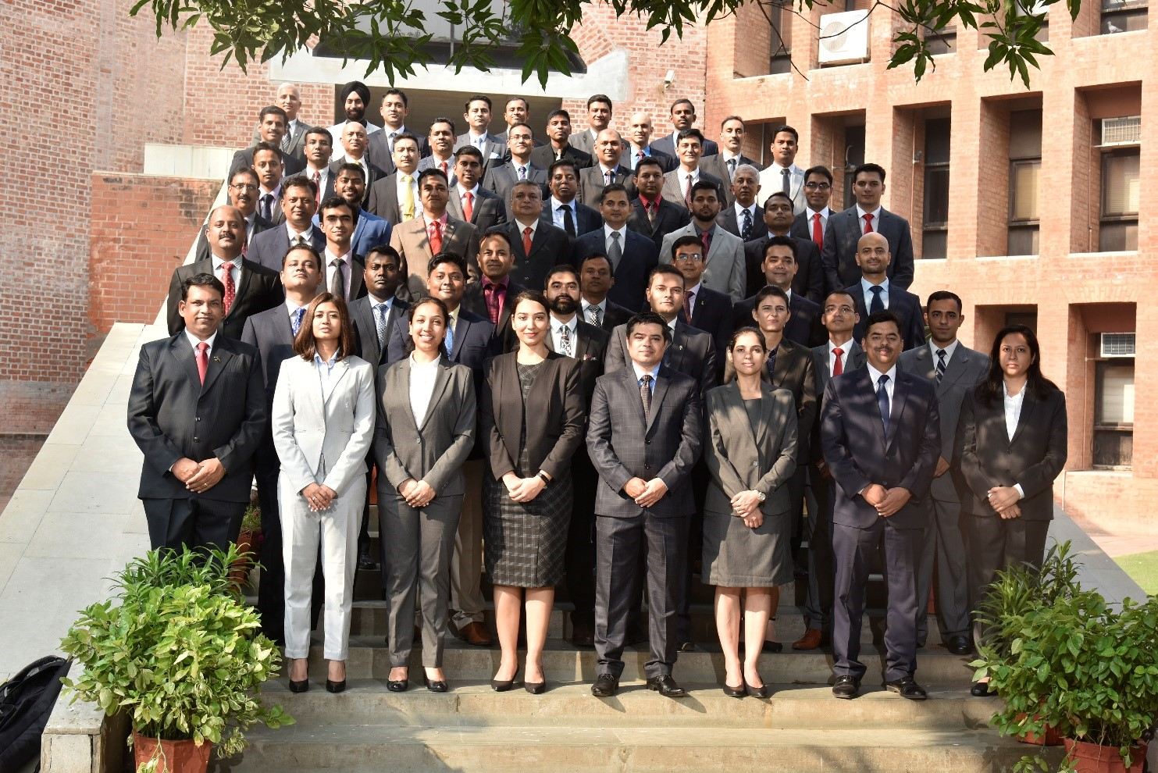

**Participants of Fifteenth AFP Programme**

**November 19, 2019 | Ahmedabad:**

IIMA is pleased to welcome the fifteenth batch of its Armed Forces Programme (AFP). The launch of yet another cohesive batch demonstrates IIMA's deep commitment to the Armed Forces in their endeavour to reorient and transit to the corporate world. The AFP is a unique selection based six month programme which is tailor made for the Armed Forces personnel. The programme synergizes the experience of the participants with the skillset identified by the IIMA faculty as the discriminator of excellence in the present corporate setup. The innovative curriculum has been designed by the faculty of IIMA by extracting the essence from their years of research, consulting and understanding of industry requirements from their global exposure. The pedagogy which is globally renowned and recognized as the gold standard builds on the strengths of the participants to make them organizational enablers in a world which looks for diversity in ideas and experience. The fifteenth batch of AFP comprises of officers from all the three wings of the Armed Forces (Army, Navy and Air Force) with the average age of 40 years. The admitted students have varied work experience from project management, operations, engineering, finance, logistics and medicine. Combined with their inherent skillset of adaptability, discipline and tenacity they represent a potent mix of go getters who are a potential asset to any organization.

The AFP programme at IIMA is unique in that the participants are selected through a rigorous entrance exam. The AFP batch has 58 participants which comprises of 35 engineers, 18 operations personnel, 3 each from logistics and finance background and 2 doctors. The officers mirror the diversity of our country and have the innate ability to understand the intricacies of cross cultural proliferation. They have won laurels ranging from gallantry in action, commendation cards to research papers.

* The End -

**For media queries, please contact:**

**Deepak Bhatt, Manager, Communication**

Ph: (Cell) +91-9426229429, (O) +91-79-66324683, Email: mngr-comm@iima.ac.in

**Mitaaly Naidu, Executive, Public Relations**

Ph: (Cell) +91-7069074816, (O) +91-79-66324684, Email: pr@iima.ac.in