

**PRESS RELEASE**

**Seven top IIMA alumni receive Young Alumni Achievers Award 2018**

**June 26, 2018 | Ahmedabad:**

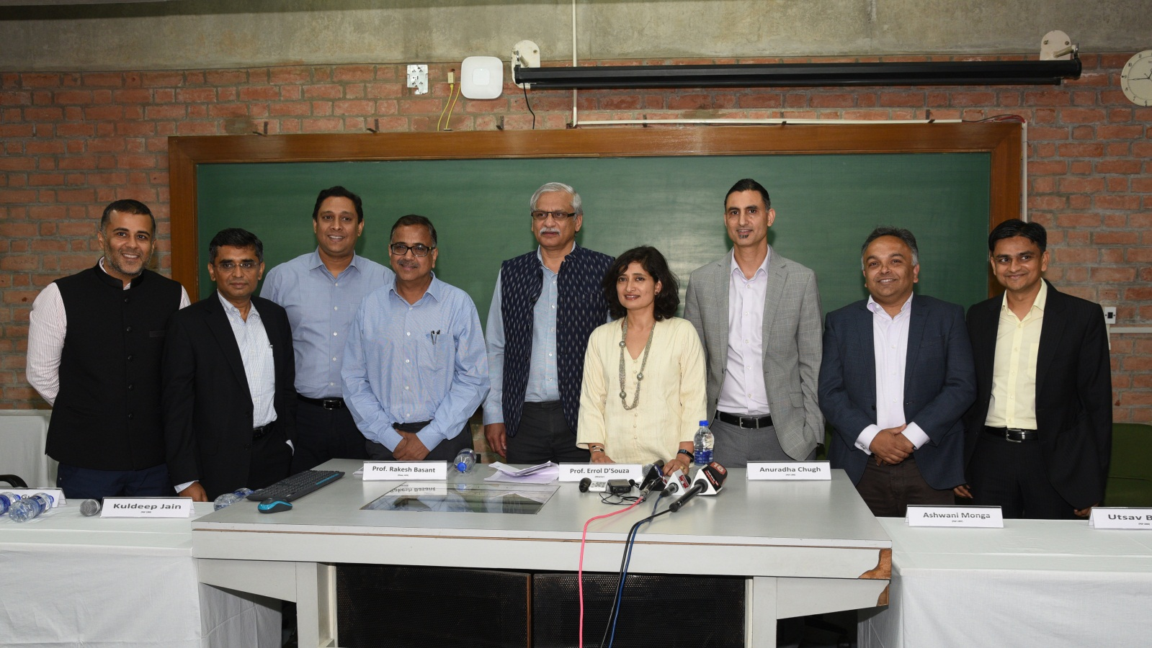

**Photograph:** Young Alumni Achiever’s Award 2018 awardee’s with IIMA Professors. (L-R) Mr. Chetan Bhagat, Renowned Author; Mr. Manish Gupta, Co-founder & CEO, Indegene; Mr. Kuldeep Jain, Founder and CEO, Cleanmax Solar; Prof. Rakesh Basant, Dean – AE&R, IIMA; Prof. Errol D’souza, Director, IIMA; Ms. Anuradha Chugh, MD, Ben & Jerry’s; Prof. Ashwani Monga, Vice Dean for Academic Programs and Innovations, Rutgers Business School, Newark and New Brunswick; Mr. Utsav Baijal, Partner, Apollo Management/Aion Capital, USA/India and Mr. Prakash Jhanwer, Regional Head – South East Asia and China, Olam International

The IIMA “Young Alumni Achiever’s Awards 2018 were presented today to seven formidable Alumni. The awards started in 2015, are given to alumni under the age of 45, to recognize outstanding achievements in various areas of work.

*Prof. Errol D’souza, Director, IIMA said, “IIMA is recognizing the contribution of seven of its young alumni who have demonstrated leadership in a range of fields, spanning corporate, entrepreneurial, academic, and public service contributions. The careers of these aspirational individuals are role models for our students as behind each success is a story of diligence in goal setting and overcoming obstacles in the endeavor to achieve them. In the process they have enriched society in addition to the organizations they have worked in. We take pride in their achievements and look forward to their future endeavors as change agents and leaders.”*

This year’s awards were given in three different Categories. As CORPORATE LEADERS three alumni were recognized:

1) **Ms. Anuradha Chugh,** PGP batch of 1994-96, currently the MD, Ben & Jerry’s

2) **Mr. Prakash Jhanwer,** PGP batch of 1996-98, currently Regional Head – South East Asia and China, Olam International

3) **Mr. Utsav Baijal**, PGP batch of 1998-2000, currently Partner, Apollo Management/Aion Capital, USA/India

*“These awards celebrate the contributions and achievements of our young alumni in diverse spaces. For any institution such a range and depth of contributions is a matter of pride. Our alumni have shown that they can be leaders and change agents in the fields of their choice and I am sure that their work will continue to inspire and motivate our students to excel in their work-spaces,” said Prof Rakesh Basant, Dean, Alumni and External Relations.*

**Mr. Kuldeep Jain**, PGP batch of 1997-99, Founder and CEO, Cleanmax Solar and **Mr. Manish Gupta**, PGP 1996-98, Co – founder & CEO, Indegene were awarded for their achievements as an ENTREPRENEUR.

The third category of honor was ACADEMICS, for which **Prof. Ashwani Monga**, PGP Batch 1995-97, Vice Dean for Academic Programs and Innovations, Rutgers Business School, Newark and New Brunswick was awarded. **Mr. Chetan Bhagat**, PGP batch of 1995-97, renowned Author, was honored in the ART & ENTERTAINMENT category.

The Alumni addressed the following queries:

1. **How did IIMA help you to pursue your dream?**
2. **What does this award mean to you?**

**CORPORATE LEADER**

**Ms. ANURADHA CHUGH** “*It’s a great feeling of accomplishment to return to campus to receive this award. It has given me a chance to reflect on the role that IIMA played in my international career, and how it equipped me to make the most of all the opportunities and challenges that came my way.*

*IIMA was a springboard for a long and enjoyable international career at Unilever. I spent most of my 22 years outside India, and everywhere I have been the rigor and quality of the IIMA education has been a valuable tool to have. Of course, you learn and relearn marketing at every stage, but Kotler remains Kotler.”*

**Mr. PRAKASH JHANWAR***“I feel truly honoured and humbled to receive this award from my alma mater. The accolade further holds special meaning for me as it coincides with the 20th anniversary of my graduation from IIMA and start of my corporate journey with Olam.*

*My journeys with IIMA and Olam have been a ‘dream come true’ and exceed everything a 21 year old IIMA entrant would have had on his bucket list – global experience, working with smart and talented colleagues, and building a network to support my zest for life-long learning. Never did I imagine that I would be running large businesses in multiple countries with global capabilities, leading customers, incredible colleagues and exciting growth prospects.*

*IIMA has been pivotal in laying a solid foundation for this success – work ethic, humility, analytical rigor and peer to peer learning. This “battle-hardened” me for the future corporate roles and more critically, instilled self-belief to persevere through challenges. This recognition is a stepping stone for my future aspirations and will motivate me on the journey of continuous learning and contribute to society at large.”*

**Mr. UTSAV BAIJAL** *“My years at IIMA helped shape my dreams and gave me the foundation on which I could build a successful career. Competitiveness, work ethic and quick thinking became real for me on campus and my two years helped me understand the first principles of business success.*

*Getting this recognition from one’s own alma mater is extra special and provides me with extra motivation to becoming an even better professional and leader going forward.”*

**ACADEMICS**

**Mr. ASHWANI MONGA***“Joining IIMA was certainly the first step in my academic journey not only from an intellectual standpoint, but also because it opened up doors for me when I applied for my Ph.D. Most important, the rigor at IIMA convinced me that I could take on any intellectual challenges. I don’t think of myself as being the best but, after IIMA, I am no longer intimidated when being around the best. I couldn’t have pursued my academic dreams without the confidence that IIMA instilled in me.*

*Receiving this recognition from IIMA means the world to me. Being recognized by my alma mater for something that I love doing is very fulfilling. This honor is less about my achievements, and more about the high value that IIMA places on academics. IIMA has always remained true to its mission of creating and disseminating knowledge. I feel fortunate that my career has progressed in line with that mission. This award encourages me to keep making progress.”*

**ART & ENTERTAINMENT**

**Mr. CHETAN BHAGAT***“I am delighted to receive the Alumni Achiever award from IIMA, which is not only my Alma mater, but also one of the top institutions in the country. So many distinguished alumni have graduated from IIMA, to be honored like this makes it really special.”*

**ENTREPRENEUR**

**Mr. KULDEEP JAIN***"IIM Ahmedabad has played a key role in shaping the professional that I am today and it continues to live up to its vision of 'educating leaders of enterprises'. The knowledge, exposure and growth one receives in IIMA is of unmatched value. It gave me a great leg up, through an initial placement at McKinsey & Company as well as the lifetime benefit of friends in various industries and geographies. In my CleanMax journey, I have used my IIMA peers in various roles like sounding board, leveraging their networks, taking their advice, and most often, just being friends. I would like to thank the faculty and the management for recognizing my achievements and hope to make the institute proud of my future endeavours."*

**Mr. MANISH GUPTA***“My years at IIMA helped create strong fundamental understanding of business, shaped aspirations and perspectives, and helped foster some very strong and meaningful friendships that mean so much to me even today.*

*I am personally indebted to IIMA for the help and guidance we got from our IIMA professors and our fellow batch mates in the early days of our company. Two of our independent board members are from IIMA and we still seek out some of our close friends from IIMA for counsel even today.*

*I feel privileged being recognized by IIMA. This is an honor that means a lot to me, coming as it does from an institution of which I am fortunate to be alumni of. My years at IIMA have been special and have contributed immeasurably to the journey I have taken since. To be recognized at this juncture is a reaffirmation of my journey and everything that’s deeply associated with it. I feel genuinely privileged and humbled. Grateful, as well.”*

**-THE END-**

**About IIMA:**

Established in 1961, the Indian Institute of Management, Ahmedabad (IIMA) is recognized globally for excellence in management education. One of the top management schools in the world, IIMA educates leaders of the enterprises. The Institute’s strategic priorities include: strengthening connection with its various constituencies, including academics, practitioners, alumni, and the community; nurturing a high performance work environment of stretch, autonomy, and teamwork; and strategic growth while maintaining emphasis on quality. As per the latest ranking by The Economist, IIMA is No. 1 School in the world on the parameter of opening up new career opportunities for students. The flagship Post Graduate Programme (PGP) is ranked 16th in the Financial Times Masters in Management Ranking 2016 and Post Graduate Programme in Food and Agri-Business Management (PGP-FABM) is ranked 1st by Eduniversal, Paris, France in 2017. As per the Financial Times’ Global MBA Ranking 2017, IIMA’s Post Graduate Programme for Executives (PGPX) is ranked 29th in the World.

**IIMA MEDIA CONTACTS**

|  |  |
| --- | --- |
| **Mr. Deepak Bhatt**  Manager, Communications  Email: [mngr-comm@iima.ac.in](mailto:mngr-comm@iima.ac.in) Phone: +91-79-66324683 | **Ms. Mitaaly Naidu**  PR Executive, Communications  Email: [pr@iima.ac.in](mailto:pr@iima.ac.in) Phone: +91-79-66324684 |