**PRESS RELEASE**

**NSE Centre for Behavioral Science in Finance, Economics and Marketing inaugurated at IIMA**

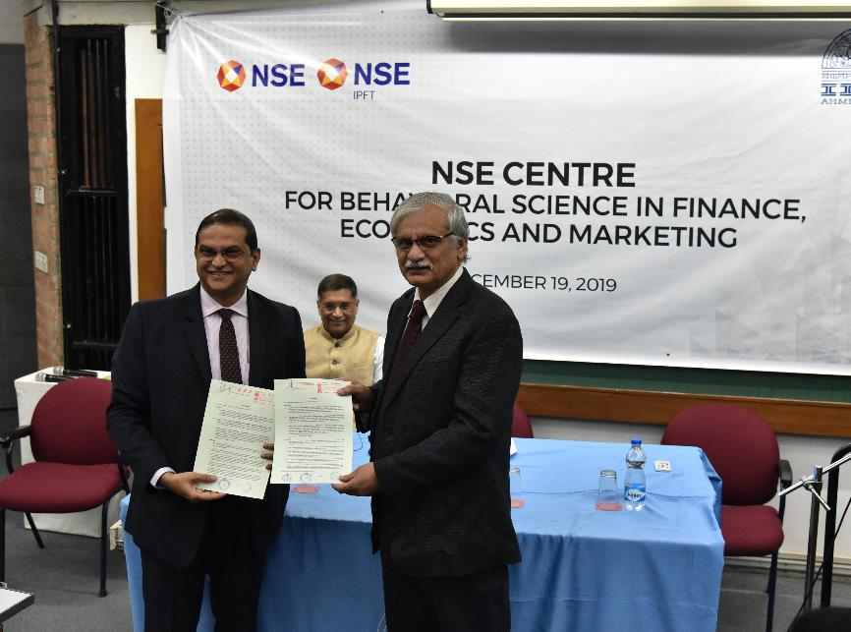

**Ahmedabad, December 19, 2019:**  The NSE Centre for Behavioural Science in Finance, Economics and Marketing was inaugurated at Indian Institute of Management Ahmedabad today. The Centre was inaugurated by Dr Arvind Subramanian, Economist and former Chief Economic Adviser, GOI with Prof. Errol D’Souza, Director, IIMA; Mr Ravi Varanasi, Chief Business Development Officer, NSE and Prof. Arvind Sahay, Professor of Marketing and International Business, IIMA.

This Centre is going to be the first of its kind in a management institution in the region with sophisticated infrastructure and technology to conduct experiments in how different aspects of behavioural science impacts processes and outcomes in markets. The objective of the Centre is to undertake knowledge creation in a range of topics related to business issues in financial markets and financial services that would be insightful to help decision making for policymakers, individual retail investors, fund managers, traders, analysts, wealth advisors, other managers and leaders. In the process it would build high-quality research, analytics, and insightful knowledge on a range of topics related to business issues in the Indian financial markets and financial services across different stakeholders. The agreement was signed between NSE, NSE IPFT and IIM A to set up centre for Behavioural Science in Finance, Economics and Marketing at IIMA.

*Mr. Vikram Limaye, MD & CEO, NSE said, “Capital markets penetration continues to be low in India compared to advanced markets. Societal and behavioural aspects tend to play a pivotal role in shaping savings and investment habits of the population. Behavioural science tools have been advancing over the years and could unearth deep rooted behavioural patterns and biases. Insights gleamed from such research could throw new light on our understanding and help shape policies that could spread the benefits of capital markets to a wider section of the population. It is in this context that we are working with a premier academic institution like IIMA to advance the frontiers of behavioural science research in India.”*

*Prof. Errol D’Souza, Director, IIMA said, “The Centre for Behavioural Science in Finance, Economics and Marketing is a promising initiative with NSE. The Centre shall focus on multi-disciplinary, thematic, and applied research in several key areas related to the behavioural applications of finance, economics and marketing. We believe, both the constituencies will benefit from this shared engagement.”*

**About National Stock Exchange of India Limited (NSE):**

National Stock Exchange of India Ltd. (NSE) is the leading stock exchange in India and the second largest in the world by nos. of trades in equity shares from January to December 2018, according to World Federation of Exchanges (WFE) report. NSE was the first exchange in India to implement electronic or screen-based trading. It began operations in 1994 and is ranked as the largest stock exchange in India in terms of total and average daily turnover for equity shares every year since 1995, based on SEBI data. NSE has a fully-integrated business model comprising exchange listings, trading services, clearing and settlement services, indices, market data feeds, technology solutions and financial education offerings. NSE also oversees compliance by trading and clearing members with the rules and regulations of the exchange. NSE is a pioneer in technology and ensures the reliability and performance of its systems through a culture of innovation and investment in technology. NSE believes that the scale and breadth of its products and services, sustained leadership positions across multiple asset classes in India and globally enable it to be highly reactive to market demands and changes and deliver innovation in both trading and non-trading businesses to provide high-quality data and services to market participants and clients.

**About NSE IPFT:**

NSE IPFT was set up under section 370 of the Companies Act, with the objective of creating and managing a fund that shall be used for promoting investor education and awareness and for undertaking research activities related to securities market.

**About IIMA:**

The Indian Institute of Management Ahmedabad (IIMA) was set up as an autonomous institution in 1961 by the Government of India in collaboration with the Government of Gujarat and the Indian industry. IIMA is the first management school in India to receive international accreditation for five years. It was the first business school in India to receive EQUIS (European Quality Improvement System) accreditation, by the European Foundation for Management Development (EFMD) in June 2008 and has maintained EQUIS accreditation since then.

In 2018, IIMA made it to the number 4 position in the Financial Times (FT) Asia Pacific Top 25 Business School Rank, ahead of all Indian B-School. FT conducted the ranking after considering the quality and breath of all the B-schools programmes. In addition, it has been ranked 19th in the Financial Times (FT) Masters in Management Rankings 2018 and 31st in the FT (Financial Times) Global MBA Ranking 2018. Over the years, the Post Graduate Programme in Food and Agri-business Management (PGP-FABM) of IIMA has been ranked number one globally in its category in the Eduniversal Best Masters’ Ranking in Agribusiness/Food Industry Management.

IIMA features at the top position in the India Ranking 2018 (National Institutional Ranking Framework) released by the Ministry of Human Resource Development (MHRD), Government of India.

For more information, please visit: [www.nseindia.com](http://www.nseindia.com/)

For any clarifications please contact:

**Arijit Sengupta**

Chief Communications Officer

Mobile: +91 9820340485

Email id: [asengupta@nse.co.in](mailto:asengupta@nse.co.in)

**Kumar Kartikey**

Chief Manager, Corporate Communication

Mobile: 98195 49984

Email id: [kumark@nse.co.in](mailto:kumark@nse.co.in)

**Deepak Bhatt**

Manager, Communication, IIM A

Ph: (Cell) +91-9426229429, (O) +91-79-7152 4683

Email: [mngr-comm@iima.ac.in](mailto:mngr-comm@iima.ac.in)

**Mitaaly Naidu**

Executive, Public Relations, IIM A

Ph: (Cell) +91-7069074816, (O) +91-79-7152 4684

Email: [pr@iima.ac.in](mailto:pr@iima.ac.in)