

**PRESS RELEASE**

**Six top IIMA alumni receive Young Alumni Achievers Award 2019**

Photograph and Caption

**June 16, 2019 | Ahmedabad:**

The annual IIMA “Young Alumni Achiever’s Awards 2019 were presented today to six formidable Alumni. The awards started in 2015, are given to alumni under the age of 45, to recognize outstanding achievements in various areas of work.

*Prof. Errol D’Souza, Director, IIMA said, “The Young Alumni Achievers Award honors alumni who, at a young age, have demonstrated leadership in their respective fields. In honoring them, we also acknowledge the diverse and significant contributions our alumni are making in various walks of life. We are sure that they will continue to do well and bring more laurels to IIMA in the future.”*

*Prof. Errol D’souza, Director, IIMA said, “IIMA is recognizing the contribution of seven of its young alumni who have demonstrated leadership in a range of fields, spanning corporate, entrepreneurial, academic, and public service contributions. The careers of these aspirational individuals are role models for our students as behind each success is a story of diligence in goal setting and overcoming obstacles in the endeavor to achieve them. In the process they have enriched society in addition to the organizations they have worked in. We take pride in their achievements and look forward to their future endeavors as change agents and leaders.” (Last year’s Quote)*

This year’s awards were given in three different Categories. As CORPORATE LEADERS three alumni were recognized:

1) **Mr. Sumit Jalan,** PGP batch of 2002-04, currently MD & Co-head of Investment Banking and Capital Markets, Credit Suisse, India

2) **Ms. Vaishali Rastogi,** PGP batch of 1997-99, currently Managing Partner, Head of South East Asia, The Boston Consulting Group

3) **Mr. Viraj Sawhney**, PGP batch of 2000-02, currently Managing Director, Walburg Pincus, India

*“We have been celebrating the contributions and achievements of our young alumni with these awards for some years now. But each year I get surprised by the diversity of areas in which our alumni have made a mark. As a teacher it brings me joy and makes me proud. Our alumni are our ambassadors and I am sure such contributions will not only inspire and motivate future students, they will also take IIMA to newer heights." said Prof Rakesh Basant, Dean, Alumni and External Relations, IIMA*

**Mr. Pranay Agrawal**, CEO and **Mr. Srikanth Velamakanni**, Group CEO who also co – founded Fractal Analytics, batchmates of PGP 1998-2000 were awarded for their achievements as an ENTREPRENEUR.

The third category of honor was ACADEMICS, for which **Prof. Suchitra Sebastian**, PGP Batch 1997-99, Professor of Physics at University of Cambridge, United Kingdom was awarded.

The Alumni addressed the following queries: (Awaiting Responses from 3 Alumni)

1. **How did IIMA help you to pursue your dream?**
2. **What does this award mean to you?**

**CORPORATE LEADER**

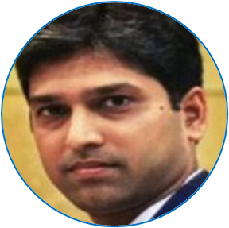**Mr. Sumit Jalan**

Coming from a family of stockbrokers, I dreamt of being a leading banker. IIMA not only turbocharged me on intricacies of finance and investment banking, but also through its unique pedagogy style of case studies and peer-to-peer learning, analytical and application orientated professors, trained me on the nuances of several soft skills and leadership concepts, which were crucial in climbing each step of the ladder all the way to the Top.

This award means life to me. It's a recognition of the collective journey of my family, friends, teachers, alma mater, colleagues, well-wishers and organizations, I have worked for. To come from the alma mater and from a pool of such extraordinary talent of IIMA alumni makes me elated, and a feeling that I know will last for eternity.

** Ms. Vaishali Rastogi**

As I reflect back, the two years at IIMA were absolutely pivotal in shaping my thinking and my career. And fast forward two decades later, I firmly believe this was the very best opportunity I could have had as a young professional.  The IIMA stint enabled me to gain incredible exposure, built my confidence and helped provide a foundation, that has stayed with me till today.

The exposure and confidence you get is unprecedented given the talent in the IIMA community, both from the very accomplished faculty, the way of learning and also through the peer group which are India’s top talent. I still remember the innumerable debates with fellow students that really pushes your critical thinking, being forced to come out of my shell and learn to at least cope (if not enjoy) class participation, and honing my teaming skills on how to work with all sorts of teams to deliver significant project work.  The foundation that IIMA provides is second to none, be it in creating a network that stays with you for support or guidance, or the opportunities it provides access to, as you set the foundations of your career.  I am still with the same firm I joined post IIMA i.e. the Boston Consulting Group, two decades later!

I am very honoured to receive the YAAA. IIMA played formative role in shaping my career and the recognition by IIMA and my peers mean a lot to me.  It’s a very special feeling to come back to the institute which gave me so much – friendships, opportunities and more. I hope the award will inspire many more young leaders from IIMA to reach for the stars in whatever they aspire to, be it business, education, social or entrepreneurship.

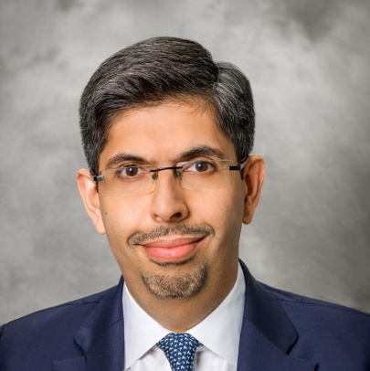**Mr. Viraj Sawhney**

I imbibed some serious life lessons at IIMA – the value of perseverance, maintaining composure in challenging situations and above all, being humble and having respect for others’ opinions. These lessons, a number of enduring friendships, and an opening at McKinsey, were the biggest things I received at IIMA and have all been instrumental in my journey thus far.

I am earnestly grateful for this award and is a helpful reminder for what I owe the institute. It reinforces that good mentors and teachers can lead to very positive outcomes, and I hope to play a similar role in the lives of younger people going forward.

**ACADEMICS**

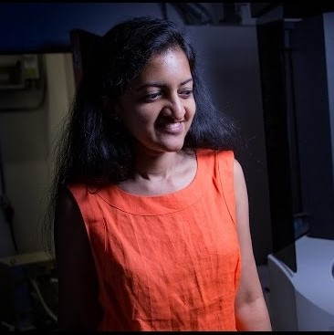 **Prof. Suchitra Sebastian**

**ENTREPRENEUR**

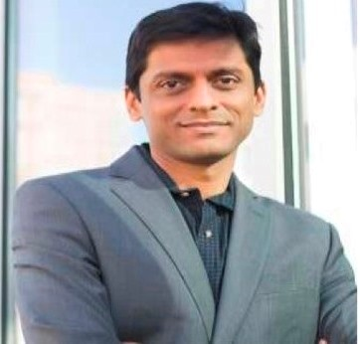**Mr. Pranay Agrawal**

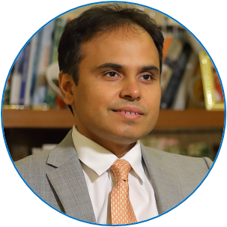**Mr. Srikanth Velamakanni**

**-THE END-**

**About IIMA:**

Established in 1961, the Indian Institute of Management, Ahmedabad (IIMA) is recognized globally for excellence in management education. One of the top management schools in the world, IIMA educates leaders of the enterprises. The Institute’s strategic priorities include: strengthening connection with its various constituencies, including academics, practitioners, alumni, and the community; nurturing a high performance work environment of stretch, autonomy, and teamwork; and strategic growth while maintaining emphasis on quality. As per the latest ranking by The Economist, IIMA is No. 1 School in the world on the parameter of opening up new career opportunities for students. The flagship Post Graduate Programme (PGP) is ranked 16th in the Financial Times Masters in Management Ranking 2016 and Post Graduate Programme in Food and Agri-Business Management (PGP-FABM) is ranked 1st by Eduniversal, Paris, France in 2017. As per the Financial Times’ Global MBA Ranking 2017, IIMA’s Post Graduate Programme for Executives (PGPX) is ranked 29th in the World.

**IIMA MEDIA CONTACTS**

|  |  |
| --- | --- |
| **Mr. Deepak Bhatt**  Manager, Communication  Email: [mngr-comm@iima.ac.in](mailto:mngr-comm@iima.ac.in) Phone: +91-79-66324683 | **Ms. Mitaaly Naidu**  PR Executive, Communication  Email: [pr@iima.ac.in](mailto:pr@iima.ac.in) Phone: +91-79-66324684 |