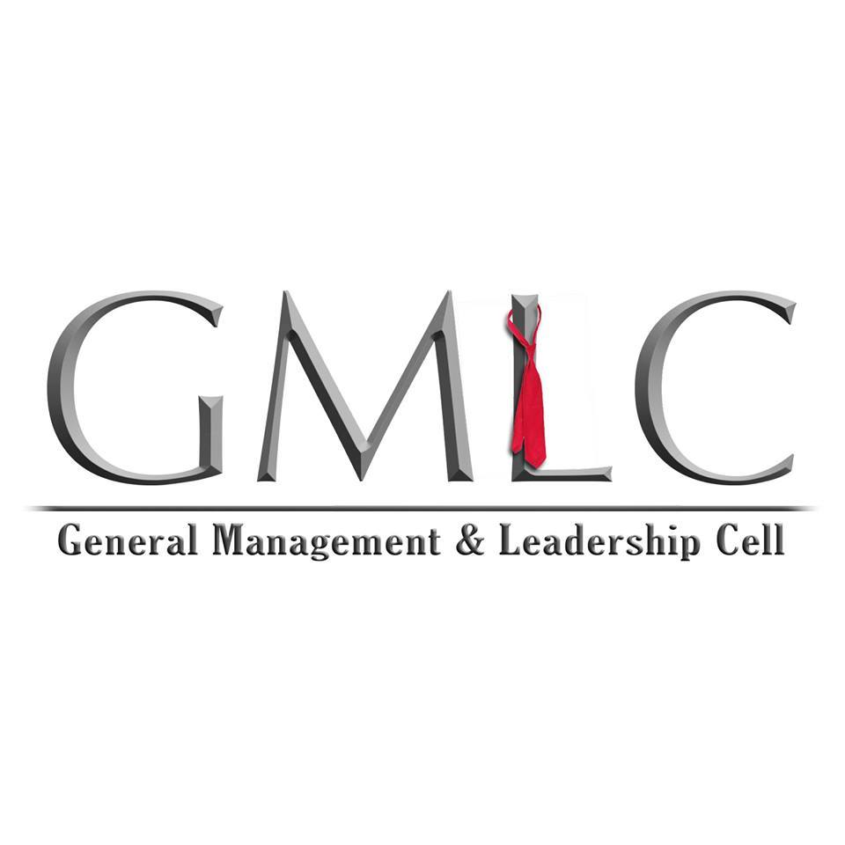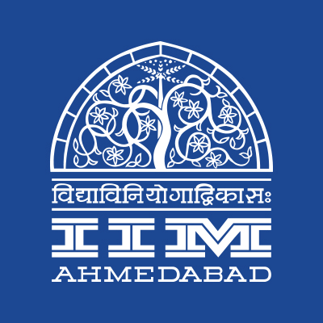

**PRESS RELEASE**

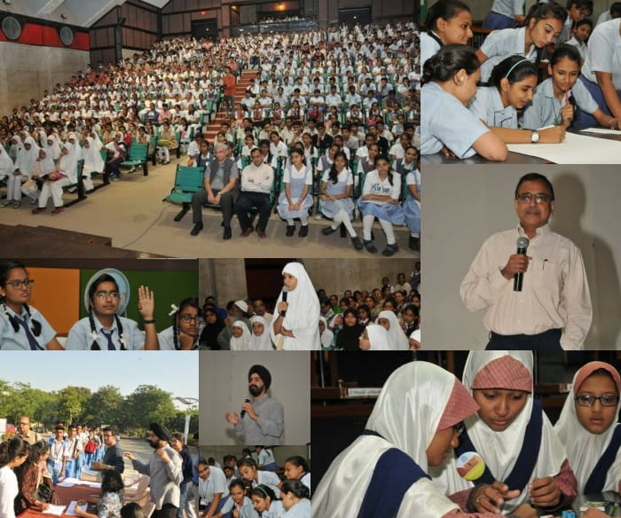**IIMA readies itself for Open Day**

**November 22, 2017 | Ahmedabad**

***Glimpses of Open Day 2016***

General Management & Leadership Cell (GMLC) of Indian Institute of Management Ahmedabad is set to host the 3rd edition of its annual flagship event, Open Day at IIMA on November 26, 2017. The program aims to make school-going children experience the life at IIMA.

Participants of Open Day will spend a day at the campus of IIMA. Sessions on Career Planning and Personality Development will be organized for the attendees. The history and significance of IIMA will be explained to the attendees through campus tours by students of IIMA. Open Day 2016 was attended by over 550 children of Classes 9, 10, 11 and 12 from various schools of Ahmedabad. The career planning session last year was held at RJM Auditorium and saw the participation of Prof. Errol D’Souza, Director-In-Charge, IIMA and also Prof. Rakesh Basant, Dean - Alumni & External Relations, IIMA.

For this edition of the Open Day, GMLC is planning to conduct events based on the theme of **learning through innovation**. Also, Prof. Rakesh Basant, Dean – A&ER, IIMA and Prof. Ankur Sarin, Professor – Public Systems Group, IIMA along with other faculty members are expected to grace the event. Over 500 school children from Ahmedabad are expected to attend the event and over 20 IIMA students of PGP program are working on ensuring hassle-free execution of the event.

*Himanshu Singh, Coordinator of GMLC, referring to the event commented “Open Day is our annual community outreach event started 2 years ago at the prodding of our former Director, Prof. Ashish Nanda. Since then, the program has been only growing by leaps and bounds.”*

*Ishita Solanki, Manager – Global Partnerships & Corporate Affairs at IIMA, who has been instrumental in the event since its inception, quoted, “Since its inception, the Open Day event has received warm response from the local community. It is one of the most looked forward events of our campus calendar as we get to engage the future Leaders and understand their aspirations.”*

For more info, please visit GMLC’s Facebook page: <https://www.facebook.com/GMLC.IIMAhmedabad/>

-End of Text-

**About Indian Institute of Management Ahmedabad (IIMA)**

Established in 1961, the Indian Institute of Management, Ahmedabad (IIMA) is recognized globally for excellence in management education. One of the top management schools in the world, IIMA educates leaders of the enterprises.The Institute’s strategic priorities include: strengthening connection with its various constituencies, including academics, practitioners, alumni, and the community; nurturing a high performance work environment of stretch, autonomy, and teamwork; and strategic growth while maintaining emphasis on quality.

As per the latest ranking by *The Economist*, IIMA is No. 1 School in the world on the parameter of opening up new career opportunities for students. The flagship Post Graduate Programme (PGP) is ranked 16th in the *Financial Times* Masters in Management Ranking 2016. As per the *Financial Times’* Global MBA Ranking 2016, IIMA’s Post Graduate Programme for Executives (PGPX) is ranked 24th in the World. IIMA has been ranked as #1 Management institute as per the National Institutional Ranking Framework (NIRF) rankings of Ministry of Human Resource Development, Government of India.

For media queries, please contact:

|  |  |
| --- | --- |
| Himanshu Singh  Coordinator, GMLC (PGP-2)  Indian Institute of Management Ahmedabad  Ph: (Cell) +91-9582263202  Email: p16himanshusingh@iima.ac.in | Balaji Uppala  Media Secretary (PGP-2)  Indian Institute of Management Ahmedabad  Ph: (Cell) +91-7042705642  Email: p16srimukhab@iima.ac.in |