

**PRESS RELEASE**

**Rahul Chaudhary, Founder of Treebo, speaks at IIMA**

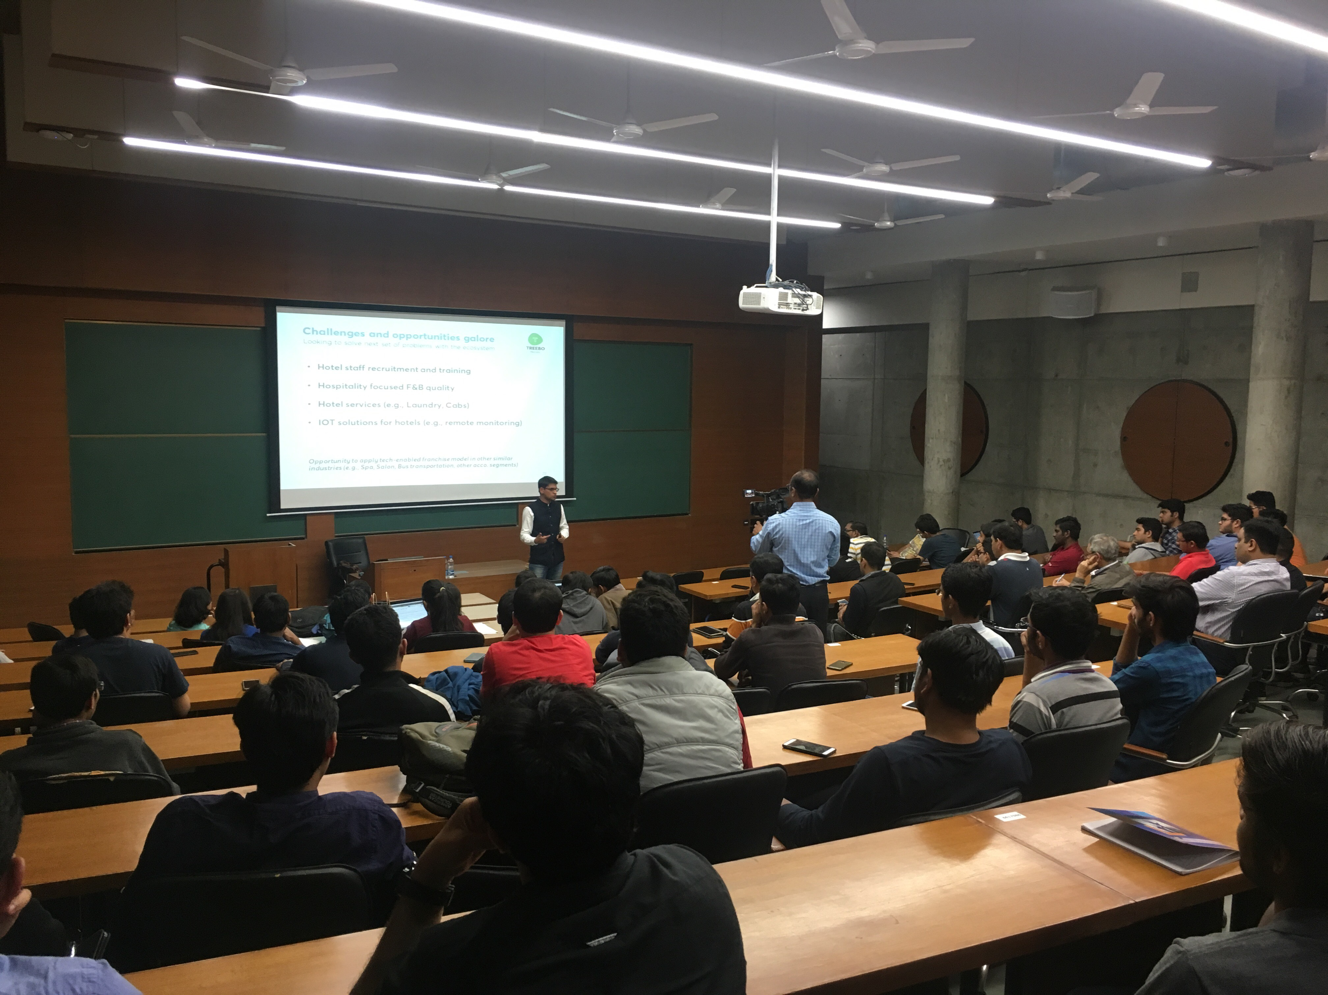

**Rahul Chaudhary addressing students at IIM-Ahmedabad**

**January 21, 2018 | Ahmedabad**

IIM Ahmedabad hosted Mr. Rahul Chaudhary, Founder of Treebo, India's third largest hotel chain as part of the How to Start a Startup 2.0 series. The eighth installment of the series was on exotic treat for budding entrepreneurs, based on the theme of ‘franchisee based entrepreneurship.’ An IIM Ahmedabad alumnus, Chaudhary started his career working at Mckinsey & Company, and Myntra before starting Treebo along with Sidharth Gupta and Kadam Jeet Jain. As he reminisced about the fledgling start-up culture when he graduated, he mentioned that startups were not popular among students, with the first start-up fair attracting merely 15 startups and 13 students showing up.

Chaudhary talked about the various challenges they faced while starting up, and most importantly, taking the decision to enter the budget hospitality industry - while choosing the business, the founders decided to ask themselves which field will not change in the next 20 years. They found that in the context of travel, people exhibited a simple consumer behavior, demanding clean hotel rooms and an anxiety-free experience. The second problem his team faced was selling this idea of a middle-class consumer. Chaudhary also talked of the importance of having the right team. There needs to be problem-founder fit just like the product-market fit. For him, this is the secret to achieving great outcomes.

He then went on to talk about why he picked travel as a sector for his start-up, highlighting that tourism as an industry benefits a lot. At the time when the founders were starting up, Rahul and his co-founders noticed that there was immense growth in the markets that Treebo planned to operate in. Within tourism, which was then a $40 billion market, railways were never an option. The budget segment, however, accounted for 0.84 mil out of the total of 1.2 mil rooms which was in his opinion a very large market. The point that sealed the deal for him, however, was that this industry was independent of consumer behavior, in his words, “People always stayed in hotels.”

Mr. Rahul then went on to talk about the initial thought process of the founders which was built on the historical facts that in budget segments, organized brands replaced unorganized providers across the sectors, quoting examples of Peter England in the textile segment and Ola in the transport sector. The next crucial step in building the company, he said, was to understand the problems that consumer faced rather than drawing on their own experiences. While talking about his target demographic, he says that they primarily wanted to hit 19 to 50-year old’s who were looking for decent value-for-money experiences. He then shared some key findings that the founders observed when they met hotelier’s door-to-door, the key one being that hotels in budget segments are usually side businesses for owners with no formal education in hotel management. He says that this led to a dilution in consumer quality. For the hoteliers, Mr. Rahul also mentioned that the key problem was to find an online sales platform.

As he went on to talk about the execution stage in his startup, he mentioned that curation is the most important stage, finding the right set of people to ensure that a minimum bar on quality is ensured. The other important factor, according to Rahul Chaudhary, to succeed as Teebo, was to ensure guest and partner’s delight. While talking about the economics of the model and why they haven't gone the ‘OYO’ route, Mr. Rahul says that there is still unsophistication in the OYO-model with the last mile in third-party hands. The other reason that he shared is that they wanted to focus on the experience that they gave to their consumers.

While talking about the potential opportunities that still exist for Treebo, Mr. Rahul says that Treebo’s present market share is only 0.7% which shows the growth potential in the market. He also talked about the possibility of extending IOT to hotels, citing the example of switching off electricity between check-in and check outs. The company also plans to extend into other hotel services like laundry and cabs in the longer term.

The session ended with a Q&A round, with attendees enthusiastically asking questions to the speaker. Chaudhary was asked about what keeps a hotel tied up with Treebo, to which he mentioned that constant vigilance is required. In this regard, the main differentiation from a local business is that hotels are not repeat products which means continued support is required for continuous acquisition. The next question that was directed to Mr. Rahul was the rationale behind selecting Irrfan Khan as a brand ambassador. Data analytics and match with the brand image of Treebo, in his opinion, led them to Irrfan Khan as a possible ambassador after which Mr. Khan wasn’t too expensive for Treebo. Another interesting question that was posed to him was regarding how the firm dealt with people who don’t show up. Treebo’s approach to this problem was confirmation calls and leveraging anxiety to ensure that customers pre-pay for their rooms.

**-End of Text-**

|  |
| --- |
| **News in Brief**  In the eighth installment of the How to Start a Startup 2.0 series – “franchisee based entrepreneurship”, was an exotic treat for all the entrepreneurs at IIM-Ahmedabad as they were privy to Mr. Rahul Chaudhary, Founder of Treebo, an organization which is today India's third largest hotel chain and operates in the [budget](https://en.wikipedia.org/wiki/Budget) segment of the [hospitality](https://en.wikipedia.org/wiki/Hospitality) industry. An IIM-A alumnus himself, Mr. Rahul went on to talk about the starting points, the reason for choosing the travel sector and initial as well as execution problems the founders faced when they started Treebo. In the Q&A session that followed, he was grilled on a series of question ranging from what keep the hotel partners committed to Treebo, the rationale behind choosing Irrfan Khan as an ambassador and how at Treebo they deal with consumers who do not show up after booking. |

**About Indian Institute of Management Ahmedabad (IIMA)**

Established in 1961, the Indian Institute of Management, Ahmedabad (IIMA) is recognized globally for excellence in management education. One of the top management schools in the world, IIMA educates leaders of the enterprises.The Institute’s strategic priorities include: strengthening connection with its various constituencies, including academics, practitioners, alumni, and the community; nurturing a high performance work environment of stretch, autonomy, and teamwork; and strategic growth while maintaining emphasis on quality.

As per the latest ranking by *The Economist*, IIMA is No. 1 School in the world on the parameter of opening up new career opportunities for students. The flagship Post Graduate Programme (PGP) is ranked 16th in the *Financial Times* Masters in Management Ranking 2016. As per the *Financial Times’* Global MBA Ranking 2016, IIMA’s Post Graduate Programme for Executives (PGPX) is ranked 24th in the World. IIMA has been ranked as #1 Management institute as per the National Institutional Ranking Framework (NIRF) rankings of Ministry of Human Resource Development, Government of India.

For media queries, please contact:

|  |  |
| --- | --- |
| Gaurav Bagde  Coordinator, Entre (PGP-2)  Indian Institute of Management Ahmedabad  Ph: (Cell) +91-7506463331  Email: p16gauravb@iima.ac.in | Balaji Uppala  Media Secretary (PGP-2)  Indian Institute of Management Ahmedabad  Ph: (Cell) +91-7042705642  Email: p16srimukhab@iima.ac.in |