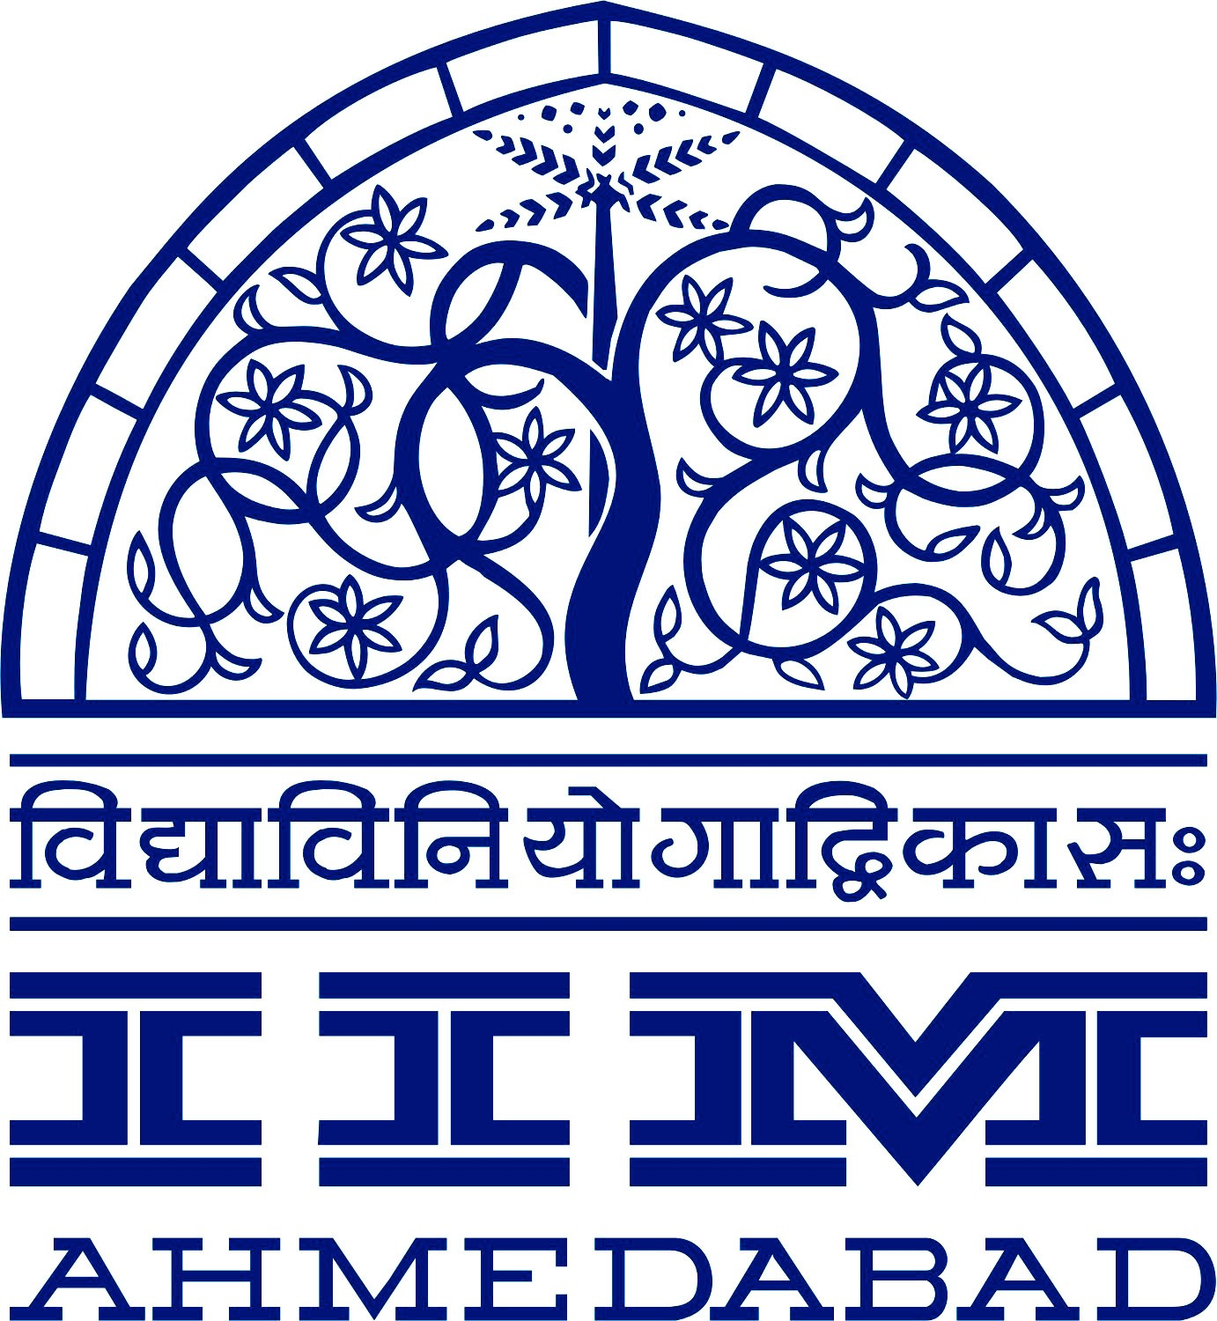

**Press release**

**IIM Ahmedabad and BRS Ventures to establish IIMA’s First International Extension Center in UAE**

• Memorandum of Understanding signed at the World Government Summit 2018

• IIMA’s first Extension Center outside India in Dubai, UAE

• Center to commence operations in June 2018

**Ahmedabad/Abu Dhabi/Dubai | February 12, 2018:** Indian Institute of Management, Ahmedabad of India and BRS Ventures of UAE today signed a Memorandum of Understanding (MOU) to establish IIMA’s first Extension Center in Dubai. The UAE Extension Center will begin with Executive Education Programs that are relevant to the region and will include both open learning and customized training programs. With the synergy, this partnership is expected to benefit both organizations, besides benefiting the UAE regional business and governance. The MOU was signed at the World Government Summit 2018, an annual event held in Dubai that brings together leaders in government for a global dialogue about governmental process and policies with a focus on the issues of futurism, technology and innovation.

IIMA will provide the academic and training expertise while BRS Ventures will facilitate the required support including infrastructure, industry links and logistics. IIMA’s parent campus in Ahmedabad that was established through active partnership with Harvard Business School almost six decades back, started with Executive Education Programs using Case Study Method and cases relevant to business. These Executive Education programs have consistently grown and remain much in demand across industries and corporates. In a phased manner, depending on response and other factors, IIMA–BRS Ventures will consider rolling out other programs in UAE of longer duration. These programs will be globally relevant to ensure that the cohort being trained is not restricted to any region and the learning environment is in an international cultural setting.

***Speaking on the occasion Prof. Errol D’Souza, Director of IIMA said,*** *“For an institute with global footprint of alumni, it is important to have physical presence beyond the national borders. UAE has been the gateway and hub for MENA region’s business connect with the world. We are very happy to partner with BRS Ventures, given their distinguished service to UAE as well as deep understanding of the region and its priorities. This will help IIMA in implementing the planned activities and programs successfully.”*

***Dr. BR Shetty, Chairman, BRS Ventures shared,*** *“Education has always been close to my heart. It is my honor to bring IIMA, the jewel of India, to UAE. The IIMA Extension Center will immediately benefit UAE and MENA regions’ economies, public policies, executive skills and industry overall. Later when longer duration programs are launched, the graduating students will be entitled for preferred employment at our own diversified businesses, while they will always remain of great interest to other government and non-government businesses in UAE and internationally”.*

IIMA and BRS Ventures believe that the IIMA Extension Center in UAE will be a major landmark to represent mutually beneficial collaboration between India and United Arab Emirates.

1



**About Indian Institute of Management, Ahmedabad (**www.iima.ac.in**)**



IIMA is consistently ranked number one by various surveys of Management and Business Schools in India for decades. It not only contributes to corporate leadership in India and top multinational corporations across the world, but also significantly trains the change agents and management thinkers in other fields including faculty at top business schools globally, not-for-profit organizations and role model entrepreneurs cum mentors. Many multinational corporations’ regional offices in UAE and MENA are led by the IIMA Alumni.

**About BRS Ventures (**www.brsventures.com**)**

BRS Ventures is a holding company belonging to Indian Padma Shri recipient Dr. BR Shetty, that manages a portfolio of diversified businesses through its subsidiary companies and JV partnerships operating in Healthcare, Education, Financial Services, Pharmaceuticals, Hospitality, Infrastructure and other Sectors in UAE and outside. In Education since more than three decades, Dr. BR Shetty has been the Honorary Chairman of Abu Dhabi Indian School which is the largest community school imparting education to over 8000 students’ very year. In addition, BRS Ventures owns and operates Schools in Abu Dhabi and Dubai with a combined capacity of 5000 students with plans to reach about 15000 students in three years.

**For media queries, please contact:**

Deepak Bhatt

Manager, Communications

Ph: (Cell) +91-9426229429, (O) +91-79-66324683

Email: [mngr-comm@iima.ac.in](mailto:mngr-comm@iima.ac.in)

Mitaaly Naidu

Executive, Public Relations

Ph: (Cell) +91-7069074816, (O) +91-79-66324684

Email: [pr@iima.ac.in](mailto:pr@iima.ac.in)

2