

**PRESS RELEASE**

**PGP – FABM Programme of IIMA reaches out to North-East**

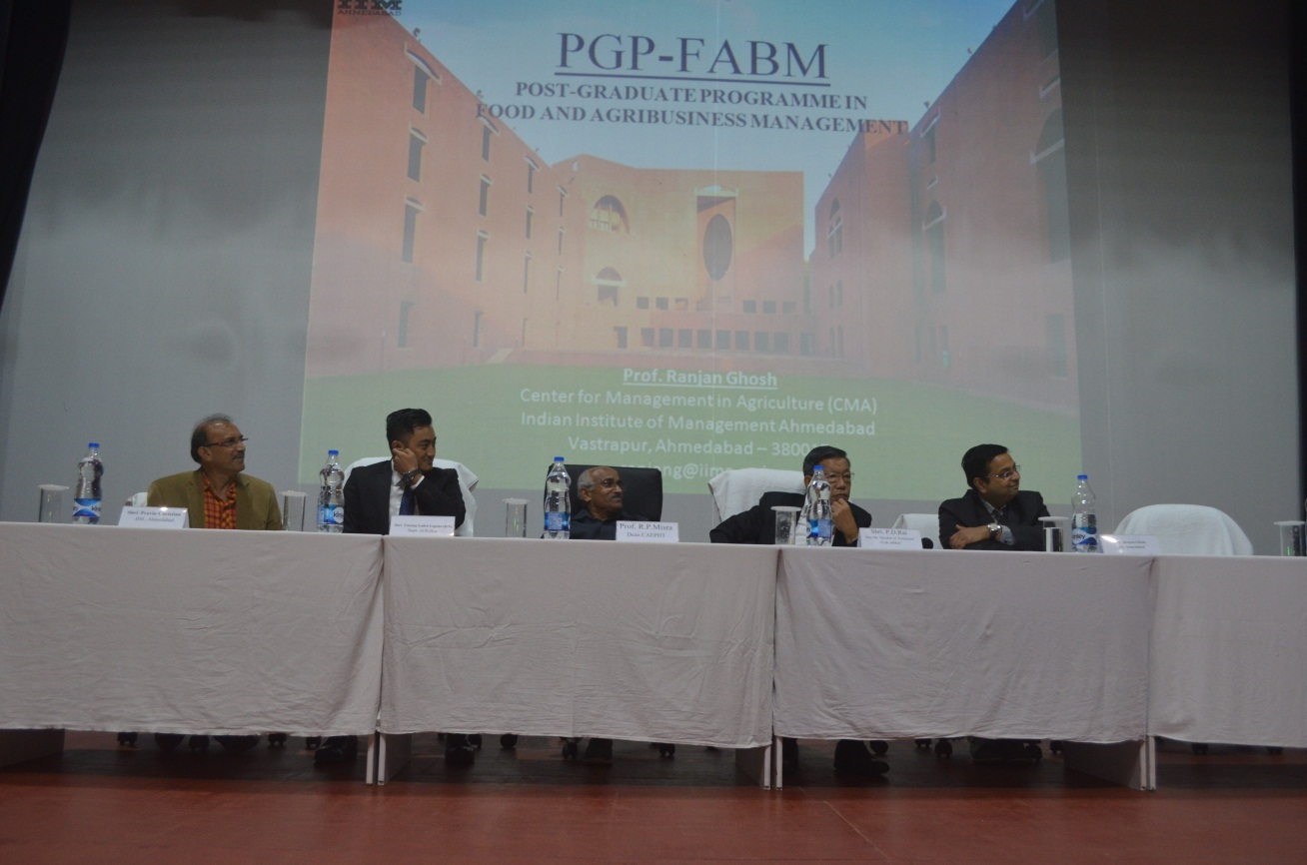

On the dais: (L-R) Mr. Pravin Christian, Programmes Officer, PGP – FABM, IIMA; Mr. Tenzing Lepcha (IPS), Supt. of Police, East Sikkim; Prof. R.P. Misra, Dean, CAEPHT; Mr. Prem Das Rai, Hon’ble Member of Parliament, GOI and Prof. Rajan Ghosh, Centre for Management in Agriculture, IIMA.

**August 23, 2017 | Ahmedabad**

The Indian Institute of Management Ahmedabad (IIMA) conducted a roadshow in two major educational institutions of northeast India, showcasing its post-graduate program in food and agri-business management (PGP-FABM). The purpose of the roadshow was to educate students about this unique management program, and answer any queries the students may have about it. These roadshows were conducted at College of Agricultural Engineering and Post-Harvest Technology (CAEPHT) in Gangtok, Sikkim and Assam Agricultural University (AAU) in Jorhat, Assam. Prof. Ranjan Ghosh, a faculty member at IIMA and program officials that run the day-to-day administration of this key program represented IIMA.

The roadshow at CAEPHT, on 14th August 2017 was special as IIMA was also represented by two of its illustrious alumni – Mr. Prem Das Rai, Hon’ble Member of Parliament, Government of India from Sikkim (1978 batch) and Mr. Tenzing Lepcha, the young and dynamic officer of Indian Police Service, who is currently serving as the Superintendent of Police, East Sikkim (2009 batch). Over 200 hundred students attended the event and interacted with the faculty and staff. Both Mr. Rai and Mr. Lepcha were kind enough to share their experiences with the students and patiently answered all the questions. Speaking at the event Prof. Ghosh emphasized the huge role food and agri-business sector plays in nation building and economic development. He highlighted the high demand for skilled managers in this sector who can work across the agri-food value chain and ensure high profits as well as re-distribution among farmers. *'Agri College in Sikkim. IIMA came to showcase Agri Mgmt Course. Very Uplifting. Many students should sit for CAT', tweeted Lok Sabha MP Mr. P.D. Rai immediately after the event.* *Prof. B.C. Kusre, faculty host and the Dean, Dr. R.P. Misra thanked IIMA profusely for reaching out to their students.*

In Assam Agricultural University (AAU), Jorhat, on the 17th of August 2017, Prof. Ghosh emphasized that with a little bit of awareness and smart preparation the dream of making into IIM Ahmedabad was very much achievable for students of North East. *'I was not even aware that PGP-FABM of IIMA is a niche program dedicated to management education in the agri-food sector and that with a background in agriculture and allied sector education, we stand a good chance to make it to the program', said Jagan Jyoti Barua, the student General Secretary of the college and a 4th year undergraduate student with an interest in a management career in the tea industry.* He echoed the sentiment of many others, of the over 100 students participating in the event at AAU, who were surprised to know about PGP-FABM ranked No.1 Masters in Management in the Food and Agribusiness sector in the world (by ranking agency Eduniversal, Paris). After the event, when asked by the Dean of the University Mr. D.K. Borah, many students said they will now seriously consider preparing for CAT and appear for the interviews for IIMA FABM programme. Announcing the event to be a huge success, the Vice Chancellor of Assam Agricultural University (AAU), Dr. K.M. Bujarbaruah, thanked Mr. Pravin Christian (Programmes Officer, PGP-FABM) for taking the initiative to organize the event and for a visit from far-off Ahmedabad.

Through these roadshows, IIMA once again displayed its commitment to quality management program that is relevant to all regions of India. More information about the program is available at: https://www.iima.ac.in/web/pgp-fabm/programme Interested students may reach out the PGP- FABM Office with further queries at [pgpfabm@iima.ac.in](mailto:pgpfabm@iima.ac.in)

**-End of Text-**

**For media queries, please contact:**

**Mr. Deepak Bhatt, Manager, Communications**

(Cell) +91-9426229429, (O) +91-79-66324683 Email: [mngr-comm@iima.ac.in](mailto:mngr-comm@iima.ac.in)

**Ms. Mitaaly Naidu, Executive, Public Relations**

(Cell) +91-7069074816, (O) +91-79-66324684, Email: [pr@iima.ac.in](mailto:pr@iima.ac.in)