

**PRESS RELEASE**

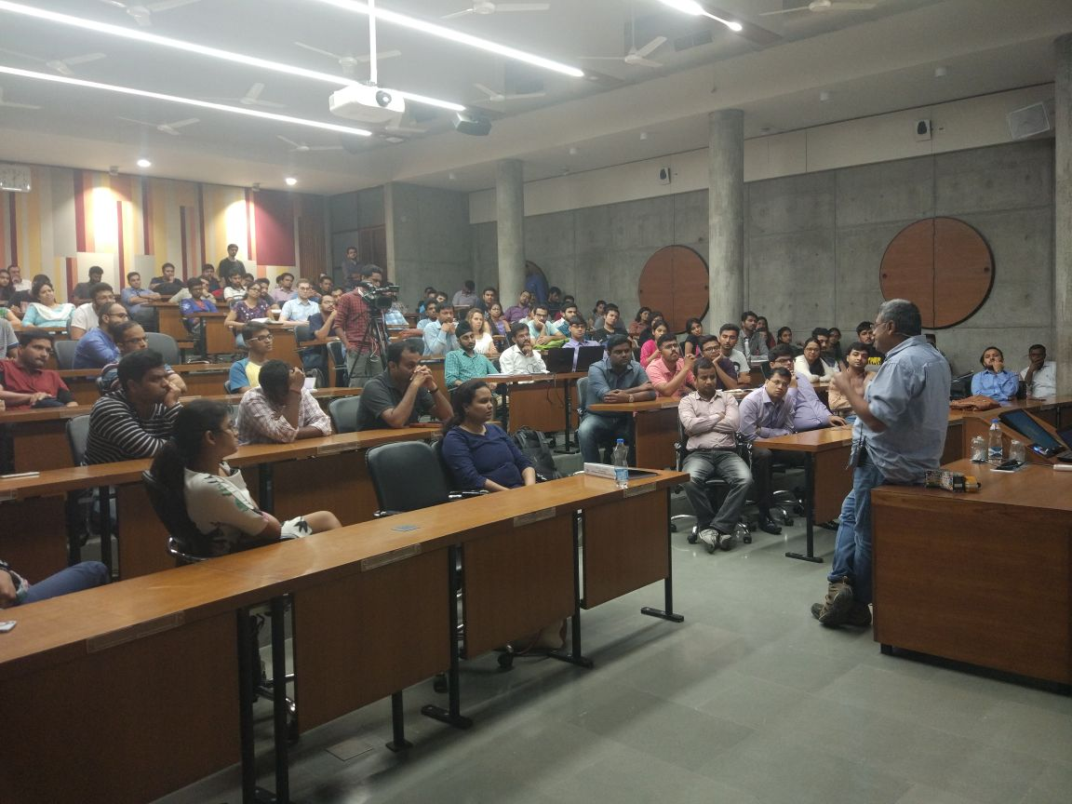**HTSAS 2.0 - Interactive session with Ambareesh Murty**

*Mr. Ambareesh Murty addressing an audience at IIMA*

**October 12, 2017 | Ahmedabad**

With the vision to impart the experiences and learning of seasoned entrepreneurs and investors to the entire country, the Entre cell at IIM Ahmedabad (IIMA) as part of it’s How to Start a Startup 2.0 series hosted Mr. Ambareesh Murty, founder and CEO of Pepperfry.com, India’s largest online furniture shopping company. An alumnus of IIM Calcutta, Ambareesh Murty has rich experiences working in the corporate industry including a stint as the Country Manager for eBay India, Philippines, and Malaysia. The interaction was held on October 4, 2017 and witnessed a packed house at PP Gupta Auditorium.

Beginning the talk with the rationale behind the name of the company, Mr. Ambareesh said that he along with his co-founder used pepper as they felt that it had a strong connect with the history of India and derived fry from “daal” which is made from pepper. Talking about the importance of the kind of people hired by the company, he said that the choices about what the organization stands for and what the culture is - will stay throughout the life of the company. Deciding that Pepperfry would employ the smartest, most passionate and hungriest people, Mr. Ambareesh attributed the success of the company to its employees.

Stating that the most important phase of a startup is when it receives its funding, Mr. Ambareesh said that this is the period when most startups falter and spend more. Quoting one of Kabir’s dohas to make his point, he said that if a startup is careful in this phase, then it will always be cash rich. Despite being cautious, Mr. Ambareesh admits that there have been instances when Pepperfry has made mistakes, and this has predominantly been due to the missing of details. Citing the example of a trek when it is essential to climb a few hundred meters down for every 1000m climb, he said that the business must sometimes take a hit for the greater good and improved growth in the long term.

The company faced innumerable challenges since its inception. Mr. Ambareesh said that the key to overcoming even seemingly insurmountable obstacles is to first realize that there is a problem and then continuously learn and evolve to solve the problem. Stressing the need to evaluate any issue dispassionately, he mentioned the specific instance of tightening headcount at the top to cut costs. Speaking of costs, Mr. Ambareesh strongly felt that any unnecessary cost, however big or small which doesn’t contribute to the business must necessarily be removed.

Speaking about a construct for any entrepreneur wishing to enter this market, Mr. Ambareesh talked briefly about the key pointers – catchment, consumers, community, content, and capabilities. Turning his attention to what makes a leader, he mentioned that a good leader always strives for continuous performance. Each time a peak is reached, a higher goal is set and this he said has been one of the reasons for Pepperfry becoming the first ever profitable B2C e-commerce company in India. He concluded by urging everyone to celebrate their milestones and enjoy all the right moments reminiscing the good times that the company had seen.

The floor was then open to questions from the audience. Questions ranging from why he started up so late in his career to why Pepperfry studios don’t sell furniture engaged the speaker and audience. In response to the latter, he said that the value proposition of Pepperfry was the variety which the company offered which would be lost if the studios started selling products without providing the large portfolio which the online platform offers. The session ended with Mr. Tapish Bhatt, Vice President of the Center for Innovation Incubation and Entrepreneurship at IIM Ahmedabad presenting Mr. Ambareesh with a memento thanking him for making the event a grand success

**-End of Text-**

**About Indian Institute of Management Ahmedabad (IIMA)**

Established in 1961, the Indian Institute of Management, Ahmedabad (IIMA) is recognized globally for excellence in management education. One of the top management schools in the world, IIMA educates leaders of the enterprises.

The Institute’s strategic priorities include: strengthening connection with its various constituencies, including academics, practitioners, alumni, and the community; nurturing a high performance work environment of stretch, autonomy, and teamwork; and strategic growth while maintaining emphasis on quality.

As per the latest ranking by *The Economist*, IIMA is No. 1 School in the world on the parameter of opening up new career opportunities for students. The flagship Post Graduate Programme (PGP) is ranked 16th in the *Financial Times* Masters in Management Ranking 2016. As per the *Financial Times’* Global MBA Ranking 2016, IIMA’s Post Graduate Programme for Executives (PGPX) is ranked 24th in the World. IIMA has been ranked as #1 Management institute as per the National Institutional Ranking Framework (NIRF) rankings of Ministry of Human Resource Development, Government of India.

For media queries, please contact:

|  |  |
| --- | --- |
| Umang Shah  HTSAS 2.0 Head (PGP-2)  Indian Institute of Management Ahmedabad  Ph: (Cell) +91-9870044780  Email: p16umangcs@iima.ac.in | Vaishnavi Kumar  External Media Relations (PGP-1)  Indian Institute of Management Ahmedabad  Ph: (Cell) +91-9654853483  Email: p17vaishnavi@iima.ac.in |