

**PRESS RELEASE**

**Day 3 of The Red Brick Summit at IIM Ahmedabad**

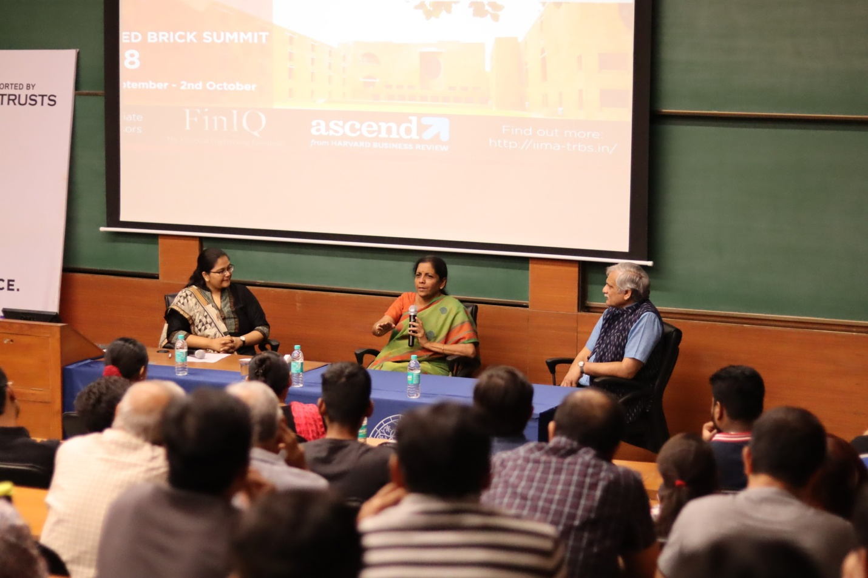

*Hon’ble Minister of Defense, Ms. Nirmala Sitharaman addressing a packed audience at IIMA*

**October 2, 2018 | Ahmedabad**

IIM Ahmedabad’s flagship management symposium, The Red Brick Summit (TRBS) continued on its third and penultimate day on October 1, 2018. The theme of the summit this year “Envision. Endeavor. Experience” was echoed in the variety of workshops, speaker sessions and events that were hosted. The day witnessed widely attended speaker sessions by two prominent women politicians of India, Ms. Nirmala Sitharaman, the Minister of Defence and Ms. Maneka Gandhi, the Minister for Women & Child Development. There were also workshops covering a gamut of themes from product management to marketing. Kaleido, the flea market at the fest, continued into its third day, selling an eclectic mix of items from indigenous entrepreneurs. Fusion navratri wear to modern wear, from skincare to house decor, from head to feet, everything under one roof. Many of the trinkets selling at Kaleido have been painstakingly designed and made by hand. The day ended with a performance by the Music Club of IIMA.

**Speaker Sessions:**

Hon’ble Minister of Defence, Ms. Nirmala Sitharaman, addressed a packed auditorium as part of the Women Leadership Summit hosted by the student-run body Women Leadership Society (WLS). The discussion was moderated by Ms. Ketki Gupta, a member of WLS. Ms. Sitharaman answered questions about her entry into politics, the representation of women in positions of power and being in charge of a male-dominated sector such as the Defence. Speaking about the barriers women face, she said that while women in India do face unequal challenges, “India is a lot more ready to accept women [in power] than many other countries”.

Ms. Maneka Gandhi, the Indian Union Cabinet Minister for Women & Child Development, Government of India was another speaker who graced The Red Bricks Summit a day before Mahatma Gandhi’s birth anniversary. Her interaction with the students was very informative and enriching. She talked about the intricate relationship of the environment, other animals and human beings, and how they are links of a symbiotic chain. She emphasised the importance of collective wellbeing and stressed the ever growing value of sustainable development. While taking a dig at the cruciality of harmonious living, she brought to notice the fact that all species be it humans or animals, are interdependent for their existence on this planet. Her speech was adorned with household examples and various instances that gave a deeper insight to all the listeners present at the event. Her valuable words will surely help tomorrow’s managers to strike a balance between business development and the environment.

**Workshops:**

Day 3 of TRBS had several workshops totaling a footfall of 400 people. The Product Management workshop hosted by Microsoft introduced the participants to the fundamentals of product management. Hosted by two industry veterans Mr. Vijay Rajagopalan & Mr. Venkateswaran Bharathan, the workshop went through Microsoft’s key areas of focus before deep diving into the role of a product manager.

There were two finance-related workshops. The first one hosted by Reliance Mutual Fund introduced the participants to the Indian economy from the perspective of an accountant and then went over the various kinds of investing techniques. The second one hosted by HDFC was a session on digital banking and innovation. The workshop highlighted the strides made by the various banks in AI, blockchain and customer experience as well as what the digital wave will bring to the banking sector.

Mad Over Marketing’s Siddhant More swept off his audience with his “MAD talk” which was an amazing take on the marketing and advertising trends that have evolved through the years and how the different brands have achieved it. He began the MoM workshop explaining what brands do to advertise. Attention, perception and message - these are the 3 key things that every advertisement should follow to strike a chord with its people. Advertising has evolved from descriptive and informative ads in the 1980s and 1990s to minimal advertising in the present years which rightly captures the attention of the crowd in a few seconds and manages to convey the right message too. Quoting numerous memorable ads, Siddhant went on to explain ambush marketing through the famous Cola Wars, and the Hindu v/s ToI ads. He spoke on e-commerce wars, Twitter brand wars and finally the evolution of marketing from jingles to breaking stereotypes. He gave an entertaining presentation along with great examples about Coca-Cola, Amul, Zomato and a number of marketing giants which the crowd loved a lot.

-End of Text-

**About Indian Institute of Management Ahmedabad (IIMA)**

*Established in 1961, the Indian Institute of Management, Ahmedabad (IIMA) is recognized globally for excellence in management education. One of the top management schools in the world, IIMA educates leaders of the enterprises.*

*The Institute’s strategic priorities include: strengthening connection with its various constituencies, including academics, practitioners, alumni, and the community; nurturing a high performance work environment of stretch, autonomy, and teamwork; and strategic growth while maintaining emphasis on quality.*

*The flagship Post Graduate Programme (PGP) is ranked 21st in the Financial Times Masters in Management Ranking 2017. As per the Financial Times’ Global MBA Ranking 2017, IIMA’s Post Graduate Programme for Executives (PGPX) is ranked 29th in the World. IIMA has been ranked as #1 Management institute as per the National Institutional Ranking Framework (NIRF) rankings of Ministry of Human Resource Development, Government of India. The postgraduate program in food and Agri Business (PGP-FABM) is ranked 1st in the Eduniversal Masters Ranking 2018*

For media queries, please contact:

|  |  |
| --- | --- |
| Kashika Lal  PR & Media Relations, TRBS (PGP-2)  Indian Institute of Management Ahmedabad  Ph: (Cell) +91-7838526332  Email: p17kashika@iima.ac.in | Ankita Saha  External Media Relations (PGP-1)  Indian Institute of Management Ahmedabad  Ph: (Cell) +91-9836550393  Email: p18ankita9@iima.ac.in |