

**PRESS RELEASE**

**IIM Ahmedabad welcomes the Third Batch of the**

**e-Mode Post Graduate Programme (ePGP*)**

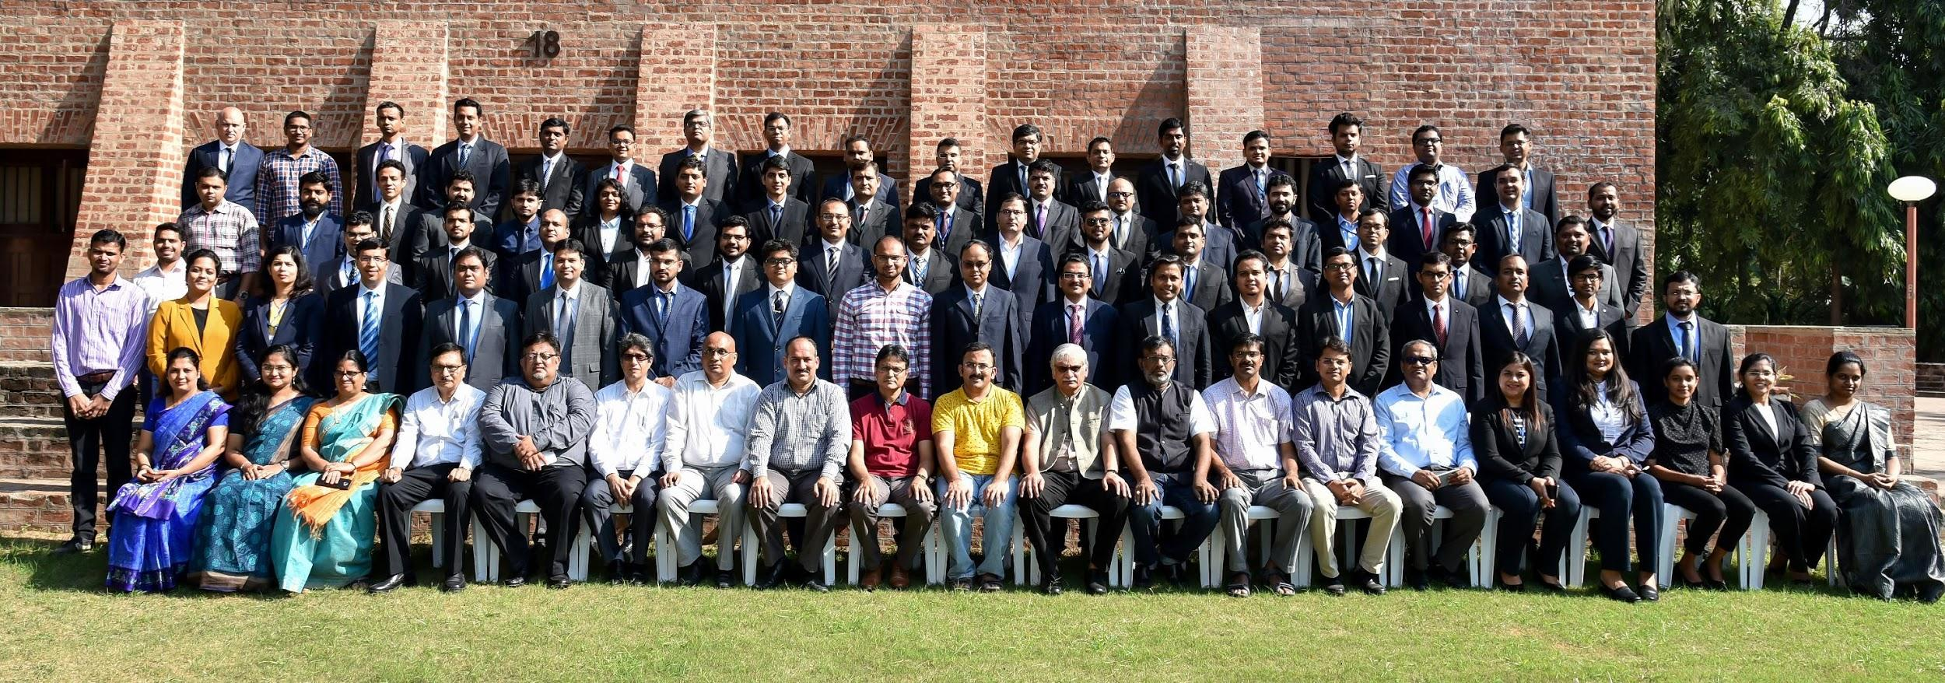

*Director, Chairperson ePGP, Faculty IIMA, ePGP Office and VCNow staff with ePGP 2019-21 Participants.*

**November 6, 2019 | Ahmedabad:**

IIMA is pleased to announce the launch of a third batch of its e-Mode Post Graduate Programme (ePGP). The launch of yet another high quality cohort batch demonstrates IIMA's deepening commitment in offering long-term hybrid management education courses. The ePGP is a hybrid learning programme, conducted through interactive live streaming sessions from study centers coupled with on-campus teaching at IIMA at regular intervals. The course also includes mentored individual and group project work. The comprehensive two-year course is designed for working executives and entrepreneurs.

The ePGP programme aims to enhancing strategic thinking and impart entrepreneurial as well leadership abilities required for taking organizations to the next level, while also advancing individual career aspirations. The innovative curriculum is designed by the faculty members of IIMA from their multi-faceted experience of having carried out research; consulting and advisory projects; in addition to teaching students and executives in long and short duration programmes around the globe. The pedagogy is benchmarked with the global standards in management education, thus providing participants with relevant experiential knowledge and decision making abilities.

The third batch of ePGP comprises of executives and entrepreneurs from 17 cities (between 24 to 48 years of age) with an increased gender diversity. The admitted students have an average of 10 years of work / entrepreneurship experience. They study in a uniquely designed technology enabled collaborative learning environment whilst holding on to their demanding professional roles. The flexibility of the ePGP programme attracts talented professionals from diverse backgrounds including Banking, Financial Services, Telecommunication, FMCG, Pharmaceuticals, Healthcare, Startups, Fashion Retail, IT and the armed forces.

The third batch of ePGP candidates have been selected by applying a rigorous selection process including qualifying tests and personal interviews. The third ePGP batch has 69 participants of which 70% hold BE/B. Tech. Degree. 28% percent of the participants have between 3-5 years of work experience, 30 % have 6-10 years of work experience, and 42 % candidates have more than 10 years of work experience. The 2019-21 batch of ePGP has 8 female candidates from Indian cities such as Pune, Mumbai, Gurgaon, Bangalore and Hyderabad participating in the programme.

*'e' stands for Electronic Mode.

**- End of Text**

**For media queries, please contact:**

**Deepak Bhatt, Manager, Communication**

Ph: (Cell) +91-9426229429, (O) +91-79-66324683, Email: [mngr-comm@iima.ac.in](mailto:mngr-comm@iima.ac.in)

**Mitaaly Naidu, Executive, Public Relations**

Ph: (Cell) +91-7069074816, (O) +91-79-66324684, Email: [pr@iima.ac.in](mailto:pr@iima.ac.in)