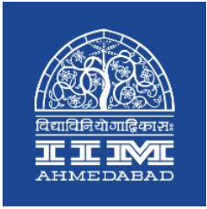

**PRESS RELEASE**

**A DAY AT IIMA ENDS WITH A SESSION WITH PRAYAAS STUDENTS**

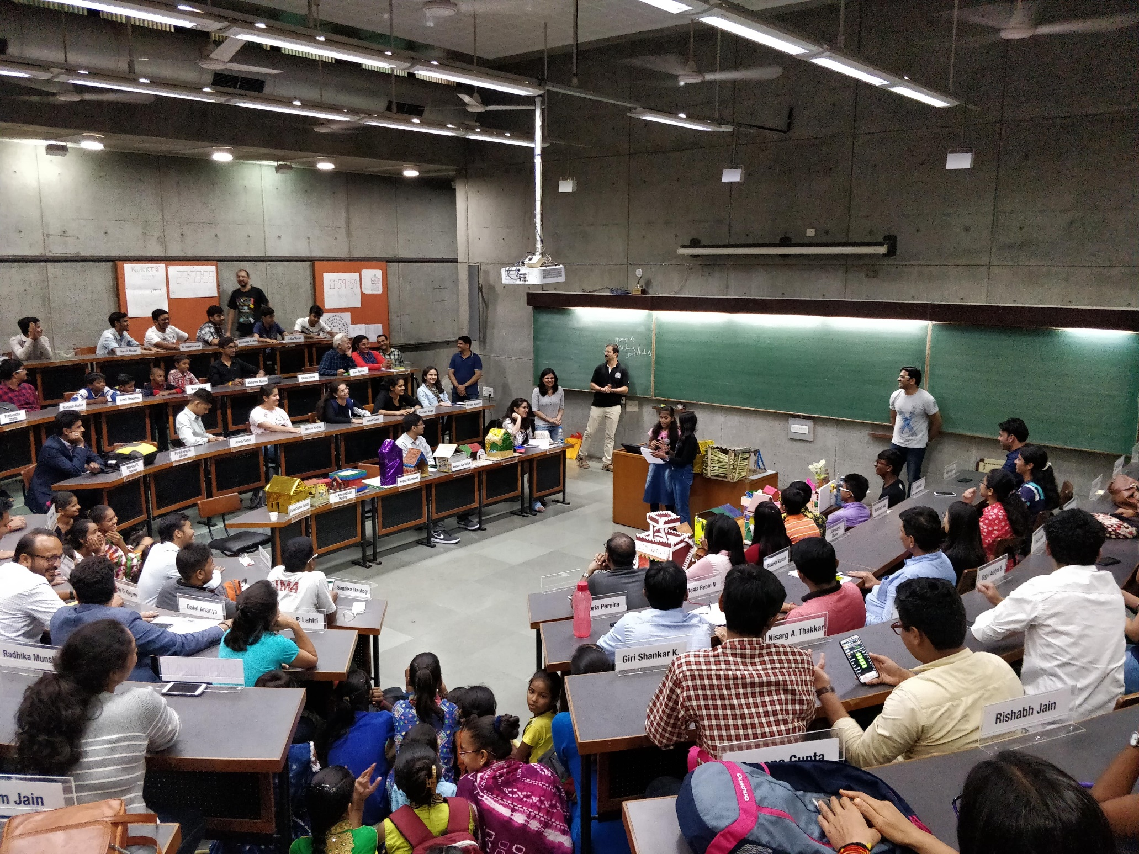

*Song Performance by Prayaas kids*

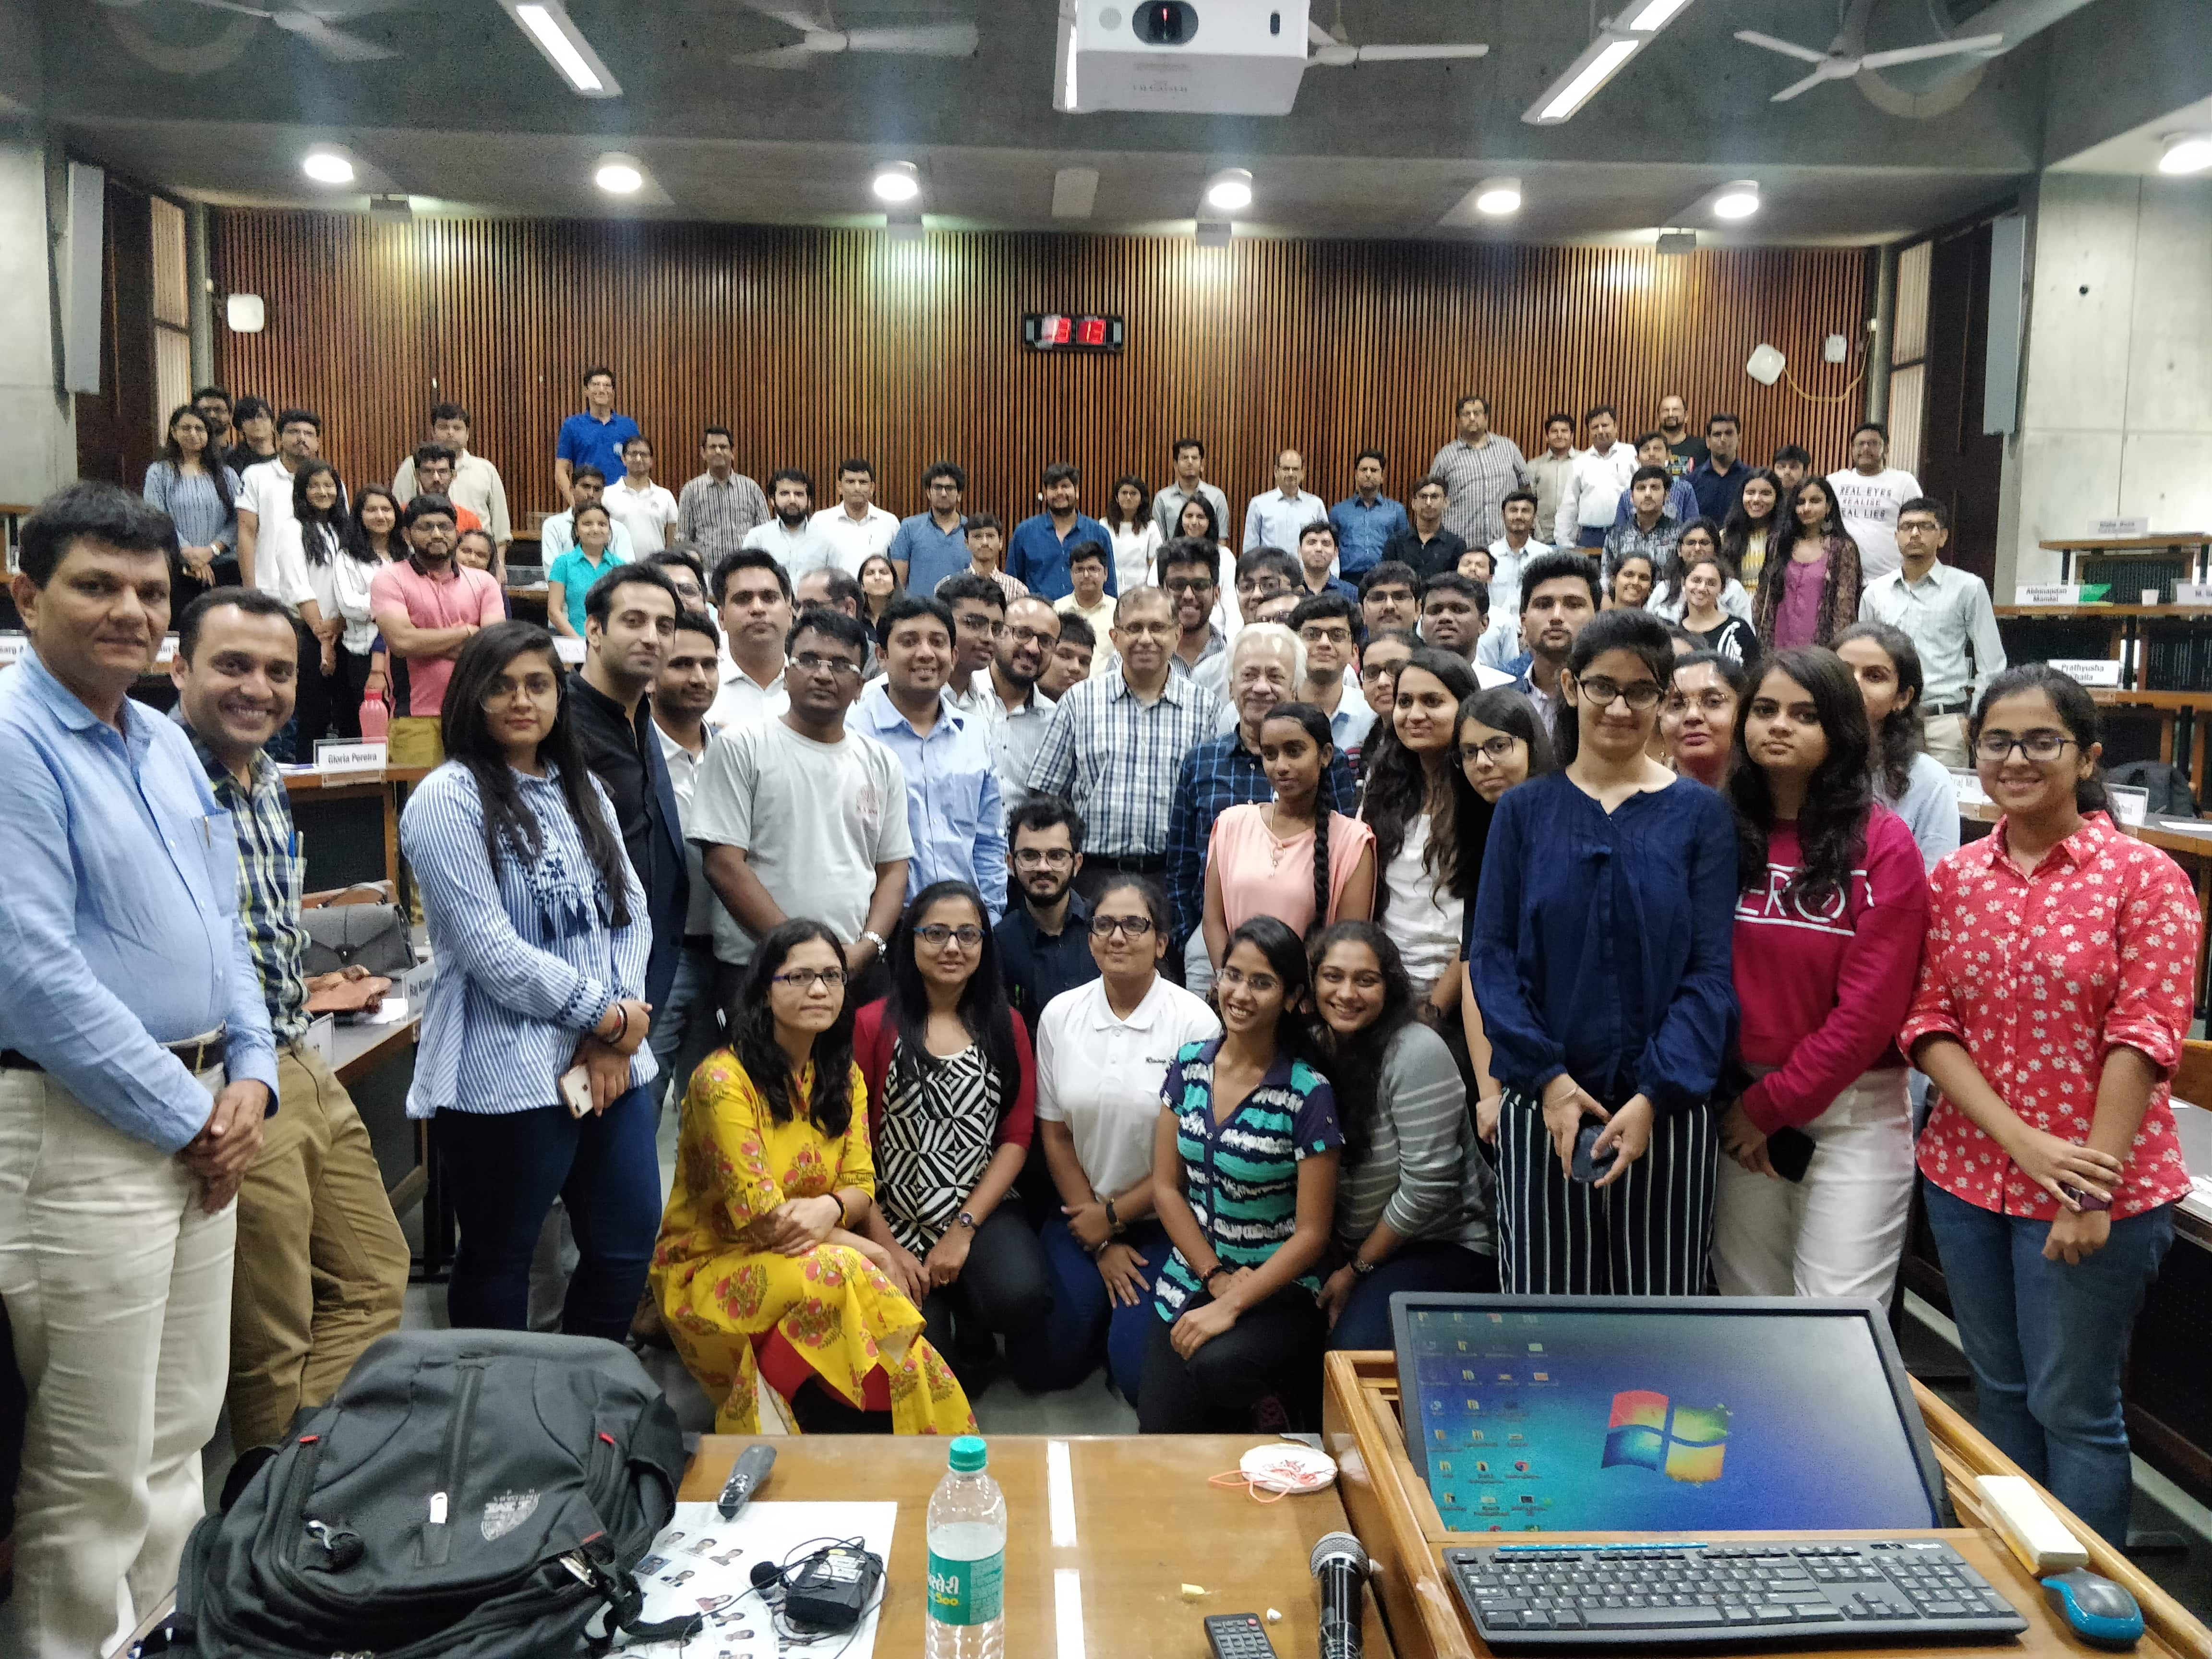

*Lecture on Marketing by Esteemed Faculty Member of IIM Ahmedabad*

**October 5, 2018 | Ahmedabad**

*“A day at IIMA was one of the best experiences of my life. I am convinced now that I will work extremely hard to make it through IIMA. Thank you Prayaas for giving me this wonderful opportunity and for all your efforts in brightening the future of these underprivileged kids,” said one of the participants at A Day at IIMA organized by Prayaas, social initiative at IIM Ahmedabad.*

**A DAY AT IIMA,** the annual flagship event organized by Prayaas witnessed a participation of 91 people this year. The participants were from diverse backgrounds and age groups. 60% were students from class 12th, pursuing undergraduate or post graduate courses and 40% were executives with 5 to 20 years of work experience, entrepreneurs, social workers, housewives, academic professionals among others, all wishing to witness the IIMA way of life. The participants experienced a mixture of academic rigor, group activities and a wonderful session with the underprivileged kids of Prayaas, social initiative at IIM Ahmedabad.

The day started with a tour of the heritage campus designed by Ar. Louis Khan and the new campus designed by Ar. Bimal Patel. The participants were then taken through a normal day in the life of a PGP1 student at IIMA. There were 4 lectures taken by esteemed faculty members – a session on Business Negotiations by Prof. Amit Nandkeolyar, a session on Business policy by Prof. Anurag Agarwal, a Marketing session by Prof. Arindam Banerjee and a session on Human resource management by Prof. Promila Agrawal. Just when the participants were saturated after 4 lectures, a surprise quiz was announced at 3:15 pm. The quiz ended at 4 pm. Finally, the participants got a sigh of relief.

The next 2 hours was full of fun activities and splendid performances by Prayaas kids – which included dance, songs, skit and speech as a tribute to Mahatma Gandhi on his 150th birth anniversary. Finally, the Prayaas kids showcased innovate models made by them on various topics like “Rain water harvesting”, “suicide prevention”, “Saving Energy”, “Natural or Green Home” among others. The participants later attended speaker sessions organized at The Red Brick Summit (TRBS) and shopped at the flea market of TRBS.

*“We had an open discussion with the participants during the break about how they felt, positives and areas of improvement. The overall response was terrific and we were asked to have this event more often than just once a year. The number of participants exceeded the capacity of the classrooms. They appreciated the event more because of the funds being used for Prayaas kids. We would like to thank the participants for their enthusiasm and spirit throughout the day and we believe that we matched their expectations. We had around 10% participants from class 11th and 12th and they brought in unique insights during classroom discussion. Apart from organizing the event more frequently, we have been requested to have one event specifically for all young and aspiring high-school students. Prayaas will look into it next year, “commented* ***Ankit Jain****,* ***the coordinator of Prayaas****, when asked about the event and response.*

-End of Text-

**About Indian Institute of Management Ahmedabad (IIMA)**

*Established in 1961, the Indian Institute of Management, Ahmedabad (IIMA) is recognized globally for excellence in management education. One of the top management schools in the world, IIMA educates leaders of the enterprises.*

*The Institute’s strategic priorities include: strengthening connection with its various constituencies, including academics, practitioners, alumni, and the community; nurturing a high performance work environment of stretch, autonomy, and teamwork; and strategic growth while maintaining emphasis on quality.*

*The flagship Post Graduate Programme (PGP) is ranked 21st in the Financial Times Masters in Management Ranking 2017. As per the Financial Times’ Global MBA Ranking 2017, IIMA’s Post Graduate Programme for Executives (PGPX) is ranked 29th in the World. IIMA has been ranked as #1 Management institute as per the National Institutional Ranking Framework (NIRF) rankings of Ministry of Human Resource Development, Government of India. The postgraduate program in food and Agri Business (PGP-FABM) is ranked 1st in the Eduniversal Masters Ranking 2018*

For media queries, please contact:

|  |  |
| --- | --- |
| Raghuram V  Media Secretary  Indian Institute of Management Ahmedabad  Ph: (Cell) +91-9800172995  Email: p17vraghuram@iima.ac.in | Ankit Jain  Coordinator, Prayaas (PGP-2)  Indian Institute of Management Ahmedabad  Ph: (Cell) +91-9989250044  Email: p17ankitjain@iima.ac.in |