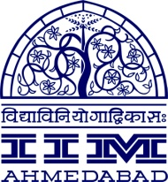

FOR IMMEDIATE RELEASE

IIM NAGPUR: SAD NEWS

January 8, 2017 (Sunday) Ahmedabad | Nagpur

With a heavy heart, IIM Nagpur and IIM Ahmedabad would like to share a sad news. In the early hours of Sunday, January 8, 2017 six IIM Nagpur students met with a tragic vehicle accident off campus.

Unfortunately, the driver and Mr. Durgesh Chauhan one of IIM Nagpur students passed away. The other students were rushed to hospital and are being provided medical care.

The thoughts and prayers of IIM Nagpur Students and Staff as well as IIM Ahmedabad community are with the students and their families.

For Media enquiries, please contact:

Deepak Bhatt  Manager, Communications  Email: mngr-comm@iima.ac.in  Phone: +91-79-66324683 | Mitaaly Naidu  Executive – Public Relations  Email: pr@iima.ac.in  Phone: +91-79-66324684

