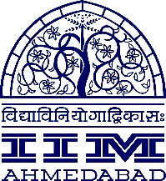

**Press Release**

A Legion of Ten

10 diverse profiles from the PGP 2020-22 Batch of IIM Ahmedabad

**October 16, 2020 | Ahmedabad**

The incoming batch of PGP 2020-22 invited by IIM Ahmedabad is the perfect amalgamation of assortment in recent years, in terms of gender diversity, educational background, work experience and extracurricular achievements. Besides that, the batch includes students who have achieved remarkable accolades in areas as unconventional as movie making, television media, sports, book publishing and the fashion world.

Here is a short introduction to some of the students of the 2020-2022 batch.

**Adya Niraj- Lawyer, Miss India Finalist**



A Bachelor of Arts L.L.B. with International Law Honours from National University of Study and Research in Law (NUSRL), Ranchi, Adya aims to work as a consultant aspiring to thrive in this sector. She also hopes to become an entrepreneur in the long term. Apart from being an institute rank holder during her under graduation, she was a Top-21 Finalist of Femina Miss India 2016 aired on Colors TV and Zoom. She was also the runner up to Femina Miss India Kolkata 2016 aired at Zoom. Post that, she worked as a model for many brands like Amazon India, Lakme Fashion Week, Elle, Big Bazaar amongst others. She also hosted several shows. Apart from these, she also has a Senior Diploma in Kathak and has been performing on stage for the last 12 years.

**Ipshita Rhea Peters- Literature Graduate, Award Winning Author**

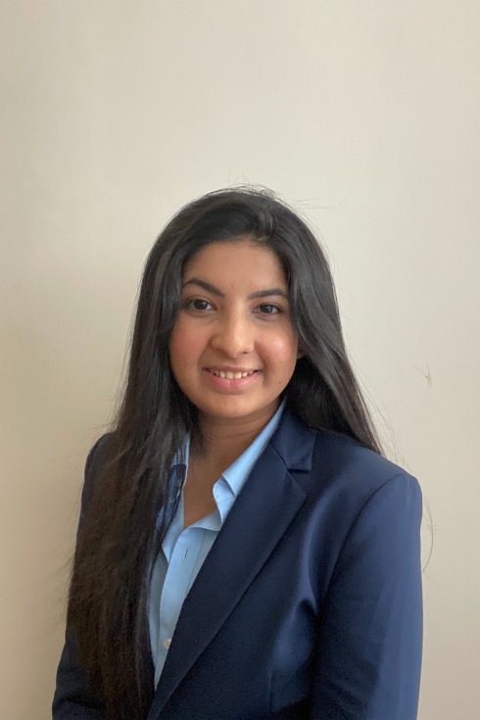

Having graduated from St. Xavier's College as a Bachelor of Arts (English Literature). Ipshita discovered a passion for digital marketing & content while working at Nykaa and ZebPay. She chose to do an MBA to further her career and gain all the necessary skills and formal management training to excel in her chosen field. Ipshita hopes to work in a field that is both creatively stimulating and intellectually challenging. She hopes to start her own venture someday and would like to create something innovative and unique in whichever domain she specialises in. An avid writer, Ipshita was a winner of the national iGenius Young Author's Hunt 2013. Her winning story was published in an anthology by Rupa Publications and is available for purchase across India.

**Palak Mishra- Social Worker, Political Science Graduate**

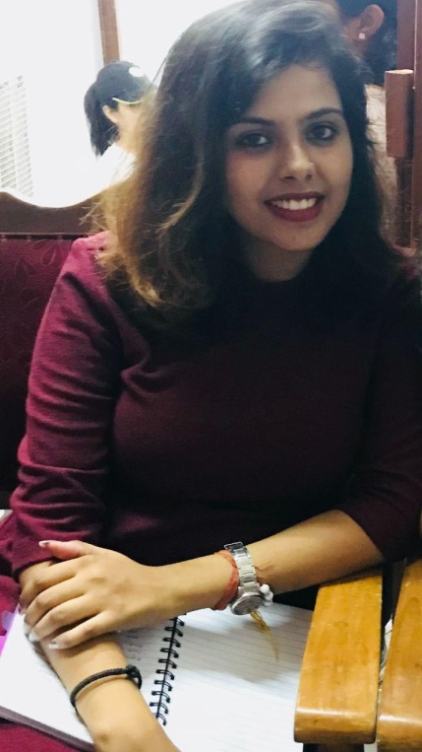

A Political Science Graduate from Banaras Hindu University, Palak was a core-member of an NGO working towards child education and health. She helped initiate the concept of smart class in two villages and also working towards establishing a library for the village kids. She is passionate about writing and has contributed articles to the Hindustan Times for nearly a year. For the next two years, she wants to focus on peer-to-peer learning to get a deeper insight of management. In a long-term goal she aims to do something which adds value to the society, since this was the motive of her shifting from social science to management. Being a culturally driven person, she would love to incorporate culture and society in the work that she does.

**Shefali Chhaya- Television Anchor, Tourism Graduate**



Having graduated in Bachelor of Arts (Tourism Administration) from Amity University Noida, she has a work experience of two years in Tourism and Media Industry. During her college, she was an active student who was involved in cultural activities since she is a trained Kathak dancer. She was also involved throughout in her corporate extracurricular activities wherein she participated in various events related to the Travel & Hospitality industry. Later she switched to Doordarshan Sports where she worked in the Social Media team and is also a television anchor for various shows on different Doordarshan channels with TRP of more than 80+ lakhs.

**Anushree Naik- C.A., Certified Graphologist**

A Chartered Accountant, who has also cleared her CS Executive, Anushree never wanted to restrict herself only to primary accounting and auditing responsibilities. She has always wanted to be skilled at decrypting the bigger picture and has been looking forward to learn the skill and art of management adding value to her role in the organisation in future. She is a certified graphologist and an examiner at the Institute of Graphological Research. A lifestyle blogger on self enhancement and career guidance, she has also been the delegate to the German Exchange Program organised by Ferdinand Porsche Gymnasium Zuffenhausen, Stuttgart.

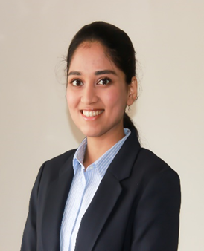

**Aayush Redij- Mass Media (Advertising) graduate**

Aayush has been working since he was 16, first in the form of various internships at Viacom 18, The Times of India and several others. This has made him realize that his true love lies in marketing. Now, he wants to make a shift to the branding vertical with an aim to create space for himself in the branding industry in the long run. He aspires to help brands keep up with the constant change in the business environment. He is a licensed scuba diver and loves playing various sports, ranging from football to tennis in school to baseball and softball to handball in college.

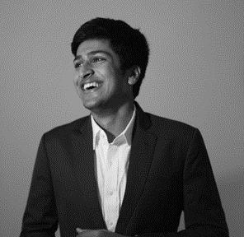

**Tanya Gupta- Fashion Technology Graduate**

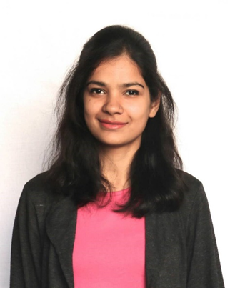

A fashion technology (apparel production) graduate from National Institute of Fashion Technology (NIFT) Delhi, she has worked with Must Garments Corp. Ltd.-Sidney Apparels as an assistant IE manager in Oman and Jordan, being the only girl in the entire Industrial Engineering department. She believes that a master’s degree in management would open opportunities to use her practical and technical expertise to lead an organization and make possible changes in the system bringing further standardization. During her final year, she designed and implemented an automatic shade marking machine (patent under process), which was the first of the kind in the industry saving 50% of the existing cost. The project was also awarded as the ‘Most Commercially Viable Project’ award.

**Sandeep Rajguru- Media Studies graduate, State level Baseball player**

A media studies (Audio Visual Production) graduate from Symbiosis Institute of Media and Communication, Sandeep has worked as a producer at various production houses in the last 4 years. He has always wanted to eventually run a business and feels that his skill sets as a producer has helped him learn a ton about how the creatives in the media industry work. In this regard, he wants to develop foundational business acumen to put himself in a good position to be able to lead businesses in his career. He aspires to learn from people and businesses who have made a mark in the industries, so that, he can create economic and social value in the society. Apart from that, he is a state level baseball player and has won several district level debate competitions.



**Tanishq Diddee- National Level Swimmer**

A chemical engineer from NITK Suratkhal with a work experience of 3 year in energy sector, he aims to work with organisation with similar focus. Tanishq is also a national level swimmer, who has been passionate about it since childhood. He won two medals in the Under 16 and Under 19 categories at the National Level and led division team in the Maharashtra State Waterpolo Championship. Recently completed a few half marathons and finished top 50 in an International Marathon. Post-graduation from IIM Ahmedabad, his final goal is to transform the energy sector to create a net-zero carbon emission world to achieve the Paris Accord goal.

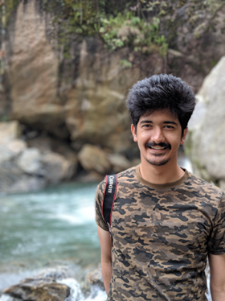

**Anushka Tamta- Economics Graduate**

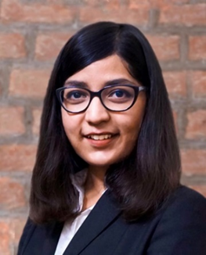

A Bachelor of Arts (Economic Honours) degree from Shri Ram College of Commerce, during graduation she was actively involved in dramatics and did various street plays to influence the society of major issues. Before coming to IIM Ahmedabad, she worked as a financial analyst for 27 months in TresVista. In the next 2-3 years, she wants to explore different options available in various industries and functions.

**About IIMA:**

Indian Institute of Management Ahmedabad (IIMA) is a premier B-school in the Asia Pacific region. Globally, the Institute's programmes have earned high reputation and acclaim, becoming the first Indian institution to receive international accreditation EQUIS. Founded in 1961 as a unique public-private partnership for development through the application of knowledge, today it has overseas presence in Dubai and associates with over 80 foreign B-schools to offer academically superior, market-driven and socially impactful programmes, research and consultancy services. In 2018, IIMA made it to the number four position in the Financial Times (FT) Asia Pacific Top 25 Business School Rank, ahead of all Indian B-Schools. FT conducted the ranking after considering the quality and breath of all the B-schools programmes. Over the last several years, IIMA is the only Indian B-school to feature in the reputed Economist ranking and emerged at number one position in India Ranking 2020 NIRF (National Institutional Ranking Framework), released by the Ministry of Human Resource Development, Government of India.

Over the years, IIMA has benefited more than 38,000 alumni who graduated from its various programmes. Currently, besides its renowned flagship Two-year Master in Business Administration (MBA), earlier known as Post Graduate Programme in Management (PGP); the Institute continues to draw top-quality students to its PhD Programme in Management, MBA in Food and Agri-Business Management (FABM), MBA-PGPX (One-Year Full-Time Post Graduate Programme in Management for Executives), Faculty Development Programme (FDP), Armed Forces Programme (AFP), e-Post Graduate Programme (ePGP), e-Post Graduate Diploma in Advanced Business Analytics (ePGD-ABA), and benefits industry professionals through its short duration Executive Education Programmes.

**MEDIA CONTACT**

|  |  |
| --- | --- |
| **Goldy Admane**  Media Secretary  Indian Institute of Management, Ahmedabad p19goldy@iima.ac.in +91-7758962987 | **Lakshay Singla**  External Media Relations  Indian Institute of Management, Ahmedabad  p19lakshay@iima.ac.in  +91- 8860105252 |