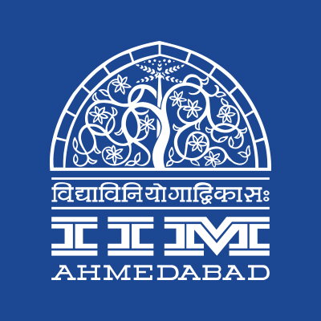
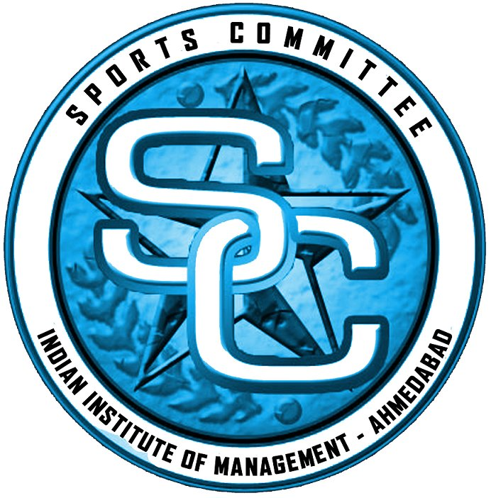

PRESS RELEASE

IIMA to host Inter-College sports event – ‘Shaurya’
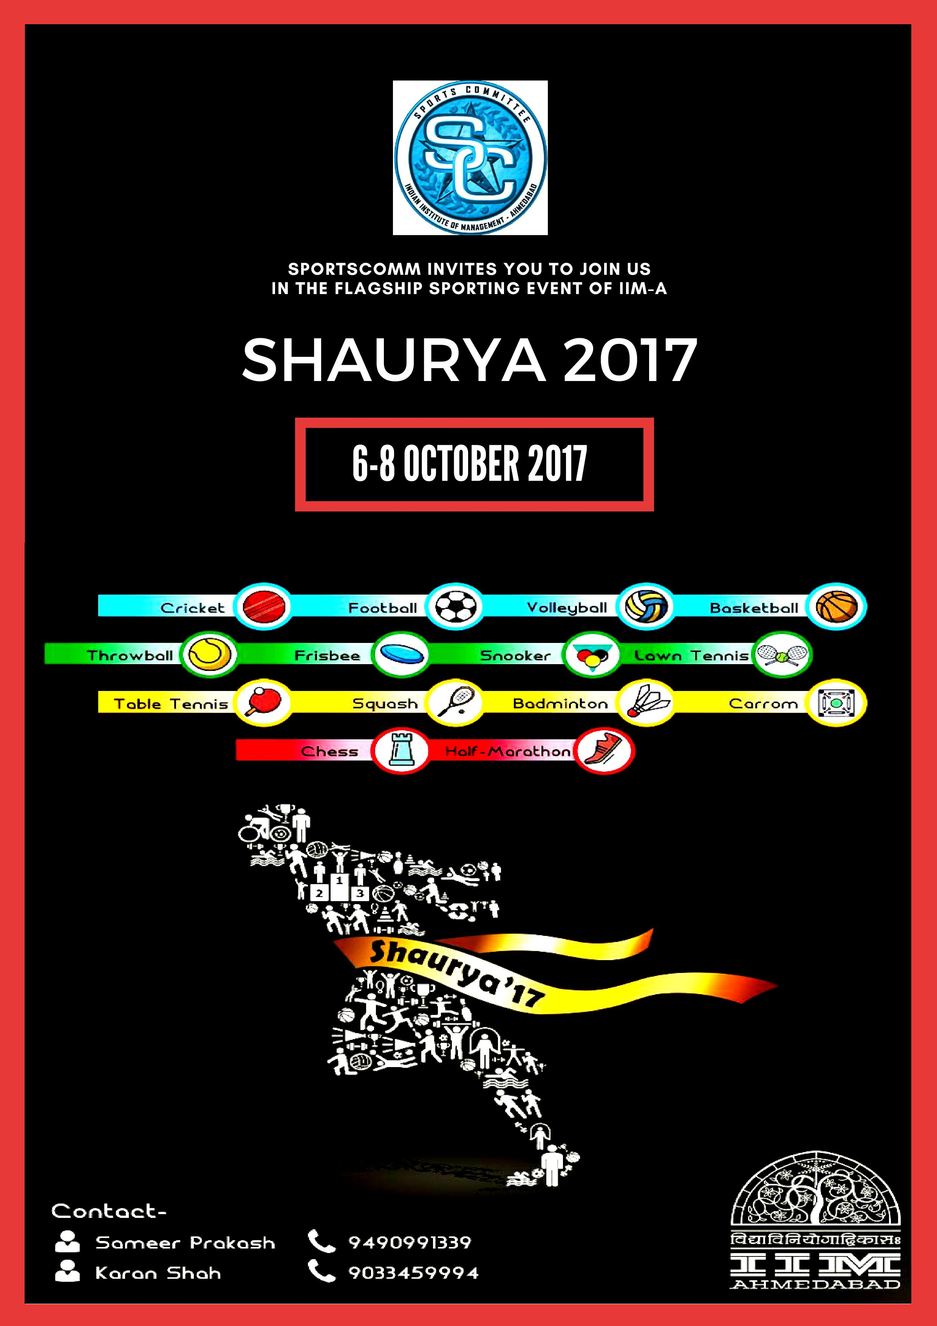
October 5, 2017 | Ahmedabad
Students of the Indian Institute of Management, Ahmedabad (IIMA) are coming together to celebrate the spirit of sportsmanship. The Sports Committee of IIM Ahmedabad is organizing an inter-college sports competition, Shaurya from October 6, 2017 to October 8, 2017. The objective of Shaurya is to push sports beyond the corridors of the college and engage with the sporting community outside IIMA. The event has attracted over 1700 registrations from the student community from over 30 institutes. It has witnessed registrations from colleges from all over India including the likes of IIFT- Delhi, IMT- Ghaziabad, and NMIMS Bangalore. The event is spread across three days, and the Sports committee is expecting a footfall of over 10,000.
The event will seek the participation of the students in 18 different games including popular sports like cricket and football and fringe sporting events like Snooker and Frisbee. While Basketball, Badminton, Volleyball, and Table Tennis have separate teams for women, other sports such as Chess, Carrom, Frisbee and Lawn Tennis shall witness participation from Mixed Teams. The various sports competitions are expecting to have more than a dozen teams compete for the final prize.
Frisbee is the ‘most- played’ sport at IIM Ahmedabad and almost has a cult-like following among the IIM Ahmedabad students. The sporting event is eagerly awaited and Shaurya – 2017 has garnered a lot of attention from Amdavadis over social media. The Facebook page of the event has already put up photographs of the teams representing IIM Ahmedabad in various sports competitions.
The event is expected to be met with a lot of exuberance and zeal this year. The total number of participating colleges has gone up by 50% this year and the alumni batches from the past five years have also come forward and agreed to take part in the events.
Sameer Prakash Uppada, Sports Secretary, IIM Ahmedabad said, “We are looking at increased participation this year. This was primarily made possible because of the support we have received from our external sponsor Vector X. Our immediate focus will be on ensuring that the participating teams enjoy their stay here. We hope to strengthen relationships with all participating colleges through this event.”
More details can be found at https://www.facebook.com/sportscomm.iima/
-End of Text-
About Indian Institute of Management Ahmedabad (IIMA)
Established in 1961, the Indian Institute of Management, Ahmedabad (IIMA) is recognized globally for excellence in management education. One of the top management schools in the world, IIMA educates leaders of the enterprises.

The Institute’s strategic priorities include: strengthening connection with its various constituencies, including academics, practitioners, alumni, and the community; nurturing a high performance work environment of stretch, autonomy, and teamwork; and strategic growth while maintaining emphasis on quality.

As per the latest ranking by The Economist, IIMA is No. 1 School in the world on the parameter of opening up new career opportunities for students. The flagship Post Graduate Programme (PGP) is ranked 16th in the Financial Times Masters in Management Ranking 2016. As per the Financial Times’ Global MBA Ranking 2016, IIMA’s Post Graduate Programme for Executives (PGPX) is ranked 24th in the World. IIMA has been ranked as #1 Management institute as per the National Institutional Ranking Framework (NIRF) rankings of Ministry of Human Resource Development, Government of India.

For media queries, please contact:
Sameer Prakash Uppada  Sports Secretary (PGP-2)  Indian Institute of Management Ahmedabad  Ph: (Cell) +91-9490991339  Email: a16sameeru@iima.ac.in | Balaji Uppala  Media Secretary (PGP-2)  Indian Institute of Management Ahmedabad  Ph: (Cell) +91-7042705642  Email: p16srimukhab@iima.ac.in

