

Press Release

**The 15th Batch of MBA-PGPX was e-inaugurated at IIMA**

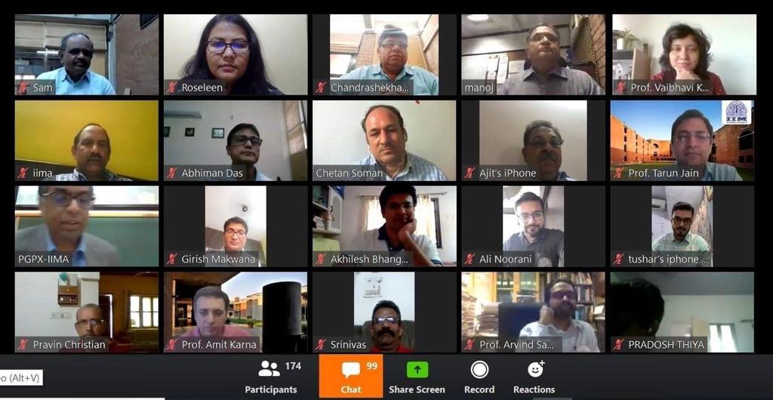

**IIMA Professors and Staff addressed the new batch via e-mode**

**April 22, 2020 | Ahmedabad**: The 15th batch of the Indian Institute of Management, Ahmedabad (IIMA)’s One-year Full time residential Post Graduate Programme in Management for Executives (MBA-PGPX) for 2020-21 was e-inaugurated today by Director, Prof. Errol D’Souza, and welcomed by Prof. Viswanath Pingali, Chairperson, MBA-PGPX and Prof. Shailesh Gandhi, Dean - Programmes amidst the current COVID lockdown. All the new batch students were greeted by IIMA Professors via e-mode for their introductory session.

*Speaking on occasion, Professor Viswanath Pingali, Chairperson, MBA-PGPX said, “Academic rigor and mental discipline would determine success in this program. Keeping in view the overall structure of the program, we decided to take a small portion of Term 1 online. This will enable the students to hit the ground running when the campus classes eventually begin. Looking at the profile of the current batch, I feel very confident that the batch will take the programme to newer heights.”*

This year too, gender diversity was on the rise (table is given below). Other than the increase in gender diversity, the current batch is also very diverse in terms of NRI students (9.29% are residing outside India, spread across eight countries) and international work-experience (36% of the batch has worked abroad before joining MBA-PGPX).

**Data for MBA-PGPX Programme: Women students**

|  |  |  |
| --- | --- | --- |
| **Batch** | **Percentage of Women Students** | **Batch Total** |
| 2017-18 | 25% | 115 |
| 2018-19 | 17% | 138 |
| 2019-20 | 23% | 140 |
| 2020-21 | 28% | 140 |

*Shruti Shekhar, Student of new the 2020-21 MBA-PGPX, IIMA said, Diamonds are a product of high stress and pressure. The PGPX course that is demanding even under normal circumstances promises to shape us into something far tougher than ever before. Being resilient in the face of calamities, adapting in the times of uncertainty, and strength to chart our course into the unknown future ahead are qualities that IIM Ahmedabad will ingrain into us this year. There is no taking away the fact that we, the class of 2021, are the “Covid Batch”. It is a badge that I will wear with pride.*

Launched in 2006, more than 1500 students have graduated from MBA-PGPX so far. ​Till 2016-17, the MBA-PGPX intake was 90, and from 2017-18, the institute added one more section to enhance the learning experience of participants. ​With the overwhelming response, we have continued the extra section and accordingly, 140 students since last year.

The 2020-21 batch has an average GMAT score of around 690 and GRE score of 317, the average age of about 31 years and seven months, average total work experience of 8.6 years, and average international experience of approximately a year and half years. ​ ​

**About IIMA:**

The Indian Institute of Management Ahmedabad (IIMA) was set up as an autonomous institution in 1961 by the Government of India in collaboration with the Government of Gujarat and the Indian industry. IIMA is the first management school in India to receive international accreditation for five years. It was the first business school in India to receive EQUIS (European Quality Improvement System) accreditation, by the European Foundation for Management Development (EFMD) in June 2008 and has maintained EQUIS accreditation since then.

In 2018, IIMA made it to the number 4 position in the Financial Times (FT) Asia Pacific Top 25 Business School Rank, ahead of all Indian B-School. FT conducted the ranking after considering the quality and breath of all the B-schools programmes. In addition, it has been ranked 19th in the Financial Times (FT) Masters in Management Rankings 2018 and 31st in the FT (Financial Times) Global MBA Ranking 2018. Over the years, the Post Graduate Programme in Food and Agri-business Management (PGP-FABM) of IIMA has been ranked number one globally in its category in the Eduniversal Best Masters’ Ranking in Agribusiness/Food Industry Management.

IIMA features at the top position in the India Ranking 2018 (National Institutional Ranking Framework) released by the Ministry of Human Resource Development (MHRD), Government of India.

For any clarifications please contact:

**Mr. Deepak Bhatt**

Manager, Communication, IIMA

Ph: (Cell) +91-9426229429, (O) +91-79-71524683

Email: [mngr-comm@iima.ac.in](mailto:mngr-comm@iima.ac.in)

**Ms. Mitaaly Naidu**

Executive, Public Relations, IIMA

Ph: (Cell) +91-7069074816, (O) +91-79-71524684

Email: [pr@iima.ac.in](mailto:pr@iima.ac.in)