

**PRESS RELEASE**

**Professionals join IIMA’s PGP Programmes**

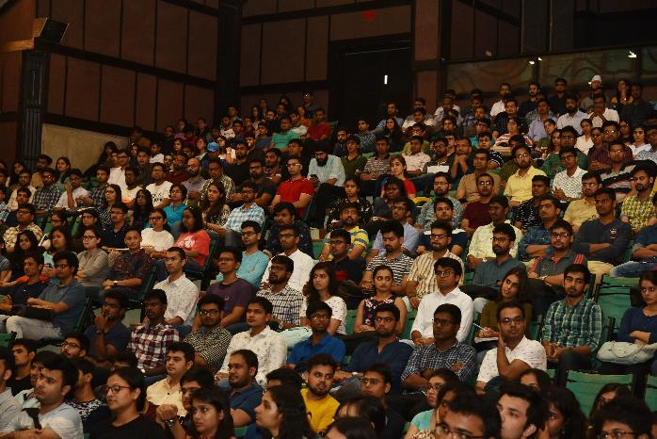

The PGP and PGP-FABM inauguration day

**June 20, 2019 | Ahmedabad:** IIMA welcomed the new batch (2019-21) of PGP and PGP-FABM on June 16, 2019.

***Professor Errol D’Souza, Director****, IIMA said, “We, at IIMA are delighted that in selecting potential future leaders who can contribute to their own and their colleagues’ growth and learning, we have also achieved a diverse mix in the entering class. In a discussion-based learning environment, such as ours, diversity of participants’ backgrounds, their experience and inclusivity of the institution’s culture contribute significantly to a positive learning environment.”*

This year, we saw a consistent and steady rise in students with work experience of 13 – 36 months joining PGP Programme, even with the increase in batch size in 2018.

***Professor Vishal Gupta****, Chairperson, Admissions, IIMA, explains “Our admissions policy helps us admit students with diverse perspectives to contribute greatly to the discussion-based learning that we employ at IIMA. This is part of a conscious effort to improve the in-class learning experience of students, who we believe would benefit from being in class with people from diverse background.”*

**Data for PGP Programme: Work Experience students**

|  |  |  |
| --- | --- | --- |
| Batch | Work Experience | Percentage |
| 2019-21 | 13-36 months | 49% |
| 2018-20 | 13-36 months | 45% |
| 2017-19 | 13-36 months | 38% |

The PGP Programme saw a slight dip in the otherwise steady growing strength of female students, with this year’s batch having 24% of women strength to support last year’s digits.

***Professor D’Souza*** *added, “We are conscious about the efficacy of increasing the percentage of women entering our class. The achievements are slow as the goal is to not give extra credits or specify a quota for gender or other diversity attributes in the admissions process.”*

**Data for PGP Programme: Female students**

|  |  |  |
| --- | --- | --- |
| Batch | Batch Total | Percentage of  Female Students |
| 2019-21 | 388 | 24% |
| 2018-20 | 399 | 27% |
| 2017-19 | 395 | 28% |

***Manasi Susarla****, Student of PGP batch 2019-21 with a background in Journalism and Communication said, "Having dealt with fast-paced businesses on an everyday basis and driven communication strategies for them for almost two years now, I have developed a keen interest in how businesses, in their entirety, function and grow.*

*My undergraduate course in Communication Studies gave me a wider perspective as it involved various facets of organisational behaviour, internet and new media, human communication, and media research and criticism. Soon after, my stint at Adfactors PR helped me gain in-depth knowledge of how and why businesses communicate with different stakeholders. Now, my key objective behind pursuing this programme is to learn all aspects of managing and strengthening a business while also obtaining necessary industry knowledge and expertise. I believe that a programme in Management, at this stage, will provide me with deeper expertise in other aspects of managing a business. Further, the diverse peer group here at IIMA coupled with encouraging faculty, an illustrious alumni network, and the unique pedagogy, will enable a holistic learning environment for me to achieve my goal of becoming a successful business professional."*

PGP-FABM programme, the world’s top-rated programme in agri-business for last three consecutive years, also had a diverse entering class of forty-six students. This year saw a leap in students from agriculture background with a slight fluctuation in students with Food/Dairy Technology background.

**Data for PGP – FABM Programme: Agriculture Background**

|  |  |
| --- | --- |
| **Batch** | **Percentage** |
| 2019-21 | 48% |
| 2018-20 | 35% |
| 2017-19 | 15% |

**Data for PGP-FABM Programme: Food/Dairy Technology Background**

|  |  |
| --- | --- |
| **Batch** | **Percentage** |
| 2019-21 | 26% |
| 2018-20 | 39% |
| 2017-19 | 9% |

***Danish S. Mehta****, Student of PGP-FABM batch 2019-21, "I come from a farmer-family in Haryana. From the very beginning of my professional endeavors, I had a keen interest in the field of agriculture and wanted to have my own agri-business. My undergraduate course B.Sc (Hons.) Agriculture from CCS Haryana Agricultural University taught me in depth about the operational nuances of agriculture as a livelihood and what importance it holds in our country.*

*Food and Agribusiness sector particularly holds a vast growth potential keeping in mind that agriculture concerns about 70% of the country's population. The PGP-FABM at IIM Ahmedabad is consistently amongst the world’s best rated management programmes in food and agribusiness sectors*

*My key objective behind pursuing this programme is to learn all the aspects of managing and strengthening a business while also obtaining necessary industry knowledge and expertise. I believe that the programme in Management, at this stage, will provide me with an all the required expertise in other aspects of managing a business.*

*Further, the diverse peer group here at IIMA coupled with the highly experienced and encouraging faculty, an illustrious alumni network, and the unique pedagogy, will enable a holistic learning environment for me to achieve my goal of becoming a successful business professional."*

- End of Text

**For media queries, please contact:**

**Mr. Deepak Bhatt**

Manager, Communication

Ph: (Cell) +91-9426229429, (O) +91-79-66324683

Email: [mngr-comm@iima.ac.in](mailto:mngr-comm@iima.ac.in)

**Ms. Mitaaly Naidu**

Executive, Public Relations

Ph: (Cell) +91-7069074816, (O) +91-79-66324684

Email: [pr@iima.ac.in](mailto:pr@iima.ac.in)