

**Press Release**

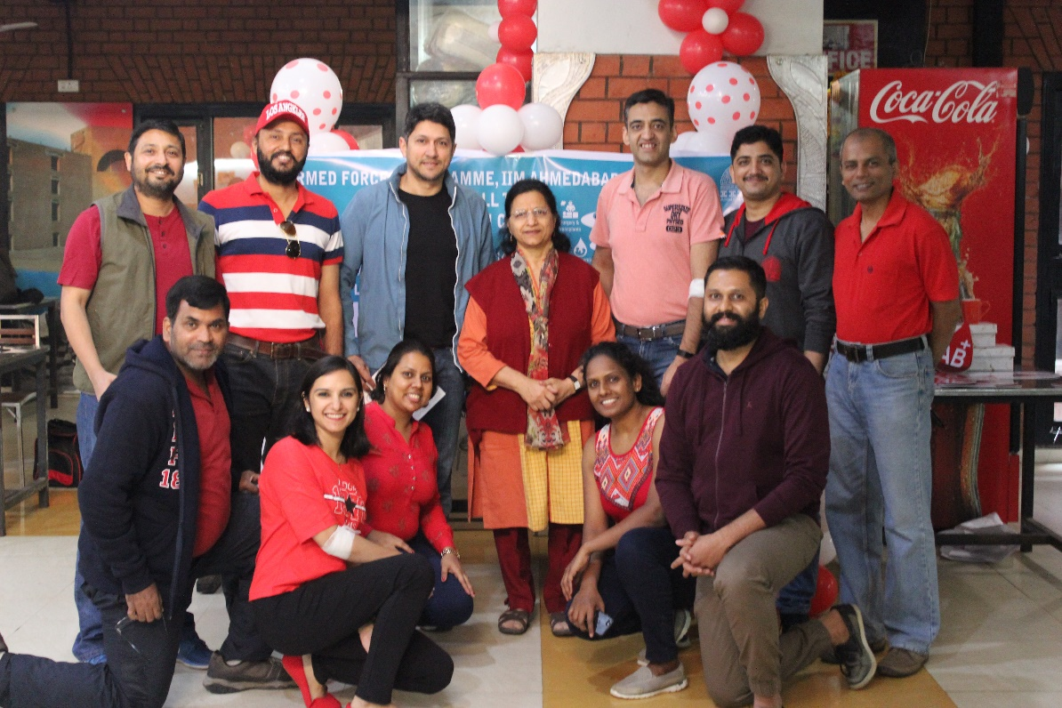

*Student Officers of the Armed Forces Programme with Prof. Parvinder Gupta, Chair, Programme (AFP)*

**January 8, 2019 | Ahmedabad**

Student officers of the Armed Forces Programme (AFP), at Indian Institute of Management Ahmedabad (IIMA), organized a Voluntary Blood Donation Camp in the heritage campus on January 6, 2019. The camp was conducted in association with the Ahmedabad chapter of Indian Red Cross Society and the donated blood will be utilised for the treatment of more than 800 children of Ahmedabad suffering from Thalassemia.

The theme of the drive was “Donate Blood & Find the Hero in You”. 252 people from the IIMA community including faculty, students, staff and their families came forward to donate blood. Out of these, 205 people successfully donated in an eight-hour long session, some even marking their birthdays by the noble deed. Mr. Kalpesh Makwana, one of the security guards on the campus, who celebrated his 44th birthday today, said, ‘I have been donating blood on every birthday for the last six years. I am extremely happy to do it today in the institution where I am employed’.

The numbers set a new record among blood donation camps held on the campus. The initiative was generously supported by grocery e-retailer, Big Basket, which provided sumptuous nourishments to all donors.

Cdr. Mohan Kumar and Sqn. Ldr. Sumedha Chopra, students in AFP and members of the organizing team expressed their sincere gratitude to the entire IIM Ahmedabad community for making this event a huge success. Commenting on the event, they said ***“We were really charged up to take on this event and make it a grand success. But it wouldn't have been possible without the immense support from the whole IIM Community. Many first time donors were extremely excited to come forward and contribute. We thank the whole IIM Community and the Indian Red Cross society for having given us this opportunity and making this event a grand success. ­­­­­”***

**About Indian Institute of Management Ahmedabad (IIMA) and Armed Forces Programme (AFP)**

Armed Forces Programme is a six months’ residential course in Business Management held at Indian Institute of Management, Ahmedabad for officers of the Indian Armed Forces, who are making a transition to civil organisations.

Established in 1961, the Indian Institute of Management, Ahmedabad (IIMA) is recognized globally for excellence in management education. One of the top management schools in the world, IIMA educates leaders of the enterprises. The Institute’s strategic priorities include: strengthening connection with its various constituencies, including academics, practitioners, alumni, and the community; nurturing a high-performance work environment of stretch, autonomy, and teamwork; and strategic growth while maintaining emphasis on quality.

The flagship Post Graduate Programme (PGP) is ranked 21st in the Financial Times Masters in Management Ranking 2017. As per the Financial Times’ Global MBA Ranking 2017, IIMA’s Post Graduate Programme for Executives (PGPX) is ranked 29th in the World. The postgraduate program in food and Agri Business (PGP-FABM) is ranked 1st in the Eduniversal Masters Ranking 2018. IIMA has been ranked as #1 Management institute as per the National Institutional

Ranking Framework (NIRF) rankings of Ministry of Human Resource Development, Government of India.

**For media queries, please contact:**

|  |  |
| --- | --- |
| **Raghuram V**  Media Secretary  Indian Institute of Management Ahmedabad  Ph: (Cell) +91- 9800172995  Email: p17vraghuram@iima.ac.in | **Mithila Hegde**  External Media Liaison (Student)  Indian Institute of Management  Ahmedabad  Ph: (Cell) +91- 9740499011  Email: p17mithilah@iima.ac.in |