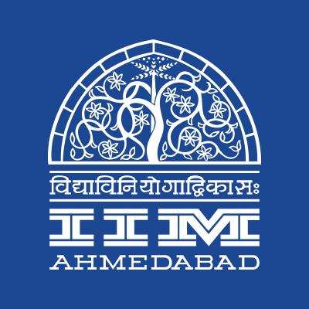

**PRESS RELEASE**

**IIM Ahmedabad Students Celebrate Sustainability Excellence; Win National Award**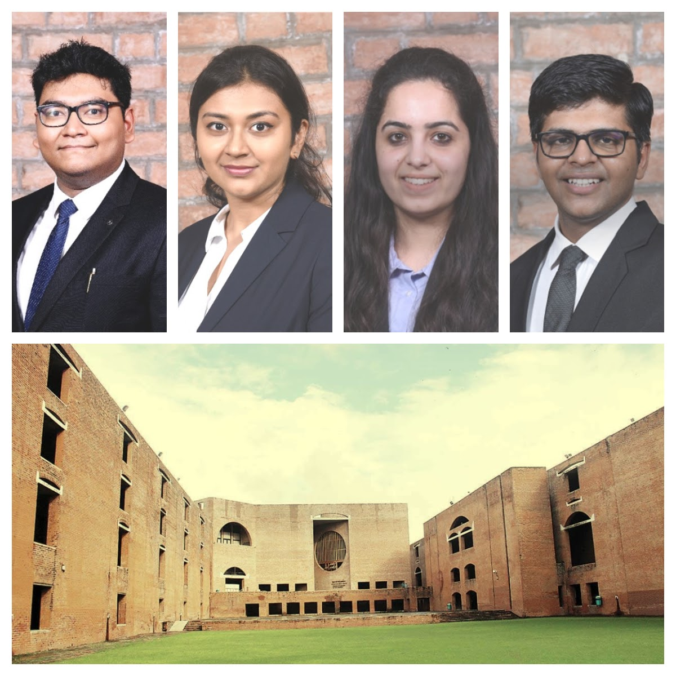

IIMA student team winning Wipro Earthian College Awards 2020 (L-R Aayush Gupta, Dr Dhairya Shrivastava, Nishima Kathuria, Kartik Mittal)

**05 February 2021 | Ahmedabad**

A team from the Indian Institute of Management, Ahmedabad (IIM-A) has emerged as one of the eight national winners in “Wipro Earthian College Awards 2020” by Wipro Foundation. The award program invited students to question and explore the nature of urban sustainability and gain a deeper understanding of urban sustainability challenges. Running since 2011, the program has seen the participation of over eight thousand institutes.

The team, comprising four second-year MBA students, Aayush Gupta, Dr. Dhairya Shrivastava, Kartik Mittal and Nishima Kathuria, worked with Prof. Rama Mohana Turaga as the registered faculty guide and mentor to highlight the problem of Delhi’s biomedical waste during the Covid-19 pandemic. Aayush Gupta, a member of the team, mentioned “While the world looks towards recovery with its hope on vaccines, we sought it essential to document the turmoil that the COVID-19 outbreak had on all our lives.”

The award-winning report documents, through primary and secondary sources of data from Delhi, the challenges the local governments face in dealing with the explosion of biomedical waste during the pandemic and the invisible contribution of informal waste workers and other frontline workers in addressing the problem. The focus of the award was on urban sustainability – the intersection of environment, economy and social equity in our cities.

The project involved telling compelling stories about sustainability and environmental issues and current developments in the space. The topics were those that affect people and the planet and our collective future to help inform the larger public, which can then take better decisions for our common good.

----------------------------------------------------------End of Text---------------------------------------------------------------

**About Indian Institute of Management Ahmedabad (IIMA)**

Indian Institute of Management Ahmedabad (IIMA) is a premier B-school in the Asia Pacific region. Globally, the Institute's programmes have earned high reputation and acclaim, becoming the first Indian institution to receive international accreditation EQUIS. Founded in 1961 as a unique public-private partnership for development through the application of knowledge, today it has an overseas presence in Dubai and associates with over 80 foreign B-schools to offer academically superior, market-driven and socially impactful programmes, research and consultancy services. In 2018, IIMA made it to the number four position in the Financial Times (FT) Asia Pacific Top 25 Business School Rank, ahead of all Indian B-Schools. FT conducted the ranking after considering the quality and breath of all the B-schools programmes. The Two-Year Master in Business Administration (MBA), IIMA’s flagship programme, is reanked at 20th position in the FT Master in Management Ranking 2020. IIMA is at number one position in India Ranking 2020 NIRF (National Institutional Ranking Framework), released by the Ministry of Human Resource Development, Government of India.

Over the years, IIMA has benefited more than 38,000 alumni who graduated from its various programmes. Currently, besides its renowned flagship Two-year Master in Business Administration (MBA), earlier known as Post Graduate Programme in Management (PGP); the Institute continues to draw top-quality students to its PhD Programme in Management, MBA in Food and Agri-Business Management (FABM), MBA-PGPX (One-Year Full-Time Post Graduate Programme in Management for Executives), Faculty Development Programme (FDP), Armed Forces Programme (AFP), e-Post Graduate Programme  (MMS), e-Post Graduate Diploma in Advanced Business Analytics (ePGD-ABA), and benefits industry professionals through its short duration Executive Education Programmes.

.

For media queries, please contact:

|  |  |
| --- | --- |
| **Goldy Admane**  Media Secretary (PGP-2)  Indian Institute of Management, Ahmedabad  Ph: (Cell) +91-7758962987  Email: mediasecretary@iima.ac.in | **Parmeshwari Bhumkar**  Media Secretary (PGP-1)  Indian Institute of Management, Ahmedabad  Ph: (Cell) +91-8411843388  Email: mediasecretary@iima.ac.in |