

**PRESS RELEASE**

**Announcement to support the IIMA Faculty Club**

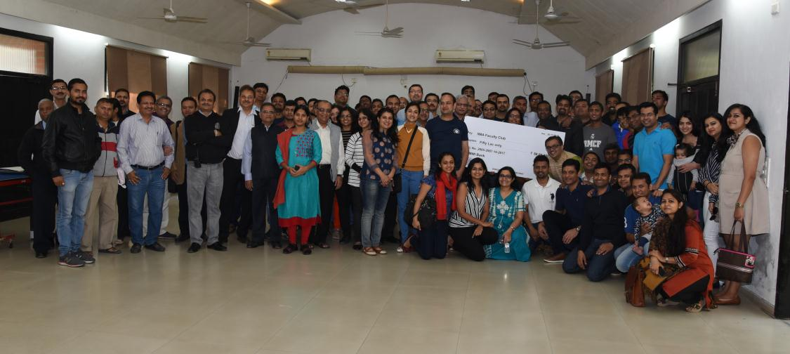

PGP 2007 Batch with their families, IIMA faculty and staff at the IIMA faculty club inaugural.

**January 1, 2018 | Ahmedabad**: IIMA Alumni in their individual capacity as well as through batch participation have made a significant contribution to the Institute for multiple initiatives on campus. The Institute is proud of their achievements and also their commitment to Alma Mater.

*“It gives me immense joy to announce the PGP 2007 batch’s contribution to support IIMA Faculty club with funding of INR 50 lakhs. This in part is their affection towards the faculty and the learning opportunities that IIMA faculty offered while they were on campus” said**Prof. Errol D’Souza, Director-In-Charge, IIMA.*

*“IIMA Alumni contribution towards IIMA Faculty Club is a new landmark in the Alumni contribution towards the priorities identified by the Institute. We are overwhelmed with their contribution and support” said Prof. Rakesh Basant, Dean A&ER, IIMA.*

*Mr. Ashwin Balasubramaniam, batch representative PGP 2007 said, “The two years in IIMA have enriched our lives in so many ways it's tough to enumerate in a few words. It is truly a great feeling to be back and contribute in our small way to help the institution that has done so much for us.”*

*Ms. Madhuri Iyer, PGP 2007 batch alumna added, “IIMA has shaped our careers and personalities and given us friendships and memories to cherish. It's an amazing feeling to return back to campus and relive some of those memories.”*

- End of Text

**About Indian Institute of Management Ahmedabad (IIMA)**

Established in 1961, the Indian Institute of Management, Ahmedabad (IIMA) is recognized globally for excellence in management education. One of the top management schools in the world, IIMA educates leaders of the enterprises.The Institute’s strategic priorities include: strengthening connection with its various constituencies, including academics, practitioners, alumni, and the community; nurturing a high performance work environment of stretch, autonomy, and teamwork; and strategic growth while maintaining emphasis on quality.

As per the latest ranking by *The Economist*, IIMA is No. 1 School in the world on the parameter of opening up new career opportunities for students. The flagship Post Graduate Programme (PGP) is ranked 16th in the *Financial Times* Masters in Management Ranking 2016. As per the *Financial Times’* Global MBA Ranking 2016, IIMA’s Post Graduate Programme for Executives (PGPX) is ranked 24th in the World. IIMA has been ranked as #1 Management institute as per the National Institutional Ranking Framework (NIRF) rankings of Ministry of Human Resource Development, Government of India.

**For media queries, please contact:**

**Deepak Bhatt, Manager, Communications**

(Cell) +91-9426229429, (O) +91-79-66324683 Email: [mngr-comm@iima.ac.in](mailto:mngr-comm@iima.ac.in)

**Mitaaly Naidu, Executive, Public Relations,**

(Cell) +91-7069074816, (O) +91-79-66324684 Email: [pr@iima.ac.in](mailto:pr@iima.ac.in)