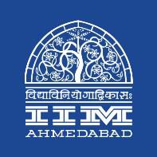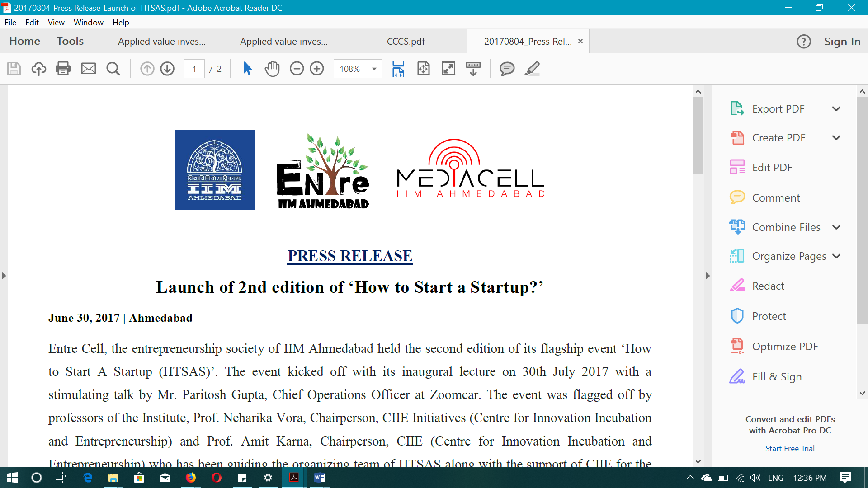

**PRESS RELEASE**

**Mr. Ankur Warikoo at IIMA’s ‘How to start a startup?’**

**September 24, 2018 | Ahmedabad**

Mr. Ankur Warikoo, featured in the list of Fortune magazine’s 40 under 40 list of young achievers in its Indian edition. He founded many start-ups in his career, some of them have been very successful.

*Talking about his early life, he said, “I did my bachelors in Physics at Hindu College, Delhi University. Then I went to the US to do PhD in Astrophysics at Michigan State University. But, something was missing in my life. I felt that this was not right and dropped out of my PhD and came back to India”. Upon returning, he did his Masters in Business from Indian School of Business (ISB). Then, he worked as a consultant for a reputed global consulting firm. That’s when his entrepreneurial journey started.*

*In his words, “A friend of mine once came up to me with an idea for ‘secondshaadi.com’, which was India’s first matrimonial website for remarriages. The website took off in a really nice way and it got a good media coverage. Then, we went on to create ‘gaadi.com’, which became India’s no.1 car classifieds website. Then, we parted ways”.*

Then, he started working as the CEO of *Groupon India*, which was the Indian arm of the US based e-commerce marketplace. He continued there for 4 years. He said, “Then, we proposed something really crazy to Groupon USA. We proposed to buy Groupon’s India operations. Initially, the proposal was dismissed. But, soon our proposal gained traction and Groupon agreed to the proposal. We brought in ‘Sequoia Capital’ for funding the transaction. This was the first instance that a 100% subsidiary of a publicly listed American company spun off after a management buy-out”. That resulted in what is known today as ‘*nearbuy.com*’. Paytm has made significant investment in the website.

*Talking about the most important thing to remember for an aspiring entrepreneur, he said “It is very important to know who you are and why you do what you are doing”. He also stressed on constantly challenging oneself and in his own words, “not get trapped in comfort zones”. Though one can come up with some novel ideas, he cautions that one should never think that he/she is the first person to come up with them. Instead, they should think on why similar ideas have failed in the past and what can be done in the future to avoid making mistakes that others have made.*

He also cautioned graduates from premier b-schools from thinking that their educational background alone would help them in their ventures. “Market decides whether a start-up is a success story or one among many that vanished without a trace”, Mr. Warikoo said. He stressed on the importance of market focus to look for opportunities and grab them as soon as they present themselves. He also highlighted the importance of problem-solving ability as a crucial element of success in an entrepreneur.

**-End of Text-**

**About Indian Institute of Management Ahmedabad (IIMA)**

*Established in 1961, the Indian Institute of Management, Ahmedabad (IIMA) is recognized globally for excellence in management education. One of the top management schools in the world, IIMA educates leaders of the enterprises. The Institute’s strategic priorities include: strengthening connection with its various constituencies, including academics, practitioners, alumni, and the community; nurturing a high-performance work environment of stretch, autonomy, and teamwork; and strategic growth while maintaining emphasis on quality.*

*The flagship Post Graduate Programme (PGP) is ranked 21st in the Financial Times Masters in Management Ranking 2017. As per the Financial Times’ Global MBA Ranking 2017, IIMA’s Post Graduate Programme for Executives (PGPX) is ranked 29th in the World. The postgraduate program in food and Agri Business (PGP-FABM) is ranked 1st in the Eduniversal Masters Ranking 2018. IIMA has been ranked as #1 Management institute as per the National Institutional Ranking Framework (NIRF) rankings of Ministry of Human Resource Development, Government of India.*

For media queries, please contact:

|  |  |
| --- | --- |
| Raghuram V  Media Secretary  Indian Institute of Management Ahmedabad  Ph: (Cell) +91- 9800172995  Email: [p17vraghuram@iima.ac.in](mailto:p17vraghuram@iima.ac.in) | Mithila Hegde  External Media Liaison (Student)  Indian Institute of Management  Ahmedabad  Ph: (Cell) +91- 9740499011  Email: p17mithilah@iima.ac.in |