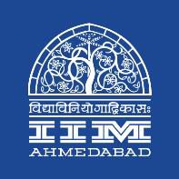 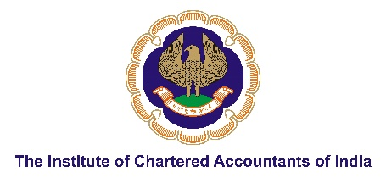

**PRESS RELEASE**

**IIM Ahmedabad and Institute of Chartered Accountants of India Co-host Advanced Leadership Development (ALD) Programme**

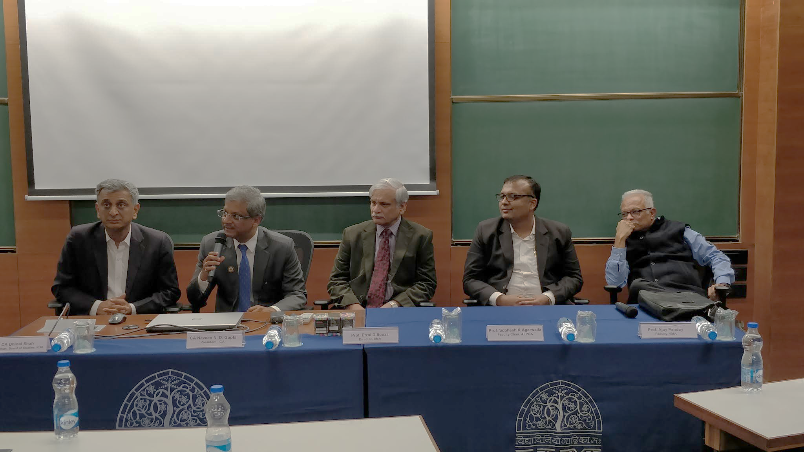

**Caption:** (L-R) CA. Dhinal Shah, Chairman, Board of Studies, ICAI; CA. Naveen Gupta, President, ICAI; Prof. Errol D’Souza, Director, IIMA; Prof. Sobhesh Agarwalla, Chair-faculty, ALD Programme, IIMA & Prof. Ajay Pandey, Co-Chair, ALD Programme, IIMA

**December 28, 2018 | Ahmedabad**

The importance of cross functional managerial knowledge has become critical in every field. The Chartered Accountant (CA) qualification prepares its members in acquiring skills through theory and practical training but there is a growing need for its members to become multi-functional managers delivering the best possible results with utmost efficiency. It is in this respect that Indian Institute of Management Ahmedabad (IIMA) - India’s leading management school with a focus on corporate leadership, public policy and governance along with the Institute of Chartered Accountants of India (ICAI) - India’s premier accounting body; would be jointly offering varied programmes for the ambitious CAs. The programmes aim is to provide in-depth domain knowledge for the participants while equipping them with business perspectives and managerial skills.

ICAI with IIMA would be organizing several programmes for the CAs. The first programme offered is a 5-day programme on leadership at the Institute campus from December 24-28, 2018. During the training period IIMA would be covering management concepts and methods covering effective leadership, emerging concepts, technology and best practices for change management; operational and strategic decision making; managerial skill enhancement; communication; entrepreneurial acumen and corporate governance frameworks.

Besides this training, IIMA would be offering three Open Enrolment Programmes (OEPs) for the CAs ranging from Young CAs, Mid-level CAs and Senior CAs.  The 30-day program for young CAs is scheduled from 7 April to 11 May, 2019. The main objective of this program is to nurture young and ambitious CAs, by providing in-depth domain knowledge and help them acquire business and managerial orientation by acquiring perspectives and requisite skills, so that they can make a difference at an early stage of their career as a manager. **“*At the end of the programme, the participants will not be only comfortable with finance and accounting functional roles but would have acquired cross-functional perspective to become an effective manager*”** said Prof. Sobhesh Kumar Agarwalla who is the faculty co-chair for the above programs.

The 22-day program for mid-level CAs will be offered in two tranches during the month of February and June 2019. ***“The program will help experienced CAs in developing a holistic perspective relevant to business and management and acquire managerial competencies and skills, so that they can evolve as an effective business manager/leader”****,* said Prof. Ajay Pandey who is the faculty co-chair for the above programs.

*“This is the first time that a connect is being established between IIMA and ICAI - the two premier institutes of India in management and accounting respectively. Going forward, I can see several other fronts - research, policy and influencing the practice, where the organizations can leverage on their mutual capabilities.”* said Prof. Sobhesh Kumar Agarwalla.

**-End of Text-**

**About Indian Institute of Management Ahmedabad (IIMA)**

Established in 1961, the Indian Institute of Management, Ahmedabad (IIMA) is recognized globally for excellence in management education. One of the top management schools in the world, IIMA educates leaders of the enterprises. The Institute’s strategic priorities include: strengthening connection with its various constituencies, including academics, practitioners, alumni, and the community; nurturing a high-performance work environment of stretch, autonomy, and teamwork; and strategic growth while maintaining emphasis on quality.

The flagship Post Graduate Programme (PGP) is ranked 21st in the Financial Times Masters in Management Ranking 2017. As per the Financial Times’ Global MBA Ranking 2017, IIMA’s Post Graduate Programme for Executives (PGPX) is ranked 29th in the World. The postgraduate program in food and Agri Business (PGP-FABM) is ranked 1st in the Eduniversal Masters Ranking 2018. IIMA has been ranked as #1 Management institute as per the National Institutional Ranking Framework (NIRF) rankings of Ministry of Human Resource Development, Government of India.

**For media queries, please contact:**

**Mr. Deepak Bhatt**

Manager, Communications

Email: [mngr-comm@iima.ac.in](mailto:mngr-comm@iima.ac.in) | Phone: 079-66324683 (O)

Mobile: +91-94262-29429

**Ms. Mitaaly Naidu**

Executive, Public Relations

Email: [pr@iima.ac.in](mailto:pr@iima.ac.in) | Phone: 079-66324684 (O)

Mobile: +91-7069074816

Website: [www.iima.ac.in](http://www.iima.ac.in)