

**PRESS RELEASE**

**HTSAS 3.0 - Interactive session with Dharmil Seth**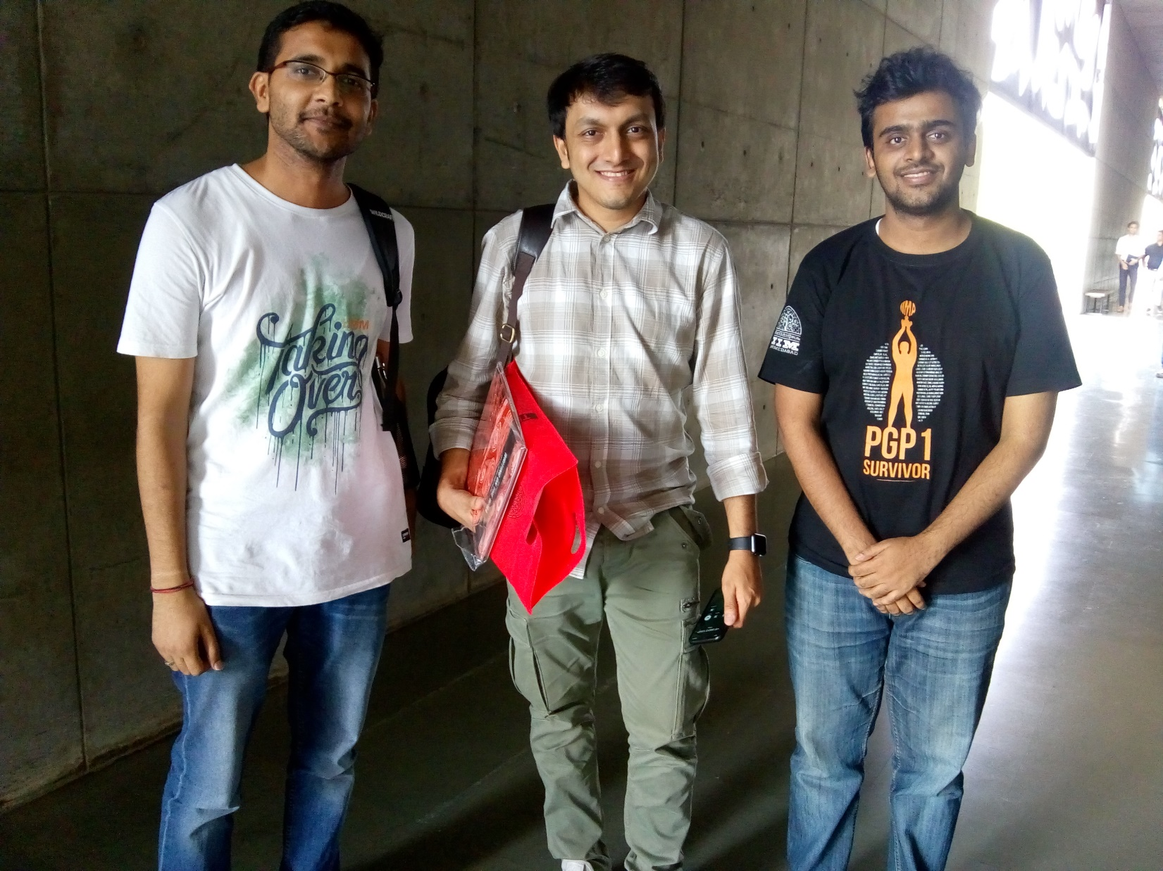

*Mr. Dharmil Seth with the Entre Cell members at IIMA*

**August 13, 2018 | Ahmedabad**

With the vision to impart experiences and learning of seasoned entrepreneurs and investors to the entire country, the third edition of How to Start a Startup series saw Entre Cell, IIM Ahmedabad, host Mr. Dharmil Sheth, co-founder of PharmEasy, a leading Mumbai-based pharma aggregator, which connects patients with local pharmacy stores and diagonistic centres. An alumnus of IMG Ghaziabad and a Forbes 30 under 30 persona, Dharmil Seth co-founded the start-up with Dhaval Shah. Prior to PharmEasy, Dharmil founded 91 Streets, a shopping search platform and BoxPlay Sports, a world-class sports infrastructure set-up for teams and individuals to play soccer, cricket. He has also laid the foundation for and is the President of Ekagrata Foundation, an NGO which works towards the welfare of underprivileged children.

He began the talk answering the universal query “Why startup?” with a simple answer that he “wanted to make money”. He reminised and shared that his friends cribbing about the low pay of IT industries which was one of the reasons why he decided to open his own company. Owing to a strong technical background, Dharmil started working on robotics after graduation, hosting workshops for school students and conducting robotic football matches. He realized that the idea wasn’t very popular and he needed more exposure, a key reason for him to futher pursue education at IMT Ghaziabad.

Dharmil echoes the biggest concern of entreprenuers starting is that they don’t have funding. He mentions the toughest part is bringing in the first investor; everything else becomes a little easy after that. When his first startup became stagnant after a good start, Dharmil met his school friend, Dhaval Shah, who introduced him to the healthcare industry. He realized that irrespective of a huge number of pharmacies and distributors in India, having stock of all medicines at every store was still a problem. Dharmil and Dhaval launched their PharmEasy app in just 48 hours of their ideation, because they believed in the cause so much.

Dharmil reminsces how they began their startup with a simple idea – delivering medicine to every customer at their doorstep with a 20% discount. It was a sweet spot since they could still keep a margin after providing a considerable discount. They made the application easy to use wherein a customer had to merely upload a photo of the prescription and the company would decode the prescribed medicines. When the number of installs peaked from 9 in the first day to 15000 in the tenth day without a dollar spent in marketing, they realized that their app addressed a genuine problem.

Emphasizing on the significance of setting expectations and priorities very well, Dharmil explains how the company faced several challenges at the retail and supplier end since its inception. He focussed on solving the issues at the consumer end because he realized only a large customer base would enable PharmEasy get enough money to solve the supply chain problems. Dharmil’s primary concern had always been to give a steady customer experience. He has even accompanied the delivery boys to closely understand the problems at the lowest level. Dharmil stresses on the importance of patience while running a startup; a slow but steady growth in business welcomes less opposition. He says that building the right team with the right kind of people has been a key in bringing credibility to the company. He urges everyone to believe in what one does, and be frustrated with the present scenario because only then, will one strive to make it better.

When the floor was opened for questions, the audience were buzzing with a number of queries. On being asked how he managed to approach retailers initially, Dharmil mentions how he realized how the startup didn’t succeed with the established medical stores so they approached people who were “as unorganized as they are”: they partnered with the local stores to create a win-win situation for both. When asked if one should research on an idea or jump to execution, he says one should immediately talk to the stakeholders first.

**-End of Text-**

**About Indian Institute of Management Ahmedabad (IIMA)**

*Established in 1961, the Indian Institute of Management, Ahmedabad (IIMA) is recognized globally for excellence in management education. One of the top management schools in the world, IIMA educates leaders of the enterprises. The Institute’s strategic priorities include: strengthening connection with its various constituencies, including academics, practitioners, alumni, and the community; nurturing a high-performance work environment of stretch, autonomy, and teamwork; and strategic growth while maintaining emphasis on quality.*

*The flagship Post Graduate Programme (PGP) is ranked 21st in the Financial Times Masters in Management Ranking 2017. As per the Financial Times’ Global MBA Ranking 2017, IIMA’s Post Graduate Programme for Executives (PGPX) is ranked 29th in the World. The postgraduate program in food and Agri Business (PGP-FABM) is ranked 1st in the Eduniversal Masters Ranking 2018. IIMA has been ranked as #1 Management institute as per the National Institutional Ranking Framework (NIRF) rankings of Ministry of Human Resource Development, Government of India.*

For media queries, please contact:

|  |  |
| --- | --- |
| Manas Agarwal  Entre Cell (PGP-2)  Indian Institute of Management Ahmedabad  Ph: (Cell) +91- 9619076467  Email: [p17manas@iima.ac.in](mailto:p17manas@iima.ac.in) | Ankita Saha  External Media Relations (PGP-1)  Indian Institute of Management Ahmedabad  Ph: (Cell) +91-9836550393  Email: p18ankita9@iima.ac.in |