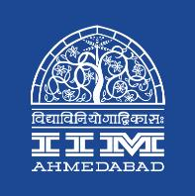

Press Release

IIMA Celebrates the International Day of Persons with Disabilities

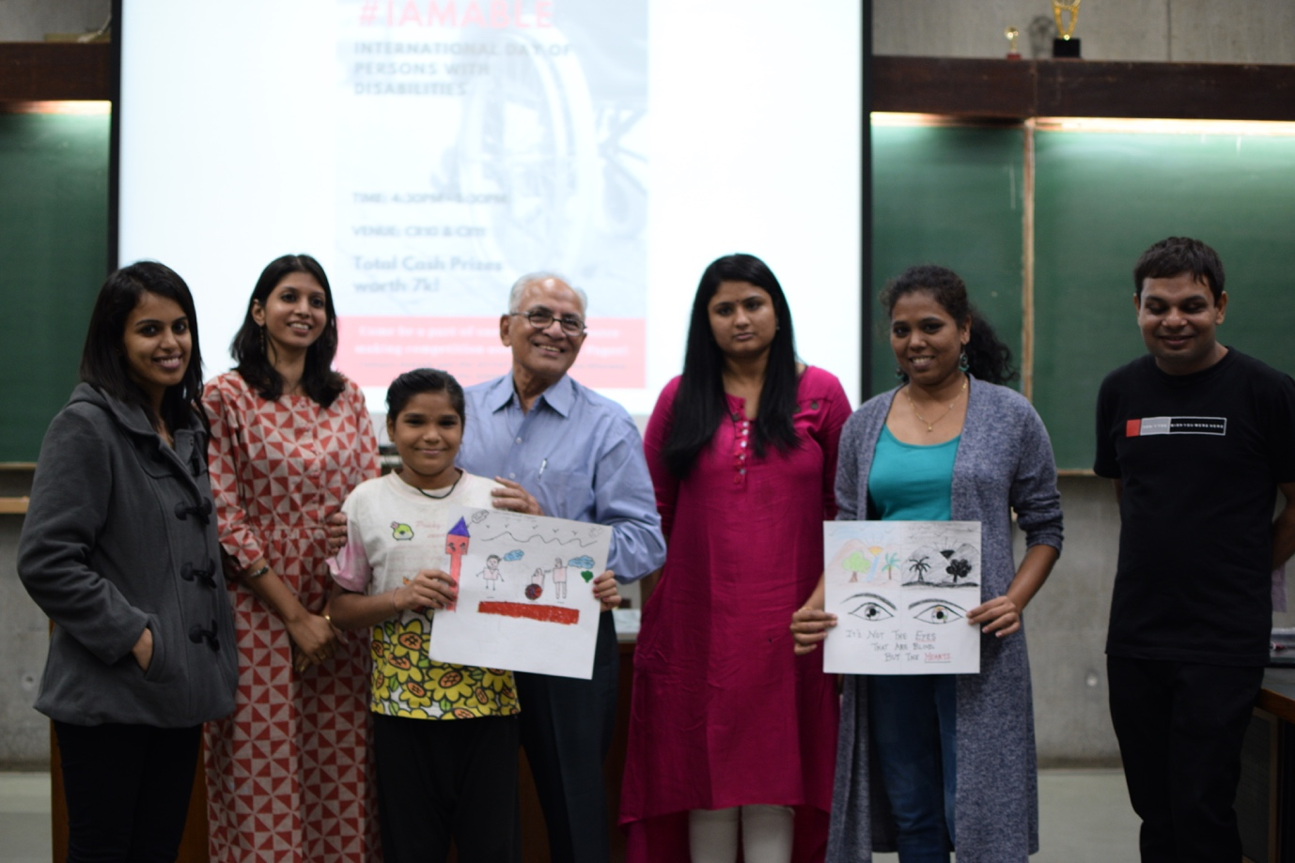

**December 5, 2018 | Ahmedabad**

Equal Opportunities Student Committee (EOSC) of the Indian Institute of Management Ahmedabad celebrated the International Day of Persons with Disabilities (IDPD) by hosting a Poster Making Competition. The event, organized by EOSC in collaboration with other IIMA student clubs – Finesse, SMILE and Prayaas, witnessed enthusiastic participation from school students under IIMA’s community outreach programme as well as from other members of the IIMA community.

This year’s theme for IDPD was empowering persons with disabilities and ensuring inclusiveness and diversity with the help of universal design. In line with the theme, the participants were shown a video of specially-abled students at IIMA and how inclusive practices can go a long way in ensuring an equitable environment for all. To further sensitize the participants, the themes for the various age groups were centered around disability and the participants were given Braille paper to design their posters.

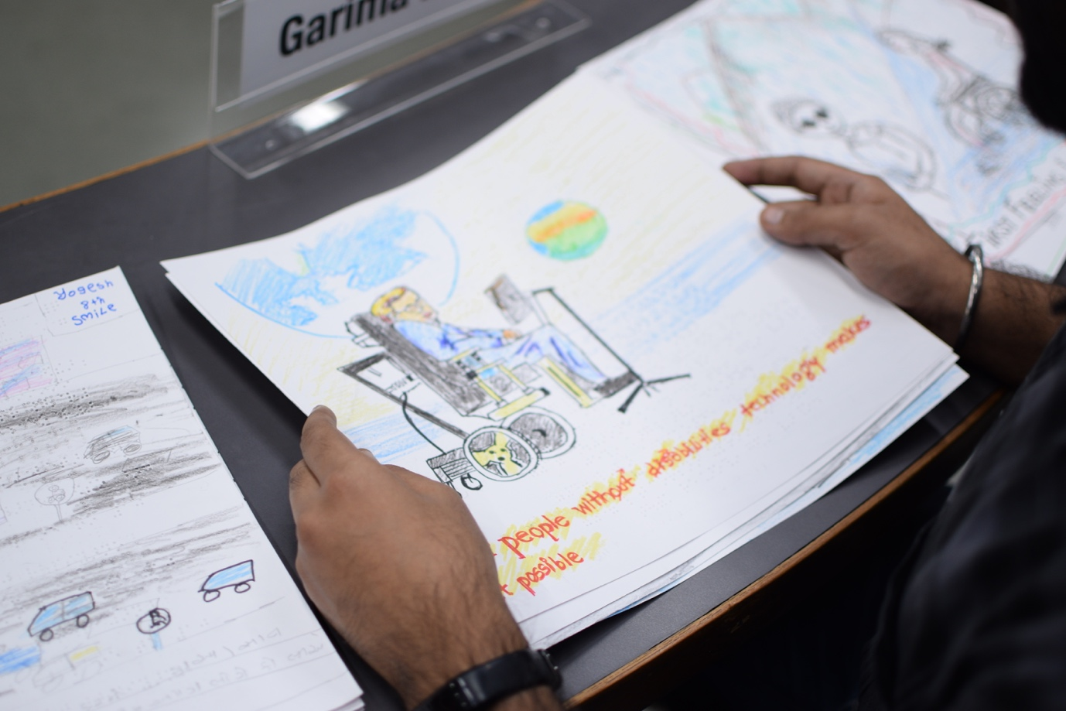

Mr. Tarun Vashisht, one of the organizers of the event and a doctoral student at IIMA, emphasized on the importance of universal design, a form of organizational design that facilitates the use by everyone. He also said, “there will always be impairment. But there is a difference between impairment and disability. If a person is wheelchair bound, but the place is wheelchair accessible, his or her disability is diminished. Thus, in an ideal society, there can be impairment without any disability. This has to be understood.”

Mr. I L Chitkara, a member of the Managing Committee of the Blind People’s Association and one of the judges for the event commented that such competitions aimed at young students would “not only sensitize the children at an early stage, but also help them grow into compassionate human beings”.

-End of Text-

*Established in 1961, the Indian Institute of Management, Ahmedabad (IIMA) is recognized globally for excellence in management education. One of the top management schools in the world, IIMA educates leaders of the enterprises. The Institute’s strategic priorities include: strengthening connection with its various constituencies, including academics, practitioners, alumni, and the community; nurturing a high- performance work environment of stretch, autonomy, and teamwork; and strategic growth while maintaining emphasis on quality.*

*The flagship Post Graduate Programme (PGP) is ranked 21st in the Financial Times Masters in Management Ranking 2017. As per the Financial Times’ Global MBA Ranking 2017, IIMA’s Post Graduate Programme for Executives (PGPX) is ranked 29th in the World. The postgraduate program in food and Agri Business (PGP-FABM) is ranked 1st in the Eduniversal Masters Ranking 2018. IIMA has been ranked as #1 Management institute as per the National Institutional Ranking Framework (NIRF) rankings of Ministry of Human Resource Development, Government of India.*

For media queries, please contact:

|  |  |
| --- | --- |
| Prachi S Sukhwani Coordinator, EOSC Indian Institute of Management Ahmedabad Ph: (Cell) +91-9998665320  Email: p17prachis@iima.ac.in | Gayatri Nair External Relations, Media Cell  Indian Institute of Management Ahmedabad Ph: (Cell) +91-8197720191 Email: p18gayatri@iima.ac.in |