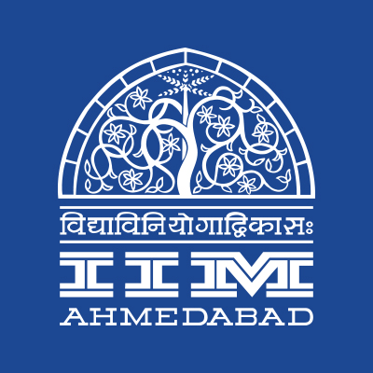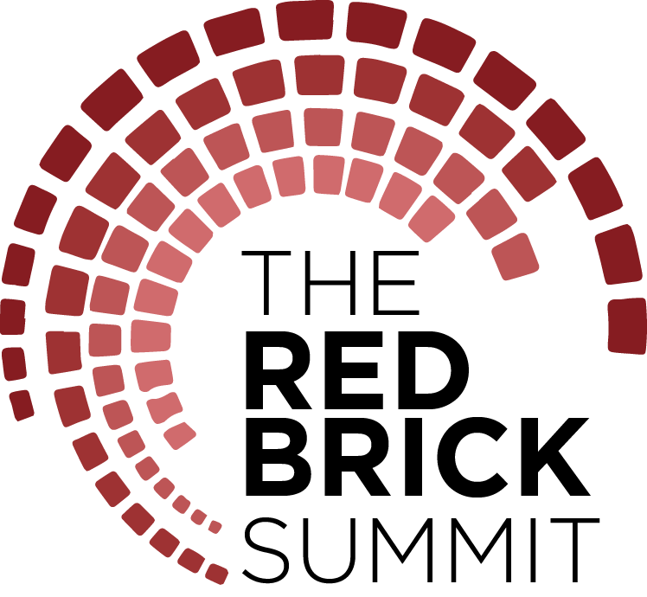

**PRESS RELEASE**

**THE RED BRICK SUMMIT, IIM AHMEDABAD**

**September 26, 2018 | Ahmedabad**

Indian Institute of Management, Ahmedabad is hosting the second edition of its management symposium, The Red Brick Summit from September 29, 2018 to October 2, 2018. Aptly named the Red Brick Summit (TRBS), after the famous environs that have come to be associated with over 50 years of academic excellence, the symposium will be a potpourri of the erstwhile Big Four fests of IIM Ahmedabad – Insight, Confluence, Amaethon and Connexions – that have been a mainstay of our institute's event calendar all these years.

The Red Brick Summit serves as a platform where tens of thousands of people across various parts of the country converge on the iconic campus to experience the four-day student-led event. It created history and distinguished itself as a one-of-its-kind management symposium in its very first edition, garnering a student footfall of 40,000+ from 350+ institutes.

The second edition, designed along the theme of *Envision, Endeavor and Experience*, aims to succinctly capture the dynamism and constant flux in which we live today, whether it be the organizational or individual level, and which transcends national boundaries and cultures.

The fest is supported by TATA Trusts and the associate sponsors include Motilal Oswal, European Union and CIIE. It features a total of 17 business competitions (the preliminary rounds of which began in mid-august), 15 top-quality workshops conducted by renowned companies, more than a dozen speaker sessions as well as panel discussions, and a number of activities, performances and exhibitions that appeal to all age groups.

The TRBS Workshops series is a great opportunity for participants to explore their interests and gain valuable insights from the biggest names in the industry. Each workshop has been tailored to ensure maximum interaction between the presenter and participants, covering a fascinating breadth of subject matter. From technology industry stalwarts such as Amazon and Uber, to the creative ones like Mad Over Marketing and Ogilvy & Mather; from firms promoting sustainability and social responsibility like our title sponsor TATA Trusts’, to ones promoting financial literacy like NCDEX, the line-up of workshops ensures there is something to pique everyone’s interests.

The renowned TRBS Speakers series’ will be replete with prominent personalities and opinionated individuals, characterized as highly influential citizens of society. The speaker series will kick-start with the opening session by the keynote speaker, Anant Maheshwari, President, Microsoft India. Maneka Gandhi, *Union Cabinet Minister, Women and Child Development*, Nirmala Sitharaman, *Union Cabinet Minister, Ministry of Defense*, Medha Patkar, *Social Activist*, Raamdeo Agrawal, *Founder of Motilal Oswal Financial Services* and Sunny Sapra, *Gujarat Head, Uber India* are just few out of the dozens of guests that will be gracing our campus and speaking on a myriad of topics. There will also be panel discussions organized that focus on specific sectors such as ICT, Energy, Consulting and Banking/Financial Services.

Not to be typified as an event focused solely on indoor learning; TRBS will also consist of a full line-up of activities that can be enjoyed under the evening skies. Kaleido, the signature flea market, is a potpourri of designers displaying their wares such as ornaments and apparels in a fun, musical setting. Disguised Marketing, a successful feature in past editions of Insight, is set to continue under the TRBS umbrella. Also in the mix will be a fresh initiative labelled as the Innovation Playground. It is designed as a platform for young business leaders with an entrepreneurial mindset to bring their ideas to reality and receive financial support from the corporate dignitaries who will be in attendance.

An emphasis on the finer cultural elements will round off TRBS festivities. *Dandiya Nights* under the awe-inspiring evening skies at the LKP as well as Drum Circle, a musical feast to foster cultural patriotism, strive to provide an evening of entertainment for the participants. Other student managed clubs such as Footloose (*Dance Club*), Music Club, Finesse *(Fine Arts Club)* and Stargazers *(Astronomy Interest Group)* will perform under the TRBS Nites segment, which promises to be an evening full of entertainment.

“*With our flagship management symposium, we are striving to provide students across the country to showcase their talent and an opportunity to learn from industry stalwarts*” – Raj Kumar Srivastava, The Red Brick Summit Coordinator, on the significance of the fest.

-End of Text-

**About Indian Institute of Management Ahmedabad (IIMA)**

Established in 1961, the Indian Institute of Management, Ahmedabad (IIMA) is recognized globally for excellence in management education. One of the top management schools in the world, IIMA educates leaders of the enterprises.

The Institute’s strategic priorities include: strengthening connection with its various constituencies, including academics, practitioners, alumni, and the community; nurturing a high performance work environment of stretch, autonomy, and teamwork; and strategic growth while maintaining emphasis on quality.

The flagship Post Graduate Programme (PGP) is ranked 21st in the Financial Times Masters in Management Ranking 2017. As per the Financial Times’ Global MBA Ranking 2017, IIMA’s Post Graduate Programme for Executives (PGPX) is ranked 29th in the World. IIMA has been ranked as #1 Management institute as per the National Institutional Ranking Framework (NIRF) rankings of Ministry of Human Resource Development, Government of India. The postgraduate program in food and Agri Business (PGP-FABM) is ranked 1st in the Eduniversal Masters Ranking 2018

For media queries, please contact:

|  |  |
| --- | --- |
| Kashika Lal  PR & Media Relations, TRBS (PGP-2)  Indian Institute of Management Ahmedabad  Ph: (Cell) +91-7838526332  Email: [p17kashika@iima.ac.in](mailto:p17kashika@iima.ac.in) | Himanshu Tandon  PR & Media Relations, TRBS (PGP-2)  Indian Institute of Management Ahmedabad  Ph: (Cell) +91-9818269147  Email: p17himanshut@iima.ac.in |