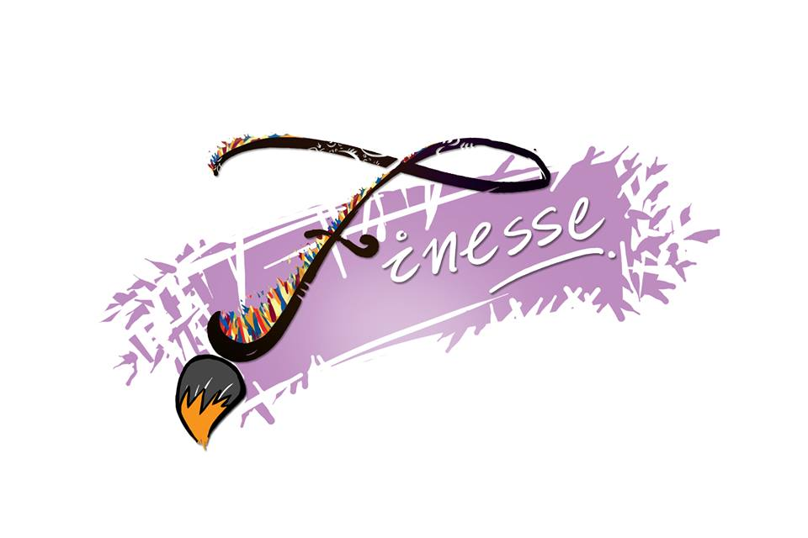
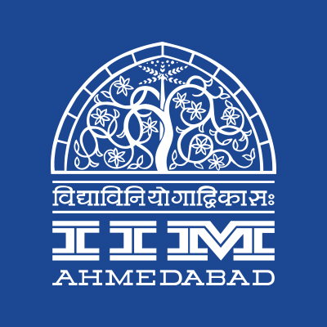


PRESS RELEASE

ART MELA at IIMA
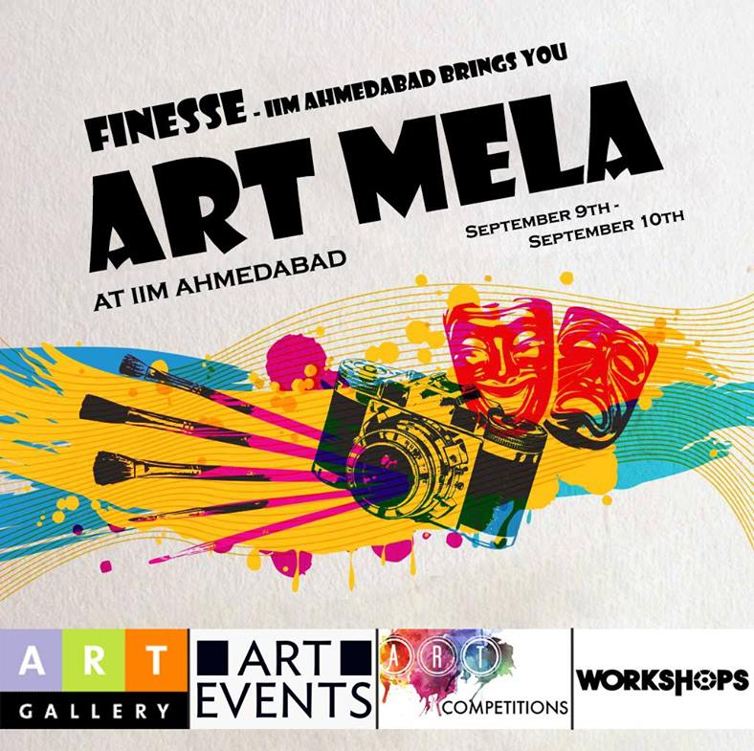

September 7, 2017 | Ahmedabad
Students of the Indian Institute of Management, Ahmedabad (IIMA) are inviting Ahmedabad to come together to celebrate color, creativity, and expression through art. Finesse - The Art Club of IIM Ahmedabad is organizing an Art Mela on September 9-10, 2017. The Mela has a host of exciting events to offer to the student community- workshops, online and offline competitions and an art exhibition. An Art Gallery will showcase creations made by the participants.
The workshops - “The Painting Party” and “3D printing” will be conducted to teach the students about painting and 3D printing. The workshops will be held by an expert artist, Ms. Nidhi Gupta and Professor Vipul Vinzuda, Associate Sr. Faculty, NID respectively. The participants will be awarded certificates as well.
Online competitions invite submissions from the student community around the themes - ‘Comic Con’ and ‘Shades of Grey.’ Offline competitions - ‘The Mystery Box’ and ‘The Painting Party’ will take place on September 9, 2017 at IIMA. For ‘The Mystery Box’ competition, participants will be given a box which would contain some items for them to use and create something innovative.
The Mela will also showcase an exhibition of the paintings created by the students. This is a great opportunity for the students to exhibit their talents and win exciting prizes. The event is being executed solely by Finesse- the Fine arts club of IIMA.
Ms. Manisha Vanka, Coordinator, Finesse commented “Ahmedabad has been hugely appreciative of arts and artists. The Heritage city tag is but a vindication of the culture that places a premium on creativity and legacy. Through the Mela, we are trying to celebrate creativity and expression of art.”
Balaji Uppala, Media Secretary, IIMA commented “Mela is being envisaged as a platform for A-league (Consortium of 14 colleges in Ahmedabad & Gandhinagar) and all the colleges in Ahmedabad to come together and admire different art forms. It aims to perpetuate a culture of appreciating the creative aspects of fine arts.”

Art Mela Events & Schedule

SHADES OF GREY: An online art competition where one can showcase their vibrant artistic talent! All forms of art (pencil, charcoal, water colors, etc.) in gray are eligible.
COMIC CON: An online competition where the participants are required to make a comic strip in just 4 squares. There are no limitations on sizes of the squares or the theme of the story.
MYSTERY BOX: Participants will be given a box which would contain some items for them to use and create something innovative. To be conducted on Saturday, 2-4 p.m.
3D PRINTING WORKSHOP: 3D Printing Workshop in collaboration with Professor Vipul Vinzuda, Associate Sr. Faculty, Transportation and Automobile Design, NID, Gandhinagar. The workshop will be held for 2 days at IIM Ahmedabad. Participants are required to make their digital art work on day 1 and print it via a 3D printer on day 2.
POT PAINTING WORKSHOP: Nidhi Gupta is a budding artist in Ahmedabad and would be in IIMA to conduct a workshop on painting pots. The workshop will be held on Sunday 2-4 p.m.
THE PAINTING PARTY: Participants will be painting the picture in the poster, all the things required for the painting (Canvas, Paints, Paint brushes, etc.) will be provided. All the participants will be guided by expert artist, Nidhi Gupta. The event will be on September 10, 2017 Saturday, 5-7 p.m. at CR lawns, IIM Ahmedabad
ART GALLERY: This would be an art exhibition for all participating artist. Applications are open to all (IIMA Community and others). The gallery would be open on both the days in Mess reading room.
For more information, please follow: fb.com/FinesseFineArtsClubOfIimAhmedabad

-End of Text-

For media queries, please contact:
Manisha Vanka  Coordinator, Finesse (PGP-2)  Indian Institute of Management Ahmedabad  Ph: (Cell) +91-8125151994  Email: p16vmanisha@iima.ac.in | Moksha  External Media Relations (PGP-1)  Indian Institute of Management Ahmedabad  Ph: (Cell) +91-8607917328  Email: a17moksha@iima.ac.in

