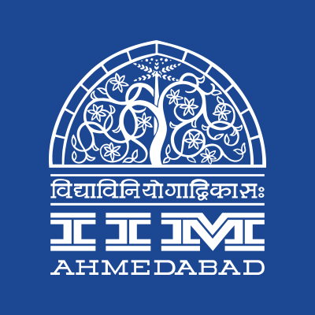
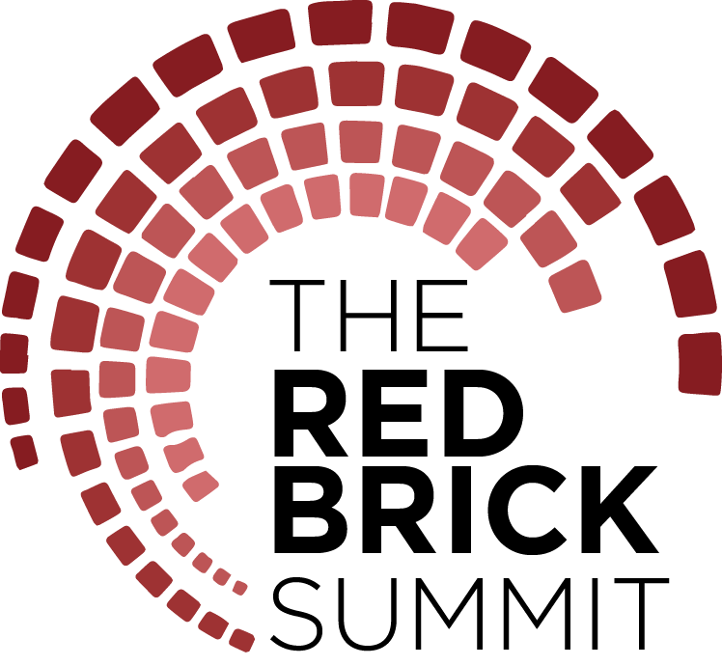

PRESS RELEASE

THE RED BRICK SUMMIT, IIM AHMEDABAD
September 27, 2017 | Ahmedabad
The inaugural edition of IIM Ahmedabad’s flagship management symposium The Red Brick Summit (TRBS) is when tens of thousands of people from Gujarat and various parts of the country converge on the iconic campus to experience the four day student-led event that is set to be the biggest of its kind in the institute’s history. The event begins on September 29, 2017 and culminates on October 2, 2017.
The theme of Challenge, Innovate, Redefine aims to succinctly capture the dynamism and constant flux in which we live today, whether it be the organisational or individual level, and transcends national boundaries and cultures.
Presented by Title Sponsor TATA Trusts and Associate Sponsors Motilal Oswal, European Union and CIIE, TRBS features a total of 20 business competitions (the preliminary rounds of which had already begun few weeks ago), 14 workshops, more than a dozen speaker sessions and panel discussions, and a number of activities, performances and exhibitions that appeal to all age groups.
The TRBS Workshops series is a great opportunity for participants to explore their interests and gain valuable insights from the biggest names in the industry. Each workshop has been tailored to ensure maximum interaction between the presenter and participants, covering a fascinating breadth of subject matter. From technology companies at the forefront of disruption in Amazon and Uber, to the creative ones like Mad Over Marketing and Ogilvy & Mather; from firms promoting sustainability and social responsibility like title sponsor TATA Trusts’, to ones promoting financial literacy like NCDEX, the line-up of workshops ensures there is something of interest to everybody.
Continuing in the same vein, the Speakers series’ will be replete with prominent personalities and opinionated individuals, all of whom have had a significant influence on society. The speaker series will kick-start with the opening session by the keynote speaker, Smt. Smriti Irani, Hon’ble Union Cabinet Minister, Textiles and Information & Broadcasting, GOI. Smt. Poonam Mahajan, Member of Parliament, Mumbai North Central, Mr Deep Kalra, Founder and CEO of MakeMyTrip and a well-known alumnus of the institute, Mr. R. S. Sodhi, M.D., GCMMF Ltd. (Amul), Dr. Harsh Kumar Bhanwala, Chairman of NABARD, Ms. Anajana Ghosh, Director of Marketing at Bisleri, Dr A. S. Kiran Kumar, Chairman of ISRO and Ms. Sagarika Ghose, journalist and news anchor are just few out of over a dozen guests that will be gracing our campus and speaking on a myriad of topics. There will also be panel discussions organised that focus on specific sectors such as ICT, Energy, Consulting and Banking/Financial Services.
Not to be typified as an event focused solely on indoor learning; TRBS will also consist of a full line-up of activities that can be enjoyed under the evening skies. Kaleido, our signature flea market, is a potpourri of designers displaying their wares such as ornaments and apparels in a fun, musical setting within the hallowed walls of our campus. Disguised Marketing, a similarly successful feature in past editions of Insight, is set to continue under the TRBS umbrella. Also in the mix will be a fresh initiative termed Innovation Playground. It is designed as a platform for young business leaders with an entrepreneurial mindset to bring their ideas to reality and receive financial support from the corporate bigwigs who will be in attendance.
An emphasis on the finer cultural elements will round off TRBS festivities. Renowned play Yugpurush – Mahatma Ke Mahatma produced by Shrimad Rajchandra Mission Dharampur will be enacted live at the RJM Auditorium on the eve of Gandhi Jayanti. With the Navratri season in full swing, the IIMA Cultural Committee has organised Dandiya Nights 2017 under the awe-inspiring evening skies at the LKP. Other student managed clubs such as Footloose, Music Club, Finesse and Stargazers will likewise be making an impact under the TRBS Nites segment, which promises to be an evening full of entertaining performances and noteworthy activities.
-End of Text-
About Indian Institute of Management Ahmedabad (IIMA)
Established in 1961, the Indian Institute of Management, Ahmedabad (IIMA) is recognized globally for excellence in management education. One of the top management schools in the world, IIMA educates leaders of the enterprises.

The Institute’s strategic priorities include: strengthening connection with its various constituencies, including academics, practitioners, alumni, and the community; nurturing a high performance work environment of stretch, autonomy, and teamwork; and strategic growth while maintaining emphasis on quality.

As per the latest ranking by The Economist, IIMA is No. 1 School in the world on the parameter of opening up new career opportunities for students. The flagship Post Graduate Programme (PGP) is ranked 16th in the Financial Times Masters in Management Ranking 2016. As per the Financial Times’ Global MBA Ranking 2016, IIMA’s Post Graduate Programme for Executives (PGPX) is ranked 24th in the World. IIMA has been ranked as #1 Management institute as per the National Institutional Ranking Framework (NIRF) rankings of Ministry of Human Resource Development, Government of India.

For media queries, please contact:
Varun Joshi  PR & Media Relations, TRBS (PGP-2)  Indian Institute of Management Ahmedabad  Ph: (Cell) +91-8410464140  Email: p16varunj@iima.ac.in | Abhishek Aggarwal  PR & Media Relations, TRBS (PGP-2)  Indian Institute of Management Ahmedabad  Ph: (Cell) +91-9999066979  Email: p16abhishek16@iima.ac.in

