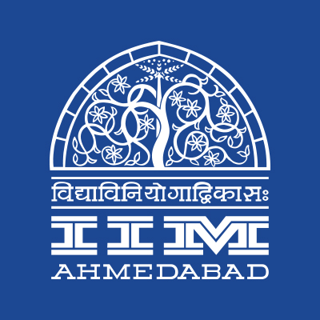 

**PRESS RELEASE**

**Blood Donation Camp at IIMA to celebrate Independence Day**

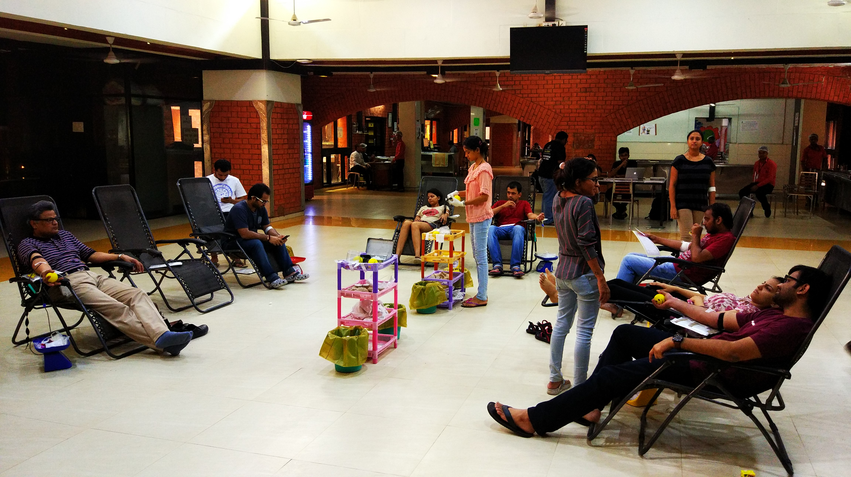

IIMA Students and Faculty at the Blood donation camp

**August 16, 2017 | Ahmedabad**

Students of the Indian Institute of Management Ahmedabad (IIMA) have come forward for a noble cause. Panacea – The Healthcare Club of IIM Ahmedabad organized a Voluntary Blood Donation Camp commemorating Independence Day celebrations inside Students’ Mess, Old Campus from 10.30 a.m. to 5 p.m. The camp was conducted in collaboration with Gujarat Cancer Research Institute, Ahmedabad. The blood units collected from this camp will be donated for the treatment of needy cancer & thalassemia patients.

Over 100 members of the IIM Ahmedabad community came forward for the blood donation activity. Faculty members such as Professor Satish Deodhar, Professor Vishal Gupta and Professor Viswanath Pingali actively participated in this event, setting an example for the students on campus. IIMA staff members and students from various courses such as PGP, PGP-FABM, FPM, PGPX, etc. showed great enthusiasm in donating blood. A record total of 83 units of blood were collected within seven hours.

Dr. Abhik Biswas, Coordinator of Panacea-The Healthcare Club of IIMA expressed his sincere gratitude to the entire IIM Ahmedabad community and the GCRI team for making this event a huge success. Commenting on the event, he said *“Every year there is a fresh batch of students, but the willingness to contribute to the society has always been increasing. The event is one of the several ways by which IIMA has expressed its sense of responsibility towards the society, and we hope that in future, we will be able to utilize every opportunity to reach out and help those in need.”*

**-End of Text-**

**About Indian Institute of Management Ahmedabad (IIMA)**

Established in 1961, the Indian Institute of Management, Ahmedabad (IIMA) is recognized globally for excellence in management education. One of the top management schools in the world, IIMA educates leaders of the enterprises.

The Institute’s strategic priorities include: strengthening connection with its various constituencies, including academics, practitioners, alumni, and the community; nurturing a high performance work environment of stretch, autonomy, and teamwork; and strategic growth while maintaining emphasis on quality.

As per the latest ranking by *The Economist*, IIMA is No. 1 School in the world on the parameter of opening up new career opportunities for students. The flagship Post Graduate Programme (PGP) is ranked 16th in the *Financial Times* Masters in Management Ranking 2016. As per the *Financial Times’* Global MBA Ranking 2016, IIMA’s Post Graduate Programme for Executives (PGPX) is ranked 24th in the World. IIMA has been ranked as #1 Management institute as per the National Institutional Ranking Framework (NIRF) rankings of Ministry of Human Resource Development, Government of India.

**For media queries, please contact:**

|  |  |
| --- | --- |
| **Abhik Biswas**  Coordinator, Panacea (PGP-2)  Indian Institute of Management Ahmedabad  Ph: (Cell) +91-9433160886  Email: p16abhikb@iima.ac.in | **Arpit Jain**  External Media Relations (PGP-2)  Indian Institute of Management Ahmedabad  Ph: (Cell) +91-9916288168  Email: [p16arpitj@iima.ac.in](mailto:p16arpitj@iima.ac.in) |