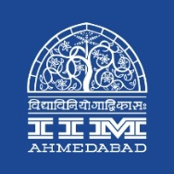

Press Release

‘iDex: Innovation for Defence Excellence’ – Dr. Ajay Kumar delivers a talk IIMA
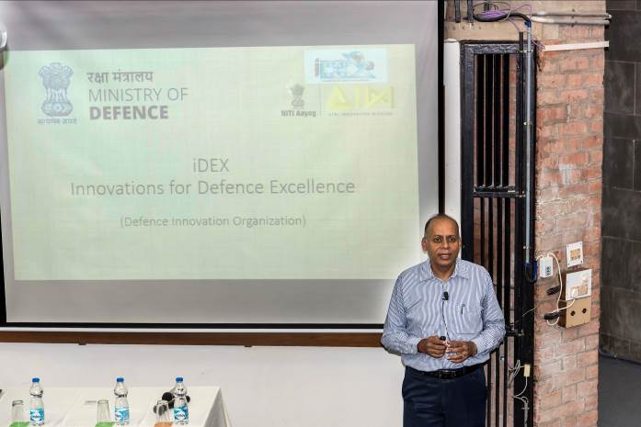
Dr Ajay Kumar, IAS, Secretary, Department of Defence Production, Ministry of Defence, Government of India talking to the AFP class.

November 20, 2018 | Ahmedabad
Dr Ajay Kumar, IAS, Secretary, Department of Defence Production, Ministry of Defence, Government of India delivered a lecture - ‘iDex: Innovation for Defence Excellence’ and addressed the participants of the Armed Forces Programme (AFP) 2018, faculty members and other students of IIM Ahmedabad today. The Armed Forces Programme is a six months full time Business Management Course conducted by IIM Ahmedabad, specifically for selected officers of various branches of Army, Navy and Air Force who are transitioning into a second career after completion of their tenure in the services. These officers come with vast leadership experience and a variety of skills which are keenly sought after by the corporate sector.
In his talk, Dr Ajay Kumar stressed on the vital need for promoting indigenous capability in the defence sector. Outlining the scope of the Innovation for Defence Excellence (iDex) project initiated under the aegis of Atal Innovation Mission (AIM), he highlighted the establishment of Defence Innovation Fund (DIF) aimed at creation of an ecosystem to foster innovation and technology development in Defence and Aerospace by engaging the industry, MSMEs, start-ups, individual innovators, R&D institutions and the academia. He spoke about provision of providing necessary assistance in terms of grants/funding and technical support would be provided to enable development of technologies with potential for adoption by Indian defence and aerospace sectors.
He spelt out the core objectives of the Defence Innovation Fund as facilitation of rapid development of new, indigenous, and innovative technologies and creation of a culture of engagement with innovative start-ups, to encourage co-innovation and co-creation for defence and aerospace sectors. iDex has invited interested participants of AFP to join them and to contribute to the to the success of this noble initiative taken up by the government.
He was accompanied by Mr Sanjay Jaju, Joint Secretary, Defence Production, Government of India and Shri Mudit of Atal Innovation Mission.
- The END of Text -

About Indian Institute of Management Ahmedabad (IIMA)
Established in 1961, the Indian Institute of Management, Ahmedabad (IIMA) is recognized globally for excellence in management education. One of the top management schools in the world, IIMA educates leaders of the enterprises. The Institute’s strategic priorities include: strengthening connection with its various constituencies, including academics, practitioners, alumni, and the community; nurturing a high performance work environment of stretch, autonomy, and teamwork; and strategic growth while maintaining emphasis on quality.

As per the latest ranking by The Economist, IIMA is No. 1 School in the world on the parameter of opening up new career opportunities for students. The flagship Post Graduate Programme (PGP) is ranked 16th in the Financial Times Masters in Management Ranking 2016. As per the Financial Times’ Global MBA Ranking 2016, IIMA’s Post Graduate Programme for Executives (PGPX) is ranked 24th in the World. IIMA has been ranked as #1 Management institute as per the National Institutional Ranking Framework (NIRF) rankings of Ministry of Human Resource Development, Government of India.

For media queries, please contact:

Deepak Bhatt
Manager, Communications
Ph: (Cell) +91-9426229429, (O) +91-79-66324683
Email: mngr-comm@iima.ac.in

Mitaaly Naidu
Executive, Public Relations
Ph: (Cell) +91-7069074816, (O) +91-79-66324684
Email: pr@iima.ac.in

