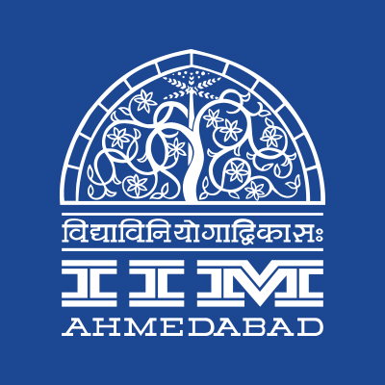

PRESS RELEASE
‘YUGPURUSH – MAHATMA NA MAHATMA’
A PLAY TRANSFORMING HUMAN CONSCIOUSNESS WORLDWIDE COMES TO IIMA.

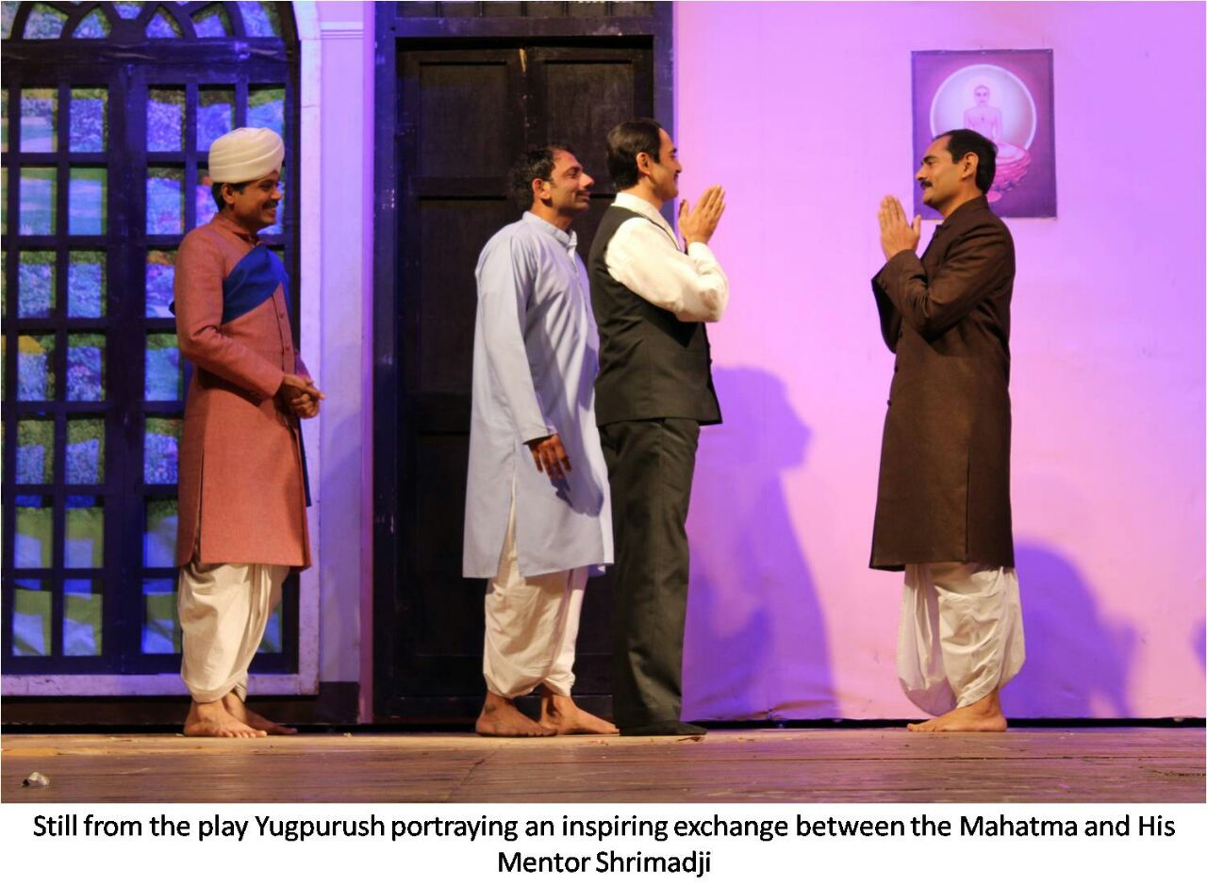
October 1, 2017 | Ahmedabad
The Red Brick Summit takes a holistic approach and encompasses the play YUGPURUSH to commemorate the birth anniversary of Mahatma Gandhi at RJM Auditorium, Indian Institute of Management Ahmedabad on October 1, 2017.
The Play - ‘Yugpurush- Mahatma’s Mahatma’ is an inspirational and riveting portrayal of the close association between Mahatma Gandhi and his spiritual mentor Shrimad Rajchandraji. What began as a sincere friendship, culminated in Gandhjii’s proclamation of Shrimadji as his spiritual mentor. The play invites the audience to journey through Gandhiji’s internal and overt advancements on the spiritual path following interactions, letters and inspiration from Shrimad Rajchandraji.
Mahatma Gandhi wrote in Modern Review on June 30, 1930 -“Such was the man who captivated my heart in religious matters that no other man has till now”
‘Yugpurush’ – a play by the Shrimad Rajchandra Mission, has taken cities across India by storm reaching its 900th show mark in a short span of 308 days, running to full houses and standing ovations, watched by over 5,85,715 people in the world.
In addition to the Transmedia Gujarati Screen and Stage Awards received previously for the Best Drama, Best Director and Best Actor in a Supporting Role, Yugpurush was recently bestowed with the prestigious Dadasaheb Phalke Excellence Award 2017 for ‘Best Drama’! Yugpurush was also the first Indian event to be staged at the prestigious Dolby Theatre in Hollywood, Los Angeles where the world-famous Oscars Awards Ceremony is held.

‘Yugpurush’ highlights the values of expanding one’s capacity to love and offer selflessly, respecting diversity, supporting truth, fostering trust, and building lasting communities. It brings to forefront a powerful experience of looking within, upholding truth and fearlessness, as well as transforming character and consciousness.
2017 marks the 150th birth year of Shrimad Rajchandraji. To celeb-rate this glorious year, this play has been produced under the guidance of Shrimad Rajchandraji’s ardent devotee and the founder of Shrimad Rajchandra Mission Dharampur, Pujya Gurudevshri Rakeshbhai.
Pujya Gurudevshri states, “The birth and life of the Great Ones are worth remembering. They awaken our latent strength and kindle the desire to become like them.”
The Gujarati play is directed by acclaimed director Rajesh Joshi of ‘Code Mantra’ fame, scripted by well-known playwright Uttam Gada of‘Maharathi’ fame. The music direction is by popular composer duo Sachin - Jigar.
The world premiere of ‘Yugpurush’ mesmerized an audience of over 4000 people, at Yogi Sabhagruha auditorium in Mumbai on 14th November, 2016. The show is seeing people queue up in large numbers, and is receiving standing ovations by the audiences. Just a month later, the Hindi production of the play had a grand premiere at the Royal Opera House in Mumbai.
Applauded by diverse audiences like the Indian Armed forces, industry professionals, theatre & film artists, social organizations, government officials, corporates, students and NGOs, the play has been inspiring audiences to walk on the path of love and ahimsa across the globe.
Acclaimed Film Director Mr. Ashutosh Gowariker, said at the Hindi premier of ‘Yugpurush’,
“In one word, it was ‘adbhut’. This play holds a great significance. This play should be seen by maximum people all over India and be translated in as many languages.”
In order to cater to the huge demand for the play, eight teams are now performing the play in eight different cities, simultaneously. The play is currently running in Gujarati, Hindi, Marathi, Kannada, Bengali, Tamil & English. Having already premiered in all parts of India, USA, Canada, UAE, Oman, Yugpurush is all set to travel to Singapore, Hong Kong, Malaysia, Australia, Kenya and South Africa to name a few in the rest of the year.
The play supports the cause of Shrimad Rajchandra Hospital – a new 200-bed multi-specialty charity hospital for the economically underprivileged in South Gujarat. SRMD’s aim behind the year-long celebration of Shrimad Rajchandraji’s 150th birth anniversary is to spread Shrimad Rajchandraji's values of ahimsa and satya that shaped Gandhiji's beliefs, and to bring His spiritually uplifting teachings to the maximum number of people from all walks of life.
For more information and passes for the show scheduled at IIM A on October 1, 2017 @ 8:00 p.m., please contact teamtrbs@iima.ac.in
- End of Text -
For media queries, please contact:
Varun Joshi  PR & Media Relations, TRBS (PGP-2)  Indian Institute of Management Ahmedabad  Ph: (Cell) +91-8410464140  Email: p16varunj@iima.ac.in | Abhishek Aggarwal  PR & Media Relations, TRBS (PGP-2)  Indian Institute of Management Ahmedabad  Ph: (Cell) +91-9999066979  Email: p16abhishek16@iima.ac.in

