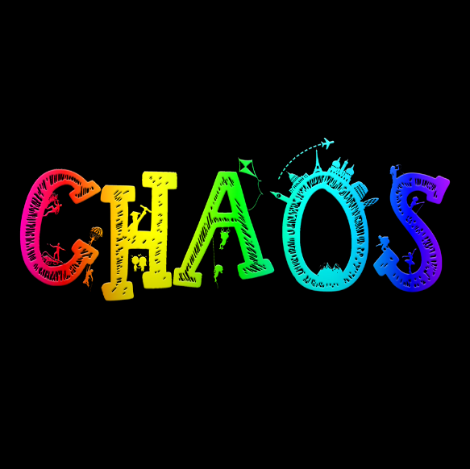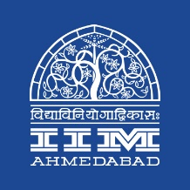

**Press Release**

**Press Release**

**IIMA’s annual cultural fest CHAOS concludes**

**January 30, 2019 | Ahmedabad**

IIM Ahmedabad’s flagship Cultural fest, CHAOS concluded with a final flourish on the 27th of January 2019 with a soulful performance by Armaan Malik. The four-day fest which is regarded as one of the biggest cultural events across management institutes in the country with witnessed over 50000 individuals attending the various workshops, on-spot events and pronates.

**Workshops**

Chaos 2019 hosted a slew of interesting workshops that attracted an appreciable crowd. Day 2 began with *“Midas Touch”*, a soap-making workshop by *Humble Bee* which took the participants through the process of making soap from scratch and gave them a chance to take their creations along with them. *Terribly Tiny Tales (TTT)* hosted its flagship writing workshop where co-founder *Anuj Gosalia* shared his approach to various formats, genres and writing styles. A major attraction, this workshop helped budding writers to brainstorm ideas and offered them tips and tricks to make a mark in the 140-character-stories genre. The other notable workshops were *“Mirror Mosaic”*, *“Balloon Crafting”*, *“Tattoo workshop”* and *“Personal Finance”* by *Mr. C. V. Ganesh* (COO & CFO, HDFC).

Model and entrepreneur *Simran Kaushik* started Day 3 with her *“Personality Development Workshop”* which covered topics on creating powerful first impressions, being corporately successful and growing one’s personality. Social media influencer and dancer, *Melvin Louis* grooved the participants of *“Bollyswag”* to popular Bollywood beats. *DJ Nihar* brought in *“Silent Disco Workshop”*, an innovative combination of silence and music that gave the participants an unusual experience. Radio Mirchi’s *RJ Dhvanit* explained in his workshop the art of interacting with the audience.

The last day had *“Spray Painting Workshop”* by artist, *Sunil Gogia* that covered the fundamental techniques and approaches to spray paint art. Mumbai-based photographer, *Ritam Banerjee* hosted a *“Photography Workshop”* to offer tips for amateurs and professionals alike. The *“Corporate Communication Workshop”* by *Anushka Khurana* featured interesting activities to explain the importance of communication in corporate and leadership roles. *Indian Film Project*’s *“Basics of Filmmaking”* workshop covered each creative aspect of a film with examples and focused on ideal processes, industry knowledge and current trends. *Sonam Nair*, screenwriter, director and filmmaker who made the award-winning short film “Khujli” for TTT, touched upon the tools and elements of screenplay writing.

**Speaker Sessions**

Mr. Ranjan Singh, the ex-marketing head of India’s iconic production banner, Phantom Films, gave an interactive talk on the nuances and tricks of film marketing on Day 2 of Chaos. The third day of the fest hosted a panel discussion on Social Media that brought in popular personalities from social media, television hosting and entrepreneurship such as MostlySane’s Prajakta Koli, sports presenter Sanjana Ganesan, YouTuber Sejal Kumar and co-founder of “Under 25 Club” Anto Philip. It was moderated by popular talk show host, Divyanshu Damani. They spoke about their beginnings in the world of social media, their inspirations and gave tips to budding YouTubers. The last day had one of India’s finest filmmakers, writer-director of the critically and commercially successful Shubh Mangal Saavdhaan, RS Prasanna speaking about movie-making and how he tacked an interesting subject with a humorous take in his debut film.

**Events and competitions**

A number of events kept the campus busy throughout the fest. The most notable ones on Day 2 were *Crescendo* (the solo singing competition), *Turncoat* (Debate) and *I, Me and Myself* (Mono Act) which had IIM A taking away most of the prizes. The Zumba Session hosted at the Mess Circle was a major crowd-puller, with the entire college shaking a leg to groovy music and cool steps. A Speed Dating event hosted in the evening saw some interesting people bonding over dinner and music. The day ended with a Midnight Treasure Hunt that hooked participants into exploring the campus to find clues for the ultimate “treasure”.

Fun activities like *Paintball*, *Zorbing* and *Archery* spanned across all days of the fest. Day 3 had *The Showman* (solo dance), *Mock Rock* and *Karaoke* among other interesting events. “*Aghaz*”, the street play competition attracted a huge audience. One of the biggest attractions of Chaos, the judges had a tough time deciding the winners because of the incredibly performed acts by all institutes. *Natya* *Katha* (Stage Play) on Day 4 was equally competitive with brilliant acts from all participants. IIM A won the coveted award in the Stage Play and the second position in the Street Play event. The evening was lit up with “*Fash-P*”, a fashion parade enthralling the audience with beautifully designed attire, ending the day with the much-awaited “*Prom* *Night*”. The last two days also had an amazing line-up of quizzes, *Parliamentary Debate*, *Blizzards of Rock* (rock band competition), *Hipnotize* (group dance event judged by Melvin Louis), *Impromptu* *Poetry*, *Beg Borrow Steal* and *Tambola*.

**Pronites**

The biggest crowd-pullers were the pronites. This year had a spectacular line-up starting off with *DJ Chetas* on Day 1 who danced the entire crowd to Bollywood chartbusters from the late nineties, sticking to Chaos’ retro theme. For Day 2, the up and coming Hindi rock band and a crowd favourite, *The Local Train*, swooned the audience with their songs from their latest album “*Vaaqif*” along with their other popular hits such as “*Aaoge Tum Kabhi*” and “*Bandey*”. *Jonita Gandhi* left the crowd grooving to her foot-tapping numbers in both Hindi and Tamil on Day 3. The event closed with an evening of sensational music by *Armaan Malik*. The playback singer enthralled the crowd with a mix of soulful and peppy music, marking the perfect end to a great fest.

**About Indian Institute of Management Ahmedabad (IIMA)**

*Established in 1961, the Indian Institute of Management, Ahmedabad (IIMA) is recognized globally for excellence in management education. One of the top management schools in the world, IIMA educates leaders of the enterprises. The Institute’s strategic priorities include: strengthening connection with its various constituencies, including academics, practitioners, alumni, and the community; nurturing a high-performance work environment of stretch, autonomy, and teamwork; and strategic growth while maintaining emphasis on quality.*

*The flagship Post Graduate Programme (PGP) is ranked 21st in the Financial Times Masters in Management Ranking 2017. As per the Financial Times’ Global MBA Ranking 2017, IIMA’s Post Graduate Programme for Executives (PGPX) is ranked 29th in the World. The postgraduate program in food and Agri Business (PGP-FABM) is ranked 1st in the Eduniversal Masters Ranking 2018. IIMA has been ranked as #1 Management institute as per the National Institutional*

*Ranking Framework (NIRF) rankings of Ministry of Human Resource Development, Government of India.*

For media queries, please contact:

|  |  |
| --- | --- |
| **Raghuram V**  Media Secretary  Indian Institute of Management Ahmedabad  Ph: (Cell) +91- 9800172995  Email: p17vraghuram@iima.ac.in | **Mithila Hegde**  External Media Liaison (Student)  Indian Institute of Management  Ahmedabad  Ph: (Cell) +91- 9740499011  Email: p17mithilah@iima.ac.in |