Press Release

Restored Vikram Sarabhai Library inaugurated at IIMA

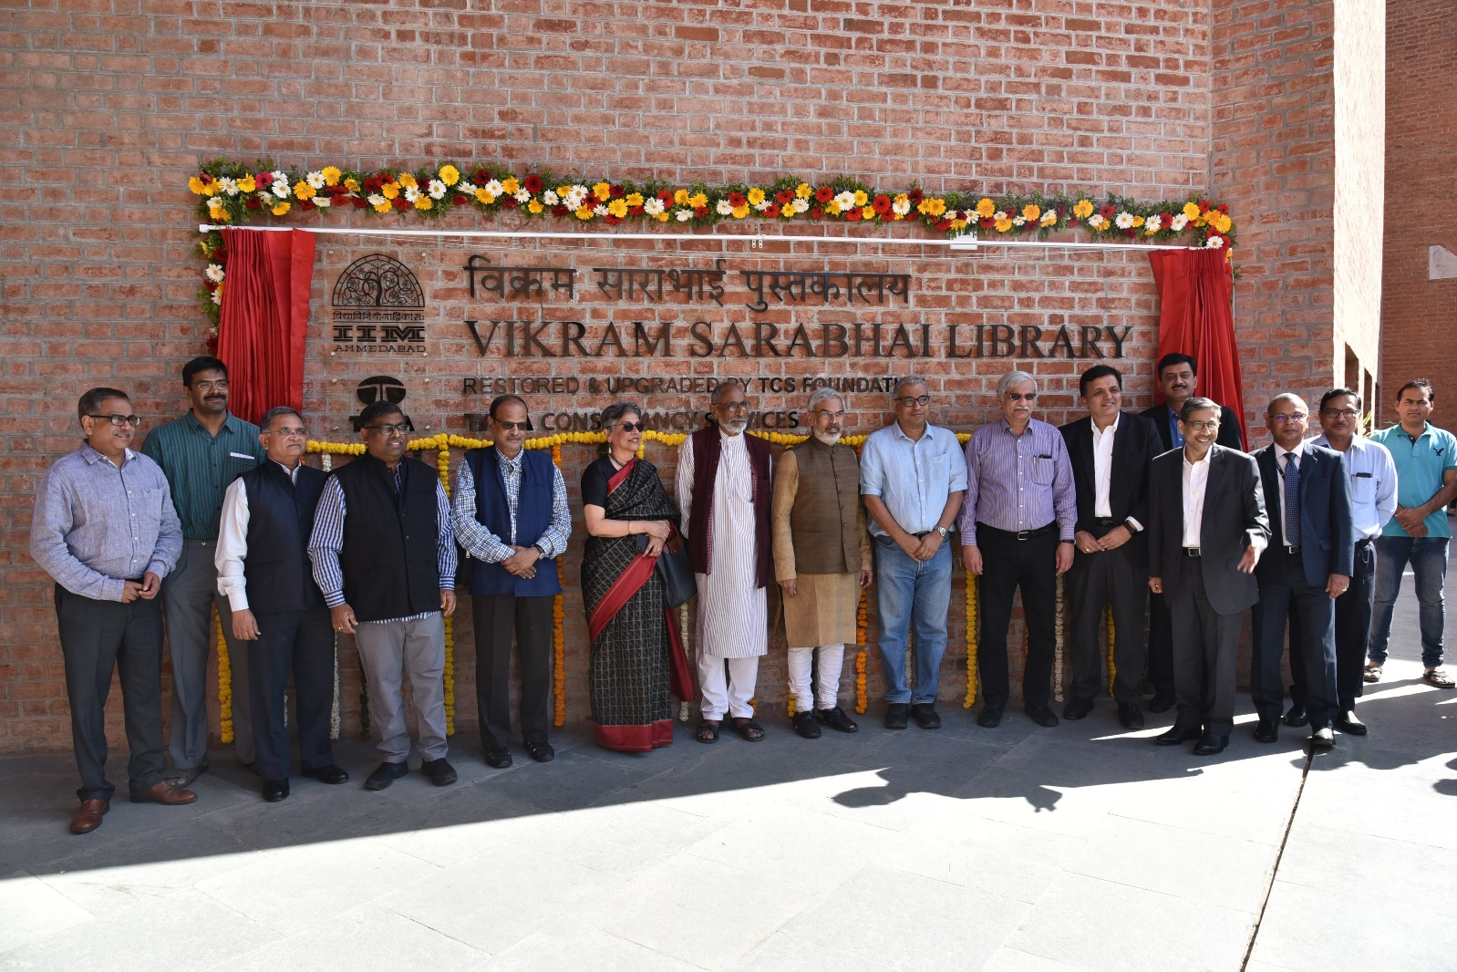

Inauguration by members of TCS, IIMA Community and Somaya & Kalappa Consultants.

**March 11, 2019 | Ahmedabad**

With a vision of becoming an interesting interactive and technology rich space for learning, collaboration and information discovery, the restored Vikram Sarabhai Library (VSL) at Indian Institute of Management Ahmedabad was inaugurated today.

Vikram Sarabhai Library at IIMA’s Louis Kahn Plaza is a landmark structure that leaves visitors awestruck. Its design and grandeur is almost impossible to miss. The iconic Louis Kahn buildings have witnessed years of academic lives on campus and even withstood the Gujarat earthquake, but had aged so as to need restoration and upgrade on priority. So, IIMA has initiated a program for the important and painstaking process of restoration and upgrade of these structures in 2016.

Tata Consultancy Services (TCS), (BSE: 532540, NSE: TCS) a leading global IT services, consulting and business solutions organization funded the restoration of the Vikram Sarabhai Library located at IIMA’s iconic Louis Kahn Plaza for a future –ready knowledge hub for Digital learning and collaboration.

*At the inaugural, Prof. Errol D’Souza, Director, IIMA said, “The Vikram Sarabhai Library is at the epicenter of the IIM Ahmedabad campus and is not just a location for preserving books but is intended to provide a workshop for readers and for conversations that expand our horizons. The architecture of the library expands on the theme of the interplay between light and darkness and is a representation of how academics is the emergence from darkness into the light. The users of the library at IIM Ahmedabad are indebted to the TCS Foundation for its contribution to the restoration of this enriching experience.”*

Tata Consultancy Services, through its CSR arm TCS Foundation, is engaged in promoting and funding projects and programs under corporate social responsibility, and supported this landmark project with funding of INR 20 crore.

*“The Vikram Sarabhai library at IIM Ahmedabad has witnessed the confluence of students and faculty ever since its inception. The TCS Foundation is proud to have associated with transformation of this iconic library to be future ready integrating leading-edge digital learning technologies and flexible collaboration spaces creating a vibrant experiential learning environment. We hope this State- of- the Art library will set a benchmark for knowledge management among academic institutions globally,” said, Milind Lakkad, Executive Vice President & Global Head -Manufacturing Business Group and Deputy Head HR, TCS.*

Somaya & Kalappa Consultants, Mumbai were appointed as the restoration and conservation architect for this project who lead the entire reconstruction of VSL building.

The reimagined Library provides a technology-rich learning environment that includes intelligent identification technologies, seamless integration, and discovery of digital content. There is an emphasis on digital collections, while print collections retain their importance to the library. Open and flexible spaces provide an environment of collaboration among students, academics, and visitors.

In addition to funding, TCS has been actively engaged with the library team in developing the VR app in addition to making valuable contribution to the discussions while finalising the layout of VSL. The app was also launched at the inaugural.

**-End of Text –**

**About Indian Institute of Management Ahmedabad (IIMA)**

Established in 1961, the Indian Institute of Management, Ahmedabad (IIMA) is recognized globally for excellence in management education. One of the top management schools in the world, IIMA educates leaders of the enterprises. The Institute’s strategic priorities include: strengthening connection with its various constituencies, including academics, practitioners, alumni, and the community; nurturing a high-performance work environment of stretch, autonomy, and teamwork; and strategic growth while maintaining emphasis on quality.

The flagship Post Graduate Programme (PGP) is ranked 21st in the Financial Times Masters in Management Ranking 2017. As per the Financial Times’ Global MBA Ranking 2017, IIMA’s Post Graduate Programme for Executives (PGPX) is ranked 29th in the World. The postgraduate program in food and Agri-Business (PGP-FABM) is ranked 1st in the Eduniversal Masters Ranking 2018. IIMA has been ranked as #1 Management institute as per the National Institutional Ranking Framework (NIRF) rankings of Ministry of Human Resource Development, Government of India.

**For media queries, please contact:**

|  |  |
| --- | --- |
| **Deepak Bhatt, Manager, Communications** | Ph: (Cell) +91-9426229429, (O) +91-79-66324683, Email: [mngr-comm@iima.ac.in](mailto:mngr-comm@iima.ac.in) |
| **Mitaaly Naidu, Executive, Public Relations** | Ph: (Cell) +91-7069074816, (O) +91-79-66324684, Email: [pr@iima.ac.in](mailto:pr@iima.ac.in) |

**About Tata Consultancy Services Ltd. (TCS)**

Tata Consultancy Services is an IT services, consulting and business solutions organization that has been partnering with many of the world’s largest businesses in their transformation journeys for the last fifty years. TCS offers a consulting-led, Cognitive powered, integrated portfolio of IT, Business & Technology Services, and engineering. This is delivered through its unique Location Independent Agile delivery model, recognized as a benchmark of excellence in software development.

A part of the Tata group, India's largest multinational business group, TCS has over 417,000 of the world’s best-trained consultants in 46 countries. The company generated consolidated revenues of US $19.09 billion for year ended March 31, 2018 and is listed on the BSE (formerly Bombay Stock Exchange) and the NSE (National Stock Exchange) in India. TCS' proactive stance on climate change and award winning work with communities across the world have earned it a place in leading sustainability indices such as the Dow Jones Sustainability Index (DJSI), MSCI Global Sustainability Index and the FTSE4Good Emerging Index. For more information, visit us at [www.tcs.com](http://www.tcs.com).

**TCS media contacts:**

|  |  |
| --- | --- |
| India: | Email: [arushie.sinha@tcs.com|](mailto:arushie.sinha@tcs.com|) [vivek.padiyar@tcs.com](mailto:vivek.padiyar@tcs.com)  Phone: +91 22 6778 9960 | +91 226778 1121 |

###