

PRESS RELEASE

IIM Ahmedabad welcomes the Second Batch of the ePGP* Programme

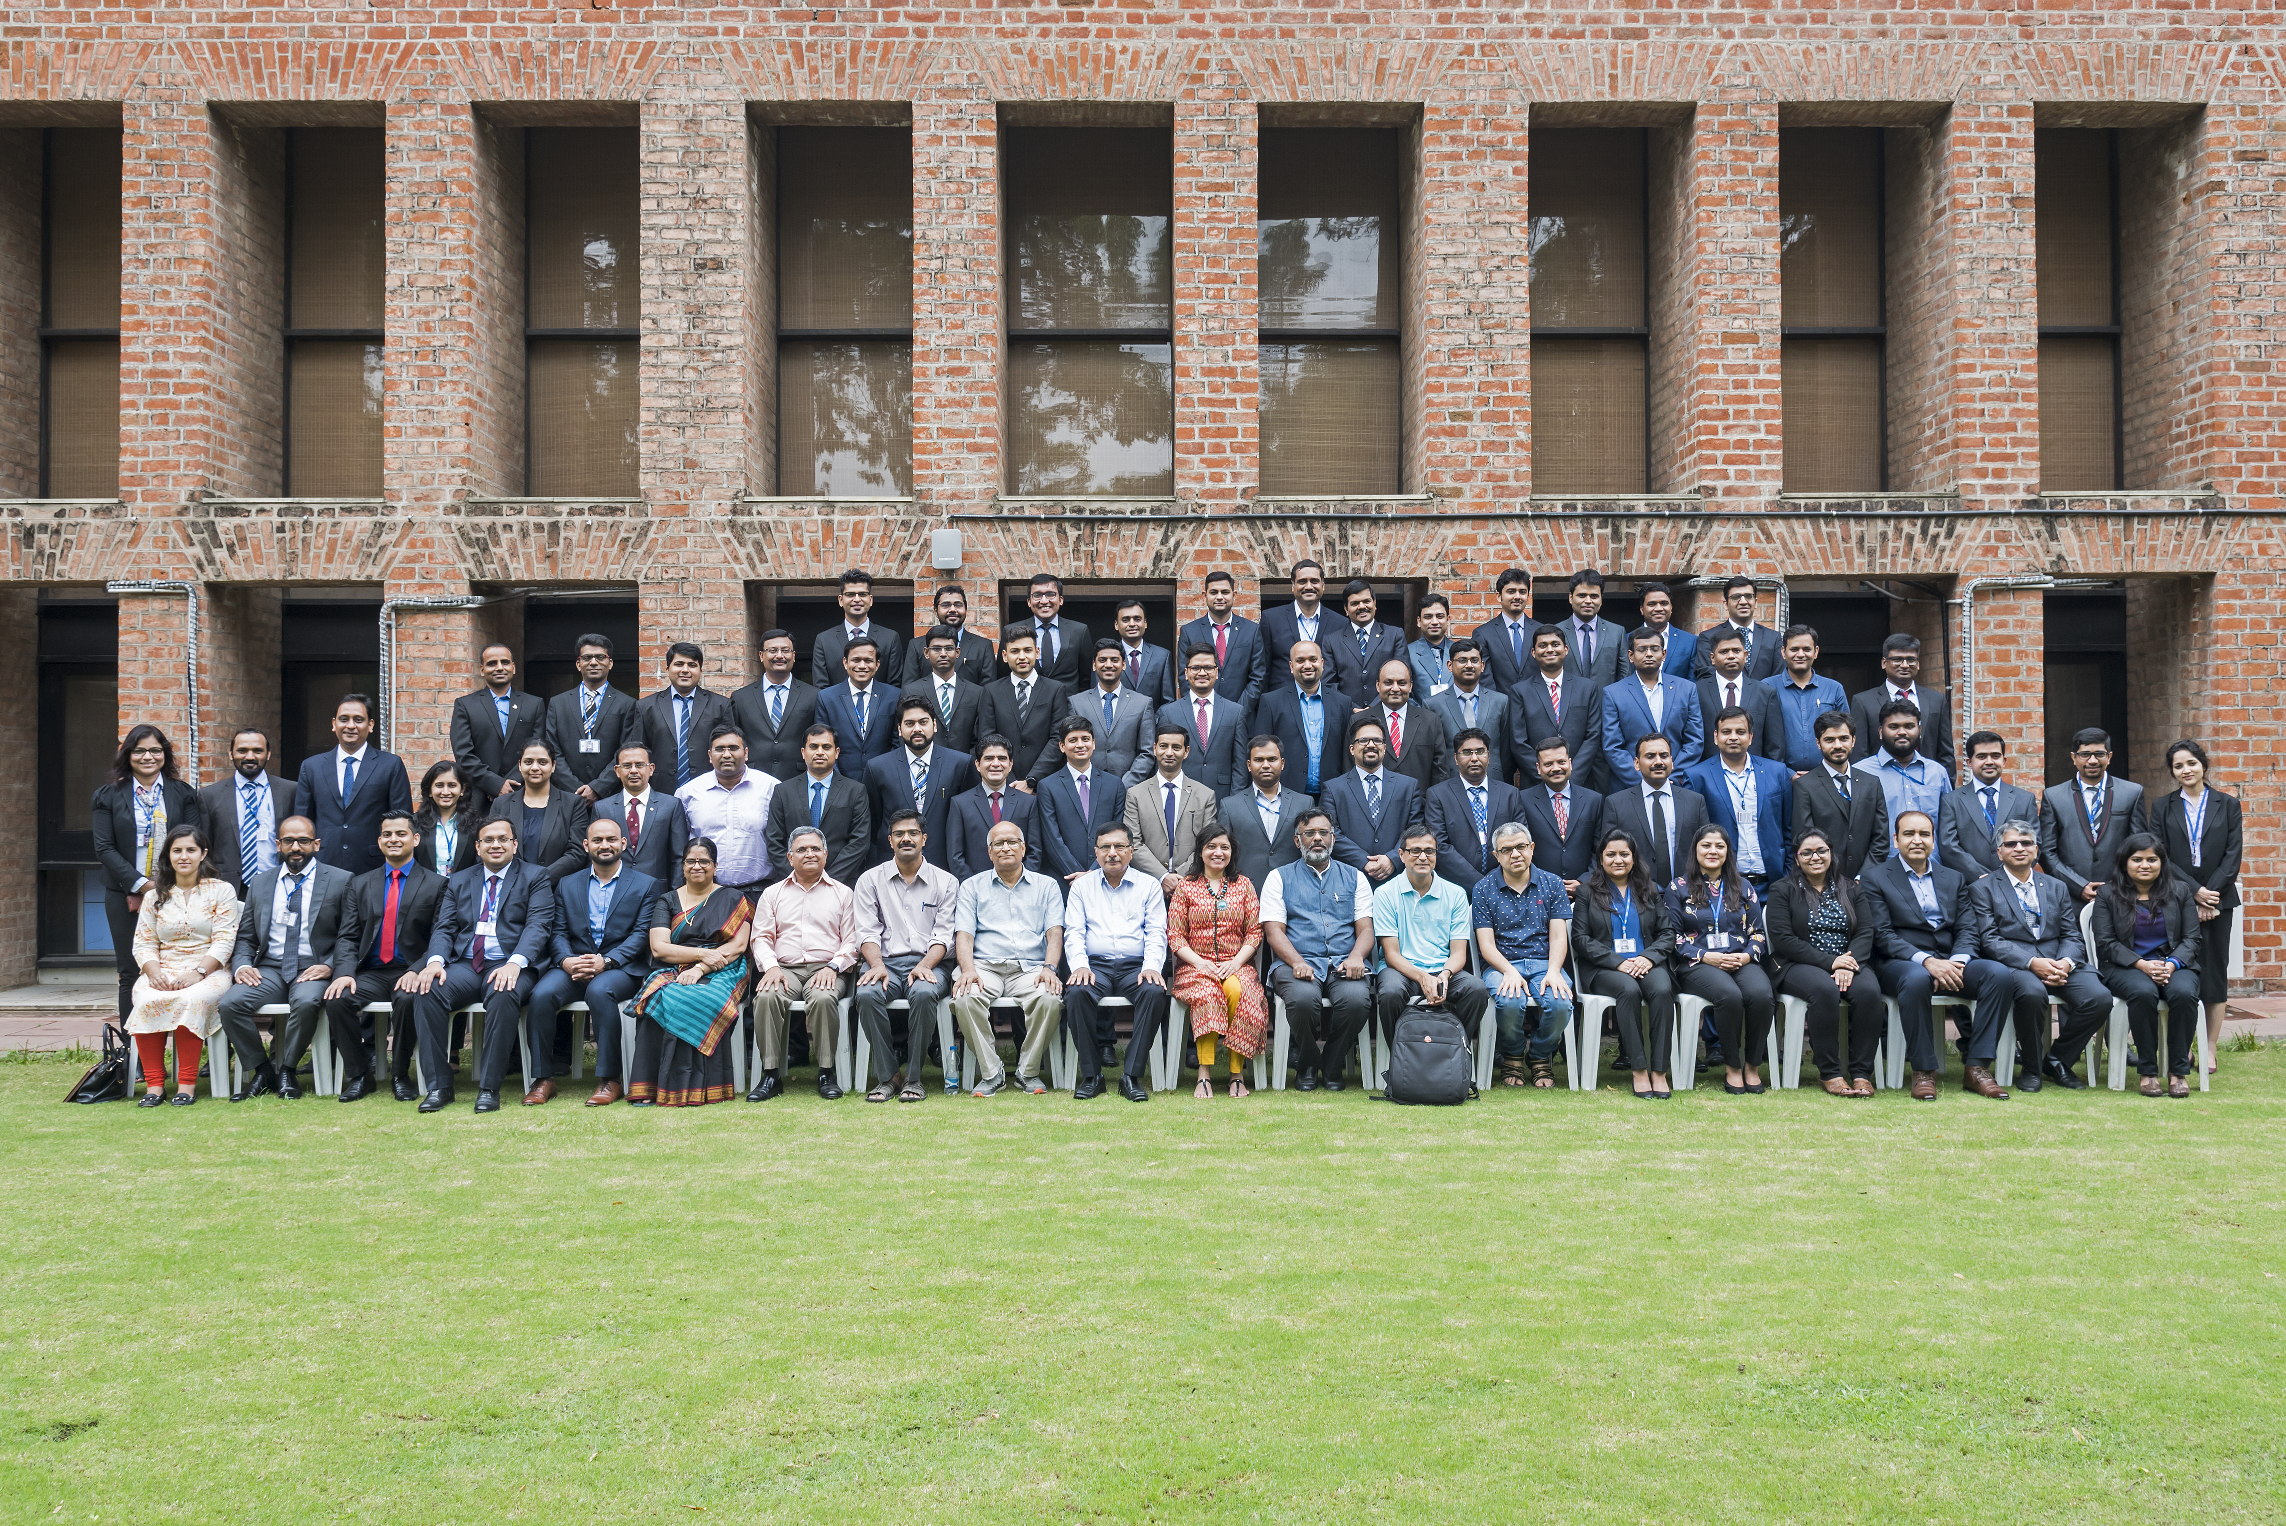

Dean(s), Chairperson ePGP, Faculty IIMA, and office staff with ePGP 2018-20 Students.

October 4, 2018 | Ahmedabad:

The e-Mode Post Graduate Programme marks IIMA's foray to offering long-term hybrid management education course leading to awarding a PG Diploma. The ePGP is a hybrid learning programme, with online lessons attended through study centers, classroom teaching at IIMA campus at regular intervals and, mentored project work. The two year course is comprehensive and designed for working executives and entrepreneurs. The programme is aimed to enhance strategic thinking and impart the entrepreneurial as well leadership abilities required for taking organizations to the next level, while also advancing individual career aspirations. The innovative curriculum is designed by the faculty members of IIMA, with their diverse experience in research, consulting / advisory, and teaching the regular students and executives in various programmes. The pedagogy is benchmarked with global standards in management education, thus providing participants with knowledge that are vital in today's knowledge economy.

The second batch of ePGP are spread in 15 cities across India, and represent a good mix of age (between 25 to 50 years), gender and high quality work and entrepreneurship experience. The flexibility of the ePGP programme attracts talented professionals, with diverse career and entrepreneurial backgrounds in industries that include Automobile, Financial services, Banking, Power, E-Commerce, and IT sector. The admitted students have an average of 10 years of work / entrepreneurship experience. They study in a unique and collaborative learning environment, while also holding to their demanding roles in organization.

The second batch of ePGP candidates have been selected by applying rigorous selection criteria and process. The second ePGP batch has 63 participants of which 70% hold BE/B. Tech. Degree. 41% percent of the participants have between 3-6 years of work experience, 24 % have 7-10 years of work experience, and 35 % candidates have more than 10 years of work experience. The 2018-20 batch of ePGP has seen a surge in female candidates, with 8 female candidates enrolling.

For the next batch of ePGP starting from September 2019, IIMA will be considering CAT/GMAT/GRE scores for shortlisting.

*'e' stands for Electronic Mode (Interactive Onsite Learning).

-End of Text -

For media queries, please contact:

Deepak Bhatt, Manager, Communications
Ph: (Cell) +91-9426229429, (O) +91-79-66324683, Email: mngr-comm@iima.ac.in

Mitaaly Naidu, Executive, Public Relations
Ph: (Cell) +91-7069074816, (O) +91-79-66324684, Email: pr@iima.ac.in

