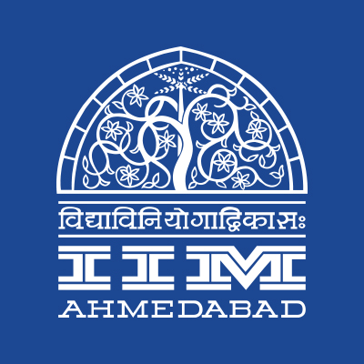

**PRESS RELEASE**

**IIMA and Citibank collaborate to offer Merit Scholarships to IIMA PGP Students**

**December 12, 2017 | Ahmedabad**

We are delighted to announce the launch of Citi-IIMA Scholarship being funded by Citibank. IIMA has contributed significantly to leaders and change agents in Indian corporates and global MNCs. Citibank has had a long association with IIMA for recruitment to match their talent needs.

Citi-IIMA scholarship being launched today is a prestigious scholarship that will offer an opportunity for three IIMA PGP students to be awarded INR 5 lakhs scholarship each (INR 2.5 lakhs per annum for the two year programme).

This long-term Scholarship program will be supported by the interest income on the Corpus (INR 2.1 crores) provided by the Citibank and will continue till the exhaustion of the Corpus.

*“We are grateful to Citibank for supporting these Scholarships at IIMA. The institute has since inception focused on all round excellence and recognizing Merit. While the students are always giving their best to excel in academic and extra-curricular activities to enrich their experience during stay on campus, these scholarships go a long way in promoting the spirit of excellence” said the IIMA Director-in-Charge Prof Errol D’Souza –* ***Draft quote***

*“Generations of Citibank executives have come to IIMA campus to learn and be trained by this Institute. IIMA compares well with the best of management schools anywhere in the world. Citibank is happy to contribute in a small way to support IIMA’s journey of excellence and strengthen our partnership with the institute that has always connected closely with the world of practice” said Anand Chopra, Managing Director Citicorp Services India Ltd. and Head Operations & Technology Citi South Asia who is also Alumnus of IIMA (PGP 1990)-****Draft quote***

- End of Text-

**About Indian Institute of Management Ahmedabad (IIMA)**

Established in 1961, the Indian Institute of Management, Ahmedabad (IIMA) is recognized globally for excellence in management education. One of the top management schools in the world, IIMA educates leaders of the enterprises.The Institute’s strategic priorities include: strengthening connection with its various constituencies, including academics, practitioners, alumni, and the community; nurturing a high performance work environment of stretch, autonomy, and teamwork; and strategic growth while maintaining emphasis on quality.

As per the latest ranking by *The Economist*, IIMA is No. 1 School in the world on the parameter of opening up new career opportunities for students. The flagship Post Graduate Programme (PGP) is ranked 16th in the *Financial Times* Masters in Management Ranking 2016. As per the *Financial Times’* Global MBA Ranking 2016, IIMA’s Post Graduate Programme for Executives (PGPX) is ranked 24th in the World. IIMA has been ranked as #1 Management institute as per the National Institutional Ranking Framework (NIRF) rankings of Ministry of Human Resource Development, Government of India.

**IIMA MEDIA CONTACTS**

|  |  |
| --- | --- |
| **Mr. Deepak Bhatt**  Manager, Communications  Email: [mngr-comm@iima.ac.in](mailto:mngr-comm@iima.ac.in) Phone: +91-79-66324683 | **Ms. Mitaaly Naidu**  PR Executive, Communications  Email: [pr@iima.ac.in](mailto:pr@iima.ac.in) Phone: +91-79-66324684 |