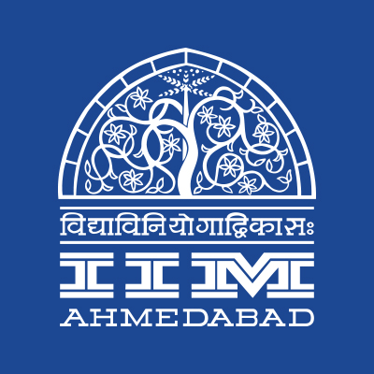

**PRESS RELEASE**

**IIMA to host Baahubali’s Director-Producer Duo and Quora’s most followed personality**

**January 24, 2018 | Ahmedabad**

Chaos, the annual cultural festival of IIMA, adds another feather to its cap this year with the introduction of the ‘Ignitus’ Speaker Sessions. The aim of the series is for Chaos to grow as an avenue to live, experience and cherish arts, culture and literature. It has been envisioned with the idea of providing a platform for talented and aspiring artists to meet and interact with reputed personalities in various cultural domains.

The inaugural edition will witness an interaction session with the director-producer duo, Mr. S S Rajamouli and Mr. Shobu Yarlagadda, of the blockbuster ‘Baahubali’ film fame. The ‘Baahubali’ films have truly set a benchmark for Indian films with the sheer magnitude of scale and technical expertise involved. ‘Baahubali 2’ is also the highest grossing film in India and has made the world over sit up and takes notice of the Indian cinema industry. The duo will interact with the students on campus on Day 1 of the festival (January 26, 2018).

Mr. Balaji Viswanathan, Quora’s most followed personality and in-house rockstar will be speaking on Day 2 of the fest (January 27, 2018). His clear style of communication, combined with close to a decade of experience in start-up ventures have made him a name people look up to in the social media space. He has been involved in various start-up ventures in the tech and education domains and is currently the CEO of Invento Robotics, a pioneer in AI-enabled hardware. The company was recently in the news for its ‘Mitra’ humanoid robot, of completely indigenous make, which launched the Global Entrepreneurship Summit, 2017 held in Hyderabad.

The speaker sessions are free and open to all. For more information, please visit https://www.facebook.com/IIMA.Chaos/.

-End of Text-

|  |
| --- |
| **News in Brief**  Indian Institute of Management Ahmedabad is all set to host Chaos, its cultural festival from 25th January to 28th January, 2018. This edition of Chaos is doubly significant as it will witness the launch of the ‘Ignitus’ Speaker Sessions. The inaugural edition will witness the likes of director-producer duo of the larger-than-life ‘Baahubali’ films,  Mr S S Rajamouli and Mr Shobu Yarlagadda on Day 1 of the festival (26th Jan) and Quora’s most followed personality and CEO of Invento Robotics, Mr Balaji Viswanathan on Day 2 (27th Jan). The aim of the series is for Chaos to grow as an avenue to live, experience and cherish arts, culture and literature through these sessions. |

**About Indian Institute of Management Ahmedabad (IIMA)**

Established in 1961, the Indian Institute of Management, Ahmedabad (IIMA) is recognized globally for excellence in management education. One of the top management schools in the world, IIMA educates leaders of the enterprises.The Institute’s strategic priorities include: strengthening connection with its various constituencies, including academics, practitioners, alumni, and the community; nurturing a high performance work environment of stretch, autonomy, and teamwork; and strategic growth while maintaining emphasis on quality.

As per the latest ranking by *The Economist*, IIMA is No. 1 School in the world on the parameter of opening up new career opportunities for students. The flagship Post Graduate Programme (PGP) is ranked 16th in the *Financial Times* Masters in Management Ranking 2016. As per the *Financial Times’* Global MBA Ranking 2016, IIMA’s Post Graduate Programme for Executives (PGPX) is ranked 24th in the World. IIMA has been ranked as #1 Management institute as per the National Institutional Ranking Framework (NIRF) rankings of Ministry of Human Resource Development, Government of India.

For media queries, please contact:

|  |  |
| --- | --- |
| Shubham Varshney  Marketing & PR Cell, Chaos (PGP-2)  Indian Institute of Management Ahmedabad  Ph: (Cell) +91-7503602678  Email: p16shubhamv@iima.ac.in | Aashish Gupta  Marketing & PR Cell, Chaos (PGP-2)  Indian Institute of Management Ahmedabad  Ph: (Cell) +91-8090026763  Email: [p16aashishg@iima.ac.in](mailto:p16aashishg@iima.ac.in) |